README.md 2025-04-15

Overview about the Business Scenario & the Data Model

The Business Scenario

The sample data set for the session represents retail transactions from a number of outlet stores located in the United States. The transaction details include the store, the sold product, and the sales manager. In addition, the information on revenue, cost, discount, and profit is available for each transaction.

The sales department is looking for a few analytics they need:

 **Top 10 Revenue Generating Products**   
 They want to discover the top 10 revenue generating products.

 **Sales Per Region**   
 Due to an increase in the number of sales, the customer wants to understand how the different regions are performing. Based on this visualization, the marketing team would identify the regions which are doing good as well as the regions which need attention or better marketing campaigns.

 **Best Sales Representative**   
 It is time for the company to reward the best sales representative for all the hard work that has resulted in the sales report. For this purpose, the company needs to have a visualization that shows revenue per sales representative.

The exercises will walk you through the steps using SAP Datasphere and SAP Analytics Cloud to answer those open questions, using the following tables:

|  |  |  |  |
| --- | --- | --- | --- |
| **Table Name** | **Description** | | **Model Type** |
| Sales Transactions | Daily Retail Transactions per Store | | Relational Dataset |
| Store | Details per Store Outlet | | Dimension |
| Sales Manager | Details on all Sales Manager | | Dimension |
| Product | Details on the Products being sold | | Dimension |
| The data is provided in CSV files in this ZIP-file: | | DA180_Resources.zip | |

The Data Model

These four tables consist of one fact table which includes the sales transactions details, and three dimension tables for more details about the product, the store and the sales manager.

The ***Time Dimension*** will be associated to the sales transaction table as shown in the Enitity-Relationship model.

1 / 2

README.md 2025-04-15

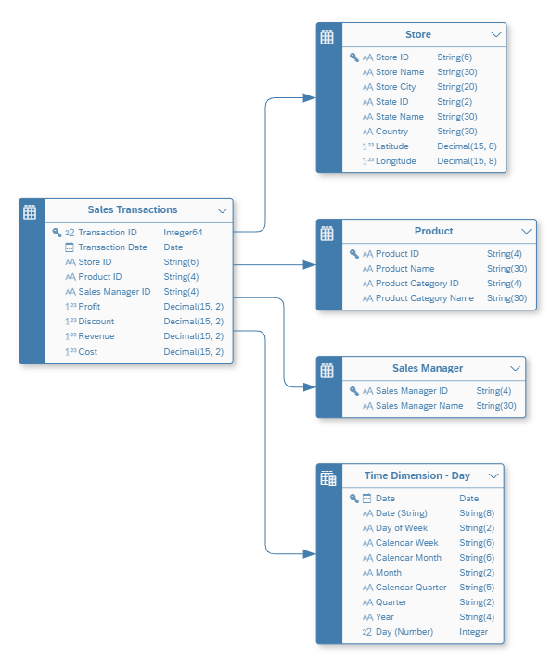

Summary

Now that you have a good understanding of the business scenario and the data model, you can start to get a

basic trial access.

Continue with Get your Basic Trial access

2 / 2

README_ExOverview.md 2025-04-15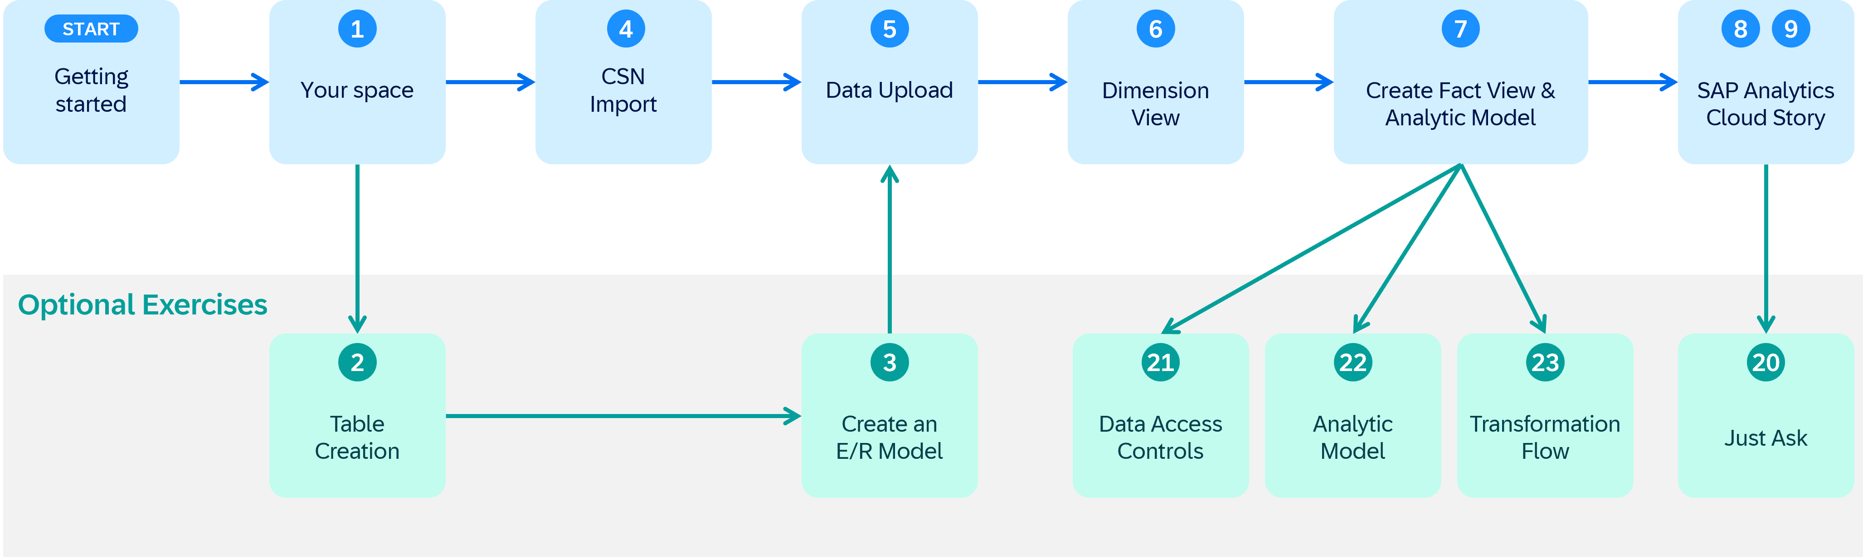

Exercise Overview

We structured the overall exercise the following way:

|  |  |
| --- | --- |
|  | Use the blue path to finish early and enjoy exploring the system on your own You can learn more and use the **Optional Exercises** for deep dives on different topics |

Let us give you a brief introduction on what can you expect in the different parts of the exercise.

1. **Getting Started**

In this area you get an overview about the business scenario & the data model used throughout the exercises.

We also give you guidance on how to get your basic trial access in case you do not have access to a SAP Datasphere system already.

If you have never touched an SAP Datasphere system you can get an overview about your first log on and how you navigate in the system.

2. **SAP Datasphere**

This section covers the main modeling exercises where you prepare tables, views and an analytic model to build the foundation for the stories in SAP Analytics Cloud.

In the first exercise Get to know your own Space you learn more about the concdpt of Spaces and the ***Time Dimension*** required for your modeling in later parts of the exercise.

You can manually create the tables and the entity relationship model, or directly generate the tables and ER model by using the importing the tables provided with the [CSN file](https://cap.cloud.sap/docs/cds/csn) called *Sales_ER_Model.json*.

Then you populate the tables with data by uploading data files using the CSV files from the ZIP file. Based on these tables you then create a dimension view as well as a fact view and an analytic model.

1 / 2

README_ExOverview.md 2025-04-15

3. **SAP Analytics Cloud**   
In this part you will create simple stories in SAP Analytics Cloud to learn how to visualize your data based on a live connection to SAP Datasphere. The first story shows the Top 10 Revenue Generating Products and the second the Revenue by Geography. Both require the previous exercises to be completed up to exercise 08.

4. **Optional Exercises**   
These exercises are all optional and you can learn how to

 leverage Just Ask with SAP Analytics Cloud to Identify Top Sales Managers with Just Ask

 enable row-level security with Data Access Controls by Creating Row-Level Permissions based on External Hierarchy

 explore more features of the Analytic Model

 and learn about Transformation Flows by Creating a Transformation Flow and the usage of delta tables

Summary   
Now that you have a good understanding of the exercises, lets get started with the hands-on part.

Continue with Overview about the business scenario and the data model

2 / 2

README.md 2025-04-15

Exercise 1: Get to know your own Space

|  |  |  |  |
| --- | --- | --- | --- |
|  | | |  | | --- | | **Note:** This is an optional exercise. | |
|  | Detour: SAP Datasphere - Spaces | |

Spaces as part of the SAP Datasphere solution are virtual team environments where your administrator has the ability to assign users and roles, as well as additional resources, connections to data sources, and allocated storage.

In SAP Datasphere all data related workflows start with the selection of a space, so you can see the space is a fundamental concept. Users can share tables and view to another space to allow users assigned to that space to use it as a source for their objects.

End of Detour

Get to know your own Space

|  |  |  |
| --- | --- | --- |
|  | **Important:** |  |

|  |
| --- |
| In case you are not using a guided experience trial system for this hands-on training, then you require |

|  |
| --- |
| a space on the SAP Datasphere tenant you are using. |

1. In the menu on the left-hand side, select the option ***Space Management***.

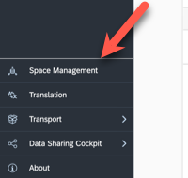

1 / 3

README.md 2025-04-15

2. After you selected the menu item, you will be presented with a list of existing spaces.

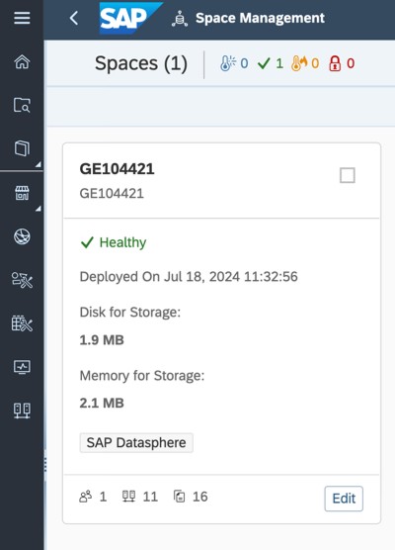

3. Click the ***EDIT*** button of your assigned space. The pre-defined spaces are usually named the same way as your user ID for example GE12345. The technical ID is identical to the space name.

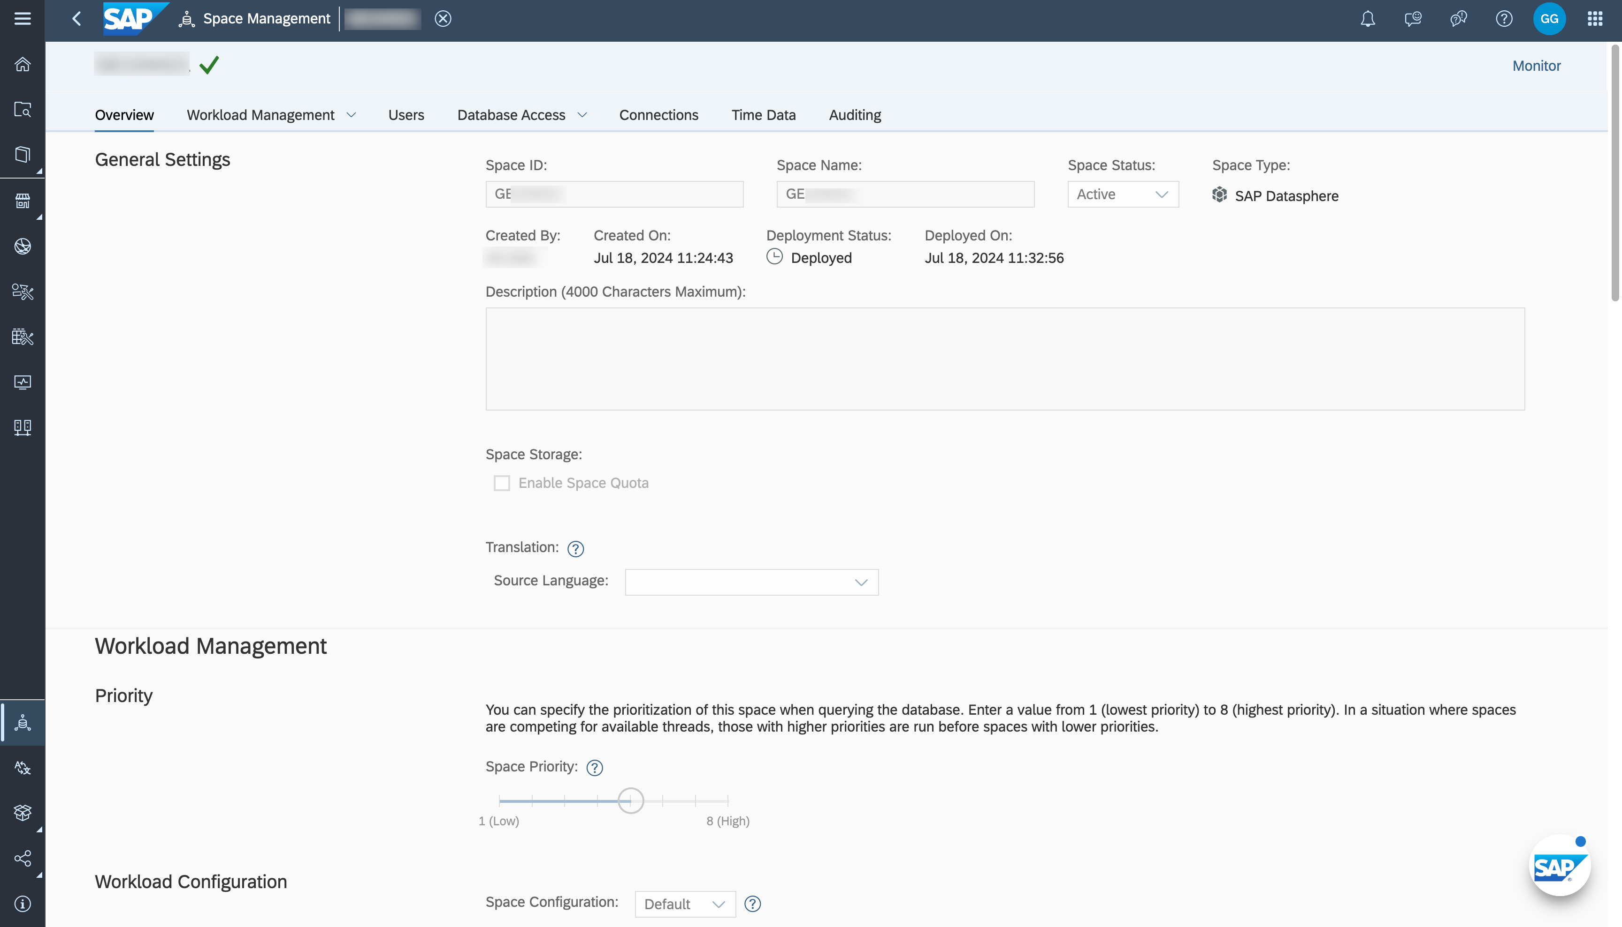

2 / 3

README.md 2025-04-15

4. You are now being presented with the properties of your space and the abilities to configure certain options.

Changing the storage assignment or workload management options is not possible in basic trial systems.

5. In the "Users" section you can see that your user (e.g. GE12345) is already assigned to the Space.

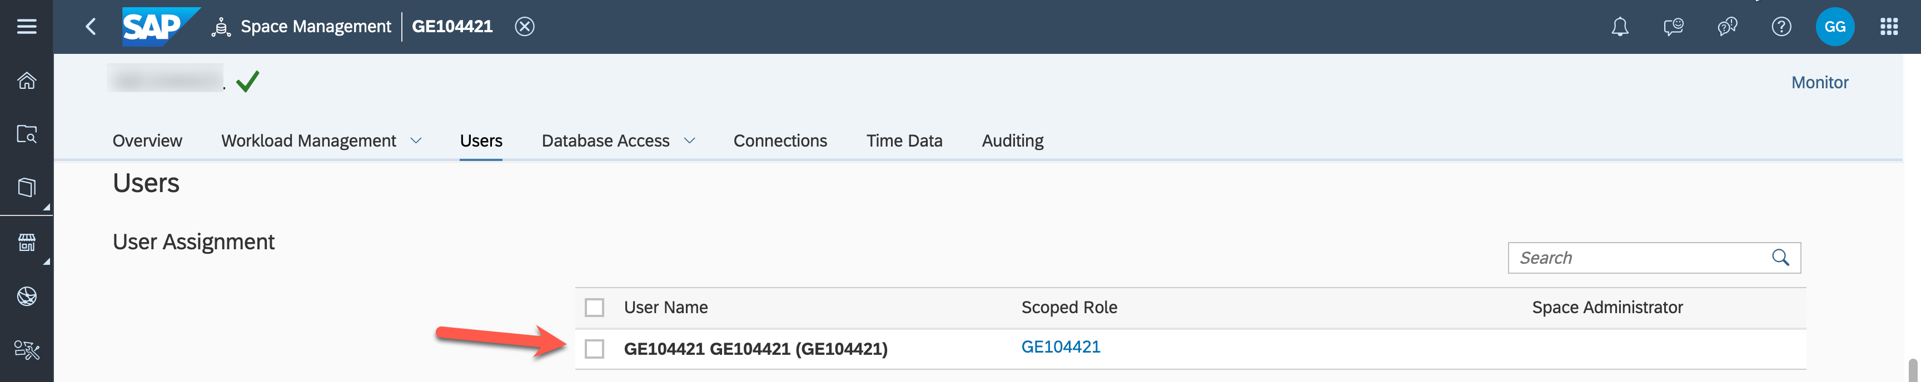

6. The **Time Data** section shows that time table and dimensions have already been created in your space.

They provide standardized time data which we will use later as part of our model to create a date hierarchy. If you are using an own Datasphere tenant, please create the Time Tables and Dimensions.

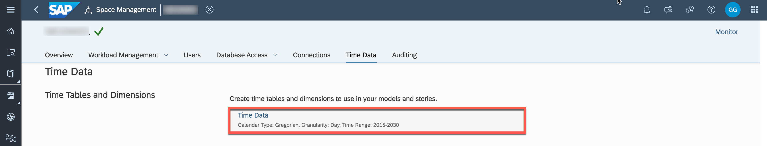

Summary

You have explored the settings of your space in SAP Datasphere. You can now start your next step and create your first data model.

Continue to - Exercise 4: Importing Tables or Exercise 02: Prepare Your Data (optional)

3 / 3

README.md 2025-04-15

Exercise 2 - Data Layer - Prepare Your Data

|  |  |  |  |
| --- | --- | --- | --- |
|  | | |  | | --- | | **Note:** This is an Optional Exercise | |
|  | Detour: SAP Datasphere - Model Types | |

Before we are going to start with the first exercise in creating a table and creating the first model, let us have a look at the different asset types that you can create in the Data Builder of SAP Datasphere.

So, let’s now look at the different asset types:

 **Table**: Create a Table to contain data by defining its column structure. You can configure each field of the Table, and already define semantics and associations. You have the ability to upload data to this Table later on.

 **Graphical View**: In the Graphical View you can leverage Tables and Views to prepare data and then create new Views using a graphical no-code/low-code editor. Join datasets as required, add other operators to remove or create columns and filter or aggregate data, and specify measures and other aspects of your output structure in the output node.

 **SQL View**: In the SQL View you can leverage Tables and Views to the create new Views by using SQL or SQL-script (table function) view in a powerful SQL editor.   
 *Not used in the DA180 exercises.*

 **Entity-Relationship Model**: Here you define the relationships between Tables or Views, which then are being leveraged when you create a new View based on the Tables or Views.

 **Analytic Model**: Analytic models are the analytical foundation for making data ready for consumption in SAP Analytics Cloud. They allow you to create and define multi-dimensional models to provide data for analytical purposes to answer different business questions.

 **Data Flow**: You define Data Flows to use data transformations and leverage the option to load data from a source system and persist it in SAP Datasphere.   
 *Not used in the DA180 exercises.*

 **Replication Flow**: Create a replication flow if you want to copy multiple data assets from the same source to the same target in a fast and easy way and do not require complex projections. *Not used in the DA180 exercises.*

 **Transformation Flow**: Create a transformation flow if you want to load data from one or more source tables, apply transformations (such as a join), and output the result in a target table. You can load full or delta data sets of data from one or more source tables to a target table.

 **Intelligent Lookup**: Create an intelligent lookup to merge data from two entities even if they do not have a common identifier.

*Not used in the DA180 exercises.*

 **Task Chain**: Create a task chain that groups multiple tasks, which can be run in series manually or through a schedule.

1 / 9

README.md 2025-04-15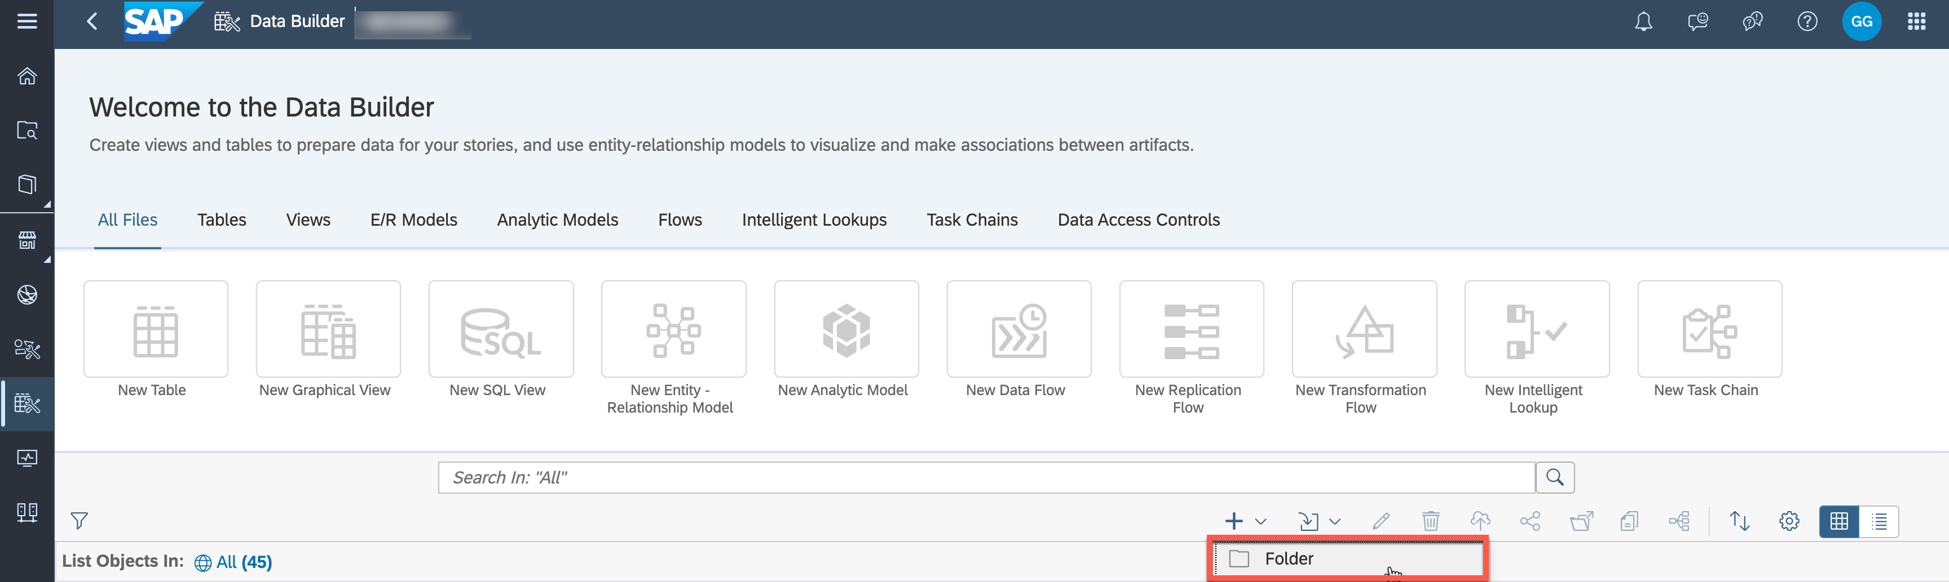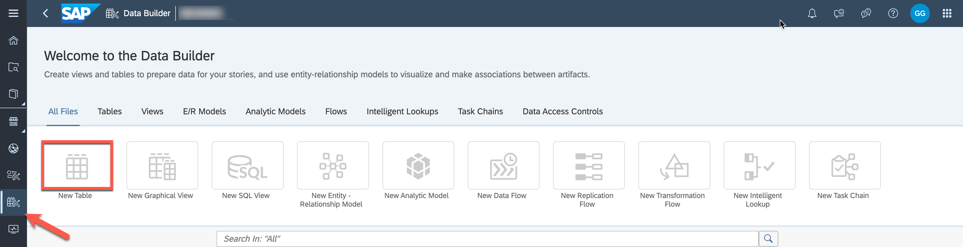

*Not used in the DA180 exercises.*

End of Detour   
Start of the exercise   
In this section we will start creating the tables for our sample models and then upload the raw data to those tables in Exercise 5.

We will start to create the tables in SAP Datasphere.

1. Log On to your SAP Datasphere tenant.

2. Select the menu option Data Builder on the left-hand side. In case you are being asked, select your space (e.g. GE12345)   
3. Create a new folder to organize the entities you will create in this jump-start session by navigating to the "+"-icon on the right and enter "TECHED2024-DA180" as business name and confirm. A new folder is displayed in the object list.

4. Select the option ***New Table***.



5. You are being presented with the details to create a new table. 6. Enter the following details:

|  |  |
| --- | --- |
|  | Business Name - Sales Transactions Technical Name - Sales_Transactions Semantic Usage - Relational Dataset |

2 / 9

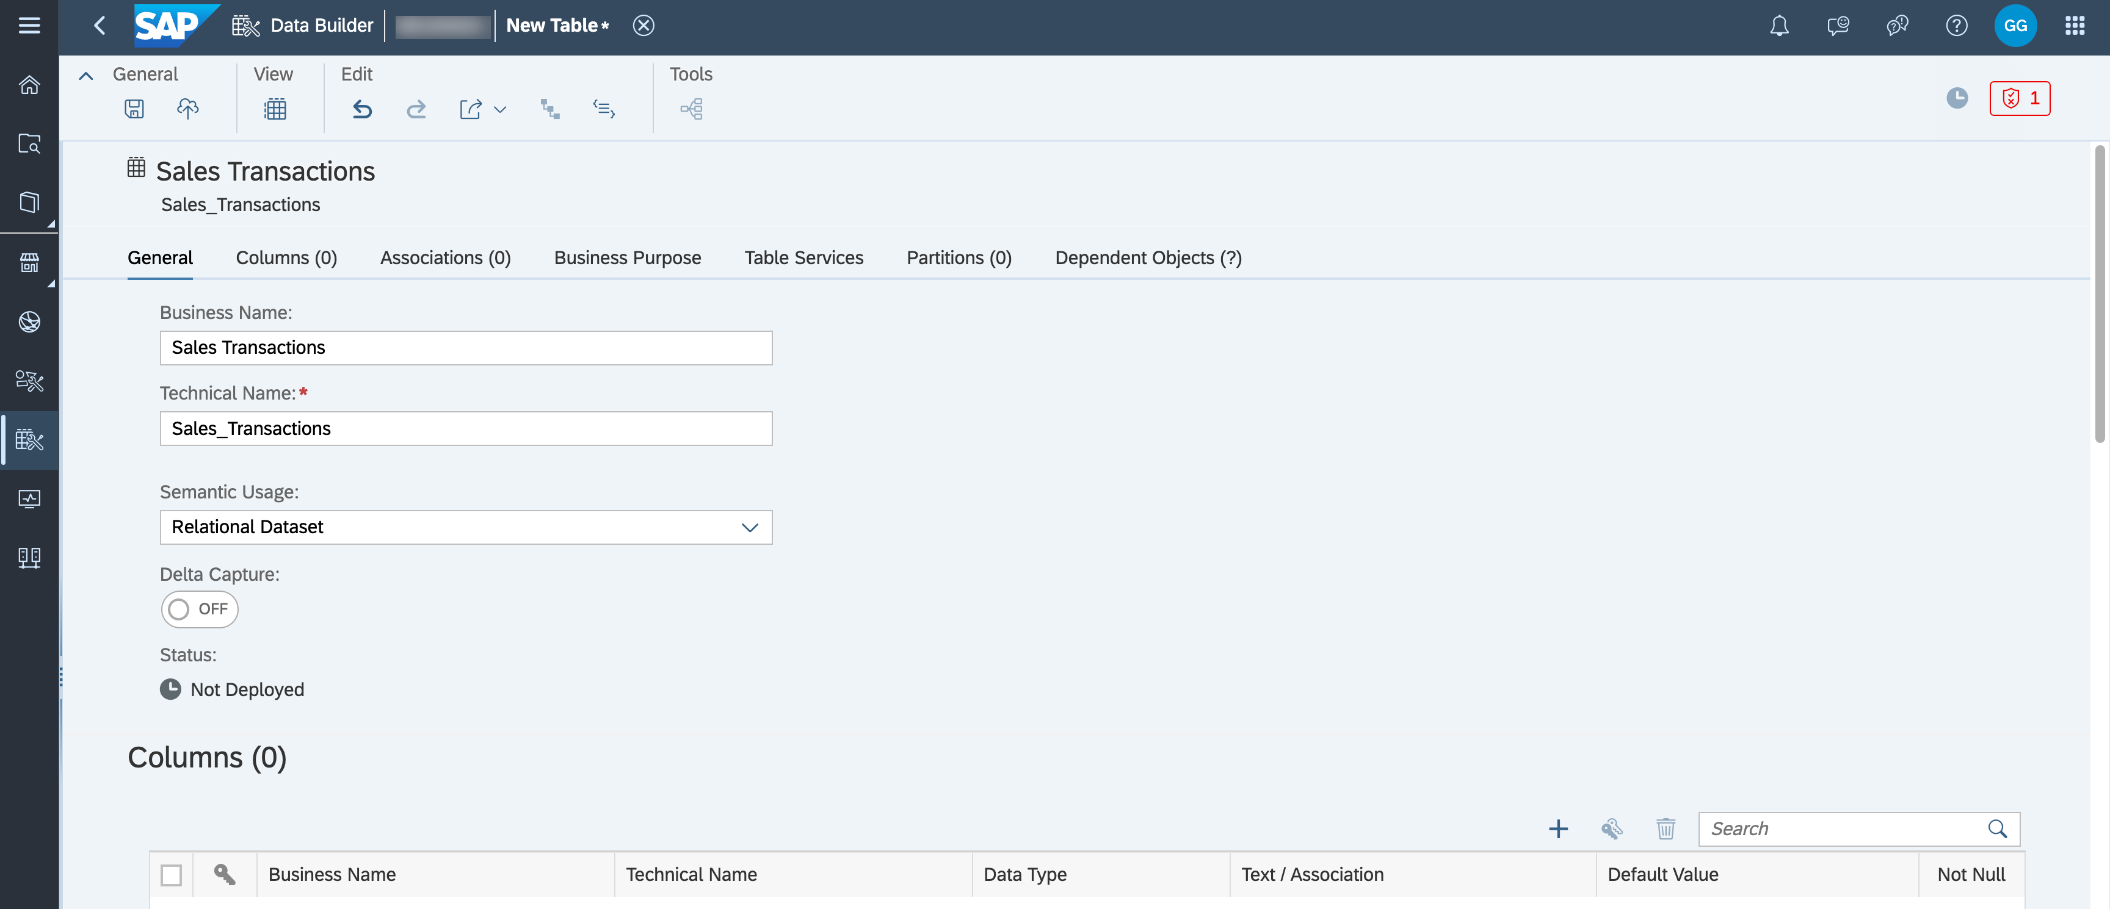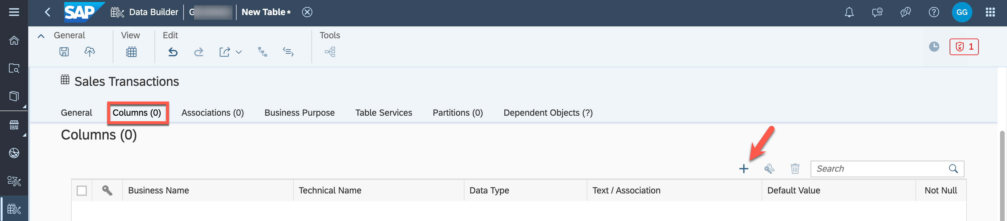

|  |  |
| --- | --- |
| README.md | 2025-04-15  Scroll down to the area ***Columns*** (you can also use the tabs in the page header for navigation). |

Here you define the structure of the table by adding the individual columns.

 Use the “+” sign in the top right corner of the ***Columns*** area to start the process of creating your first table column

|  |  |
| --- | --- |
|  | You now need to enter a business name, a technical name, and you need to configure the Data |

Type

 For the first column, enter the following details:

Business Name - Transaction ID   
Technical Name - Transaction_ID   
Data Type - Integer64

|  |  |
| --- | --- |
|  | **Tip:** Please note, that you can change the **Data Type** simply by clicking on the default data type |

|  |
| --- |
| (e.g. String(100)) in the Data Type column. |

11. After you entered the details for the first column, please enter the additional columns. All columns of the table are listed as follows:

|  |  |  |  |
| --- | --- | --- | --- |
| **Key:** | **Business Name:** | **Technical Name:** | **Data Type:** |
| X | Transaction ID | Transaction_ID | Integer64 |
|  | Transaction Date | Transaction_Date | Date |
|  | Store ID | Store_ID | String (6) |

3 / 9

|  |  |  |  |  |
| --- | --- | --- | --- | --- |
| README.md | | **Technical Name:** | **Data Type:** | 2025-04-15 |
| **Key:** | **Business Name:** |
| Product ID | | Product_ID | String (4) |  |
| Sales Manager ID | | Sales_Manager_ID | String (4) |  |
| Profit | | Profit | Decimal(15,2) |  |
| Discount | | Discount | Decimal(15,2) |  |
| Revenue | | Revenue | Decimal(15,2) |  |
| Cost | | Cost | Decimal(15,2) |  |

12. After you entered all columns for the table, ensure you enable the Key Column option for the column Transaction ID.

13. Now use the ***Save*** option in the General menu.

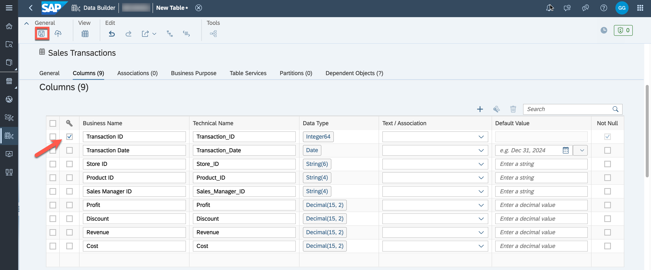

14. Select the folder "TECHED2024-DA180". On the first time you save the table, you will be asked to confirm the name and technical name.

4 / 9

README.md 2025-04-15

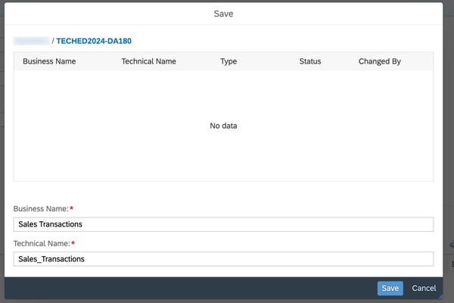

15. Click ***Save***.

16. After you saved the changes, you also have to deploy the table, so that we can later on upload data to the table.

17. Use the Deploy option from the General menu.

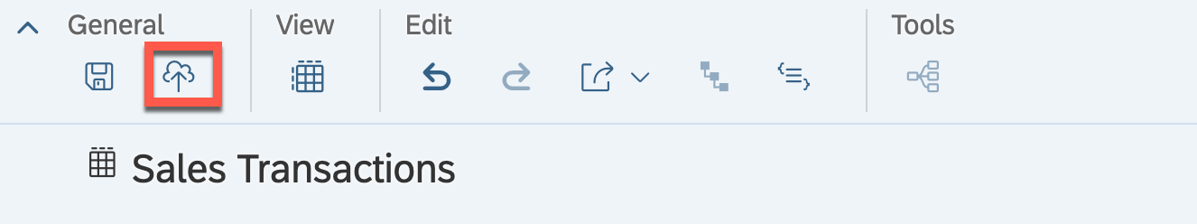

18. We configured, saved, and deployed our first table.

19. Click on the ***"back arrow"*** on the top menu bar to navigate back to the list of tables.

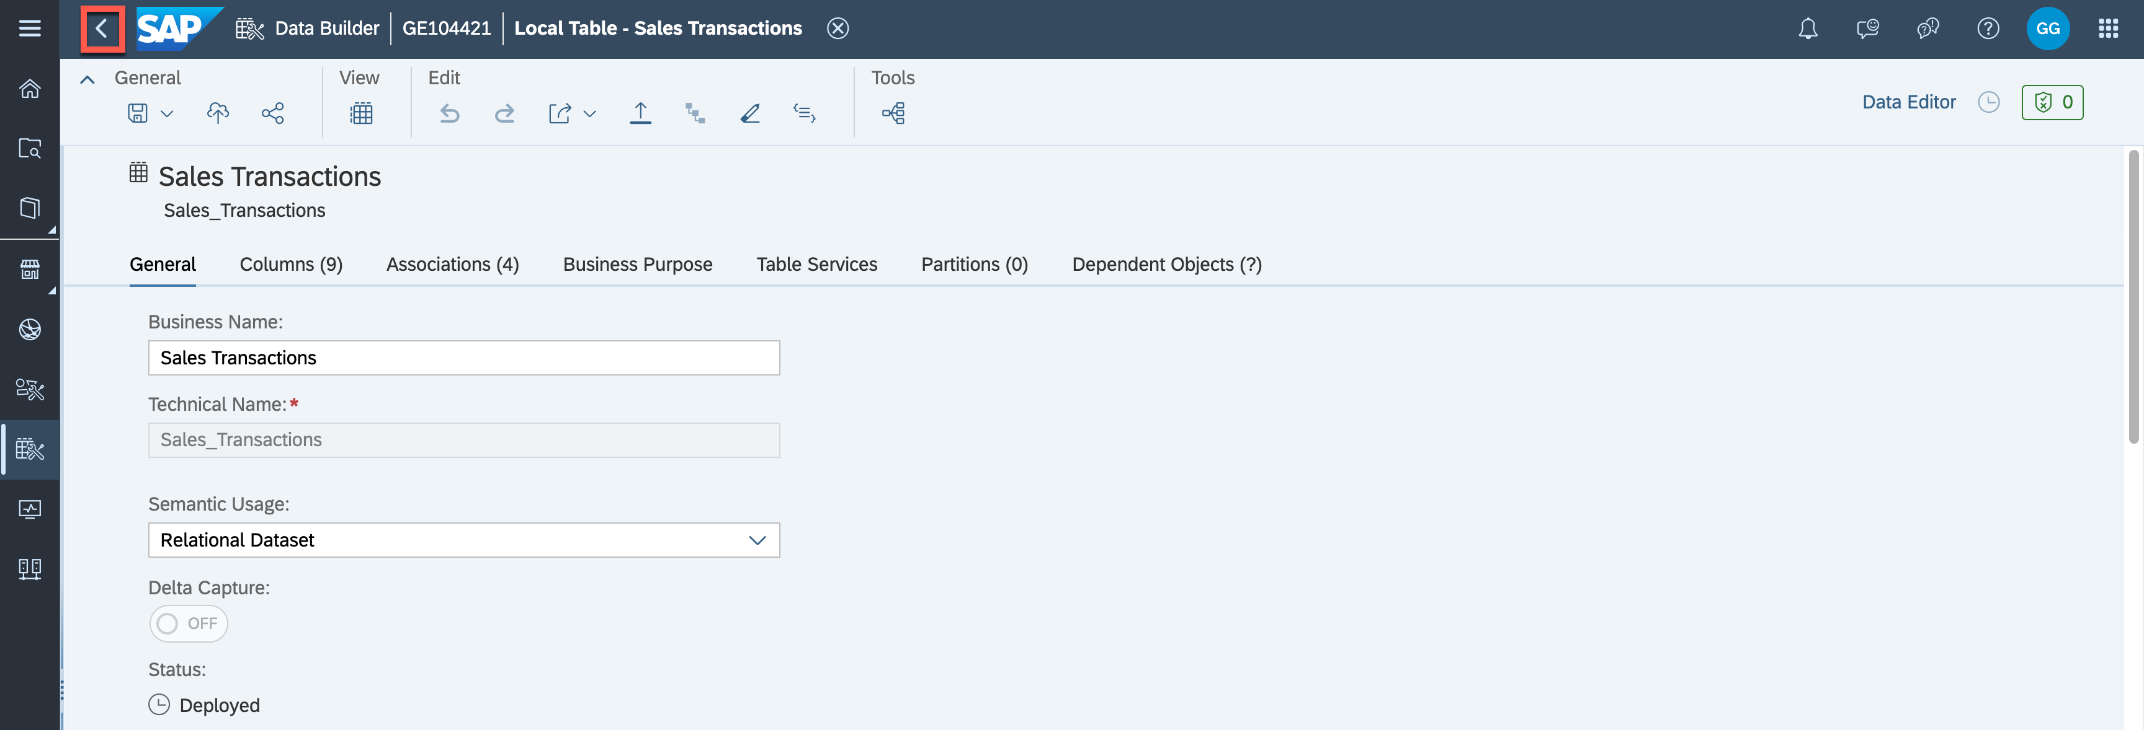

20. You are back at the home screen of the Data Builder and you should see your table in the list of objects. 5 / 9

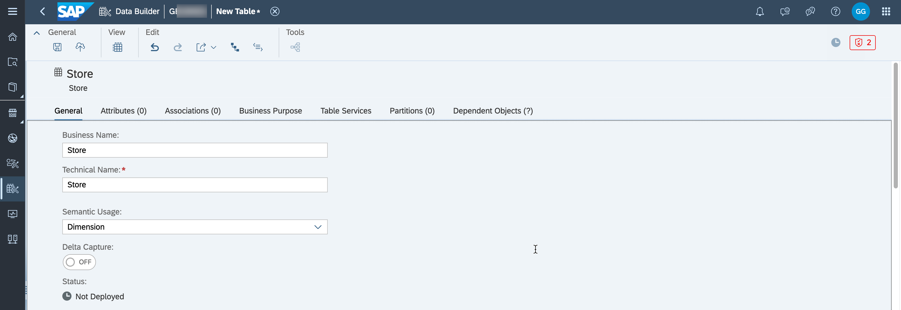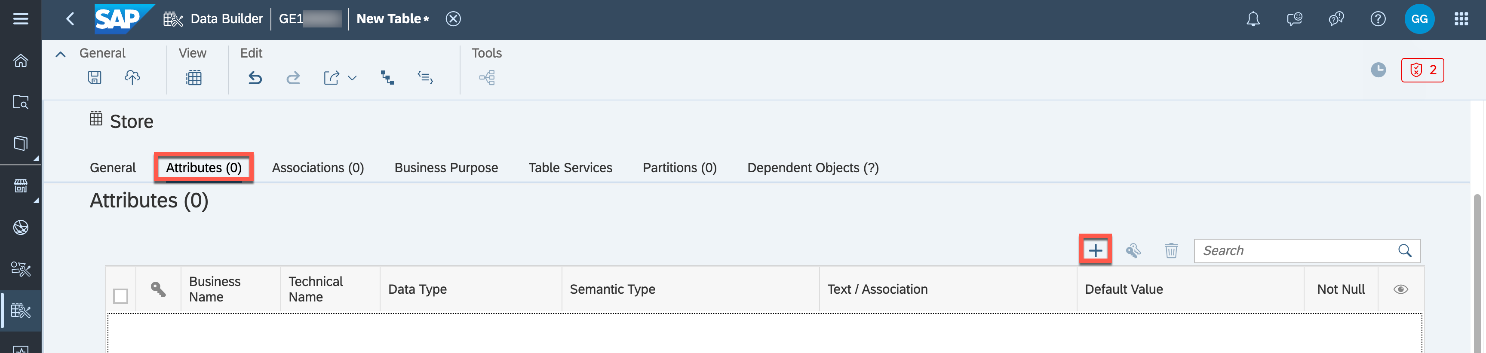

README.md 2025-04-15

21. Use the option ***New Table***.

22. Enter the following details:

 Business Name - Store

 Technical Name - Store

 Semantic Usage - Dimension

 Navigate to the ***Attributes*** area.

|  |  |  |
| --- | --- | --- |
|  |  | Use the “+ sign to create new attributes. |
|  | **Tip:** You will notice, based on the Type Dimension, we now have two additional options for each | |

|  |
| --- |
| Column: Semantic Type and Text/Association. |

|  |
| --- |
| The column Text/Association allows you to specify the purpose of an attribute when your entity is |

|  |
| --- |
| consumed later. For example, you could have a Product ID and a Product Description in the table and |

|  |
| --- |
| use the Product Description column as text for the Product ID. |

|  |
| --- |
| The Semantic Type option provides you with several options to choose from, so that you can configure |

|  |
| --- |
| an additional context for the column, such as the option to configure the column as a Currency column |

|  |
| --- |
| or a Language column. |

25. Enter the following ***Attributes*** for the table:

|  |  |  |  |  |  |
| --- | --- | --- | --- | --- | --- |
| **Key:** | **Business Name:** | **Technical Name:** | **Data Type:** | **Semantic Type** | **Text/Association** |
| X | Store ID | Store_ID | String (6) | None | Store Name |
|  | Store Name | Store_Name | String (30) | Text |  |

6 / 9

|  |  |  |  |  |  |  |  |  |
| --- | --- | --- | --- | --- | --- | --- | --- | --- |
| README.md | | 2025-04-15 | | | | | | |
| **Key:** | **Business Name:** | **Technical Name:** | | | | **Data Type:** | **Semantic Type** | **Text/Association** |
| Store City | | Store_City | | String (20) | | | | |
| State ID | | State_ID | String (2) | | | | | |
| State Name | | State_Name | | | String(30) | | | |
| Country | | Country | String(30) | | | | | |
| Latitude | | Latitude | Decimal(15,8) | | | | | |
| Longitude | | Longitude | | Decimal(15,8) | | | | |
|  | **Tip:** Please note, that you can only select the Store Name for the column **Text/Association** after | | | | | | | |

|  |
| --- |
| you entered the details for the Store Name into ***Attributes*** and select “Text” as the Semantic Type. |

26. After you entered all columns for the table, ensure you enable the Key Column option for the column Store ID.

27. Click ***Save*** in the General menu.

28. Select the folder ***TECHED2024-DA180***. You will be asked to confirm the business name as well as the technical name.

29. Click ***Save***.

30. Click ***Deploy*** in the General Menu.

31. Navigate back to the list of tables.

32. Create a new table.

33. Enter the following details:

|  |  |  |  |  |  |  |
| --- | --- | --- | --- | --- | --- | --- |
| **Key:** |  | Business Name - Product | | **Data** | **Semantic** | **Text/Association** |
|  | Technical Name - Product | |
|  | Semantic Usage - Dimension | |
|  | Navigate to the ***Attributes*** area. | |
|  | Enter the following attributes for the table: | |
| **Business Name:** | | **Technical Name:** |
| **Type:** | **Type** |
| X | Product ID | | Product_ID | String | None | Product Name |
| (4) |
|  | Product Name | | Product_Name | String | Text |  |
| (30) |

7 / 9



|  |  |  |  |  |  |
| --- | --- | --- | --- | --- | --- |
| README.md | | **Technical Name:** | **Data** | **Semantic** | 2025-04-15 |
| **Key:** | **Business Name:** | **Text/Association** |
| **Type:** | **Type** |
| Product Category ID | | Product_Category_ID | String | None | Product Category |
| (4) | Name |
| Product Category | | Product_Category_Name | String | Text |  |
| Name | | (30) |

36. After you entered all columns for the table, ensure you enable the Key Column option for the column Product ID.

37. Click ***Save*** in the General menu.

38. Select the folder ***TECHED2024-DA180***. You will be asked to confirm the business name as well as the technical name.

39. Click ***Save***.

40. Click ***Deploy*** in the General Menu.

41. Click on the return arrow on the top menu bar to navigate back to the list of tables.

42. Use the option ***New Table***.   
43. Enter the following details:

|  |  |  |  |  |  |  |
| --- | --- | --- | --- | --- | --- | --- |
| **Key:** |  | Business Name - Sales Manager | | **Data** | **Semantic** | **Text/Association** |
|  | Technical Name - Sales_Manager | |
|  | Semantic Usage - Dimension | |
|  | Navigate to the ***Attributes*** area. | |
|  | Enter the following attributes for the table: | |
| **Business Name:** | | **Technical Name:** |
| **Type:** | **Type** |
| X | Sales Manager ID | | Sales_Manager_ID | String (4) | None | Sales Manager |
| Name |

8 / 9

|  |  |  |  |  |  |
| --- | --- | --- | --- | --- | --- |
| README.md | | **Technical Name:** | **Data** | **Semantic** | 2025-04-15 |
| **Key:** | **Business Name:** | **Text/Association** |
| **Type:** | **Type** |
| Sales Manager | | Sales_Manager_Name | String | Text |  |
| Name | | (30) |

46. After you entered all columns for the table, ensure you enable the Key Column option for the column Sales Manager ID.

47. Click ***Save*** in the General menu.

48. Select the folder ***TECHED2024-DA180***. You will be asked to confirm the business name as well as the Technical Name.

49. Click ***Save***.

50. Click ***Deploy*** in the General Menu.

51. Use the Back option in top menu or as an alternative you can click on your Space name to navigate back to the home screen of the Data Builder.

Summary

You have now created all tables that we need for our model and the overview in the Data Builder when you filter on tables should look like this:

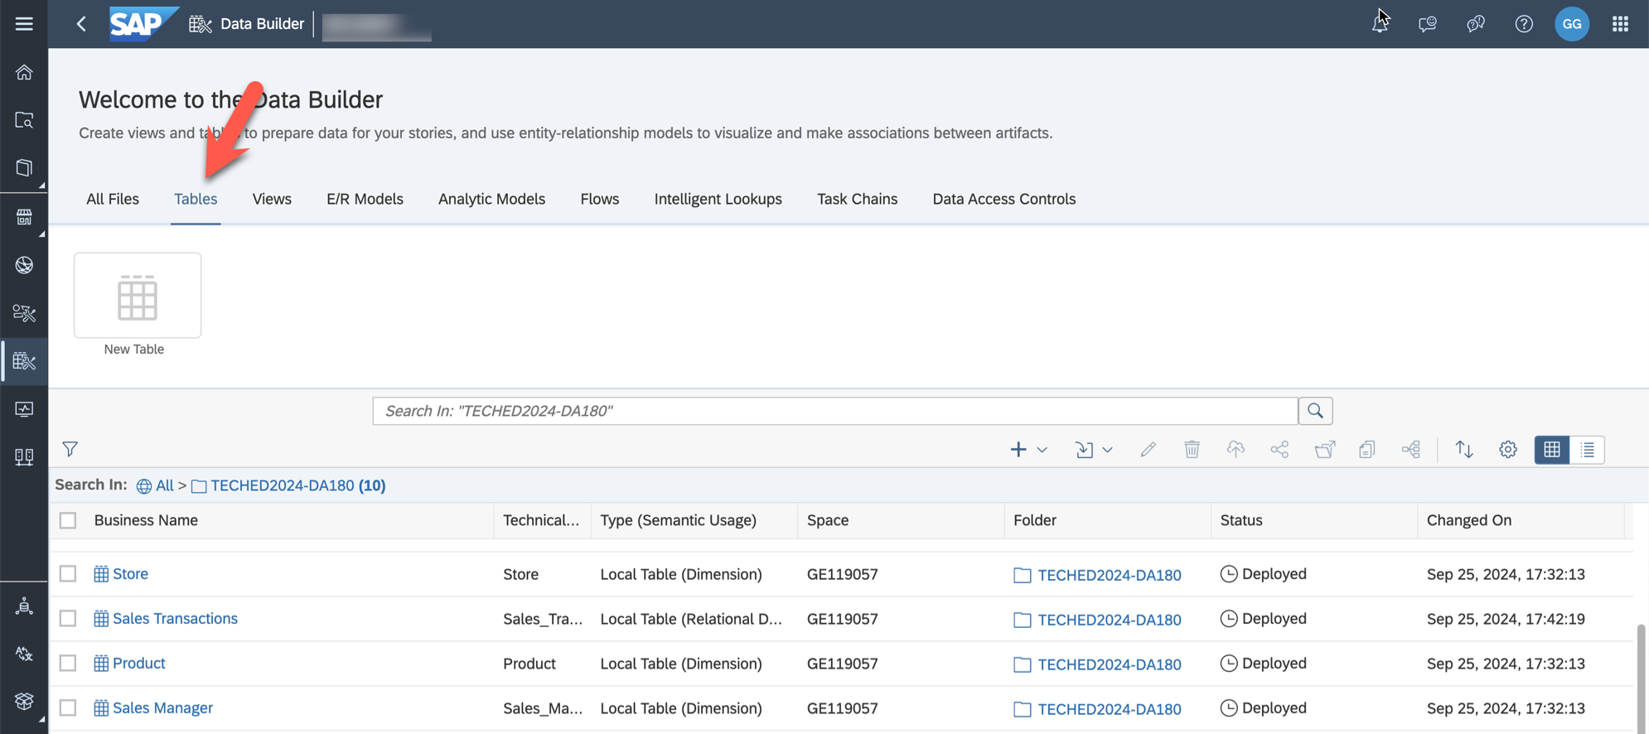

Continue to Exercise 03 - Creating the Entity Relationship Model

9 / 9

README.md 2025-04-15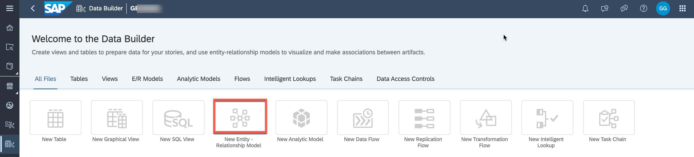

Exercise 3 - Creating the Entity-Relationship Model

|  |  |  |  |
| --- | --- | --- | --- |
|  | | |  | | --- | | **Note:** This is an Optional Exercise. You need to have finished Exercise 02 before. | |
|  | Detour: SAP Datasphere - Entity-Relationship Model | |

Let us clarify what an Entity-Relationship model is and why we are creating it, before we start the exercise.

An Entity-Relationship Model provides a variety of benefits:

|  |  |
| --- | --- |
|  | Depict the relationship of different entities  Design physical or remote database models  Re-use existing entities (table, view) from Data Builder Add new entities on-the-fly  In-editor real time data preview  Model Import / Export |

Basically, the Entity-Relationship Model is not a view that you would consume in SAP Analytics Cloud, but instead it represents the relationship between the tables or views, and it helps you to define the relationship once, so that you can reuse those when creating a new view.

Maintenance of associations and other capabilities of the E/R Model (like definition of semantic properties) can also be done in the table/view editor. Rules for creating associations depend on the Semantic Usage. The advantage of the E/R Model is that multiple entities can be modified at the same time while being visualized as diagram.

End of Detour

Create a new Entity-Relationship Model

1. Log On to your SAP Datasphere tenant.

2. Select the menu option Data Builder on the left-hand side

3. Select the option ***New Entity - Relationship Model***.

4. On the left-hand side you are presented with the local tables and views from your Repository. You also have the option to bring in tables from any remote sources configured.

1 / 7

README.md 2025-04-15

5. Ensure to select the option ***Repository*** and the folder ***TECHED2024-DA180***, so that you see the entities available. You should see the four tables that you created previously.

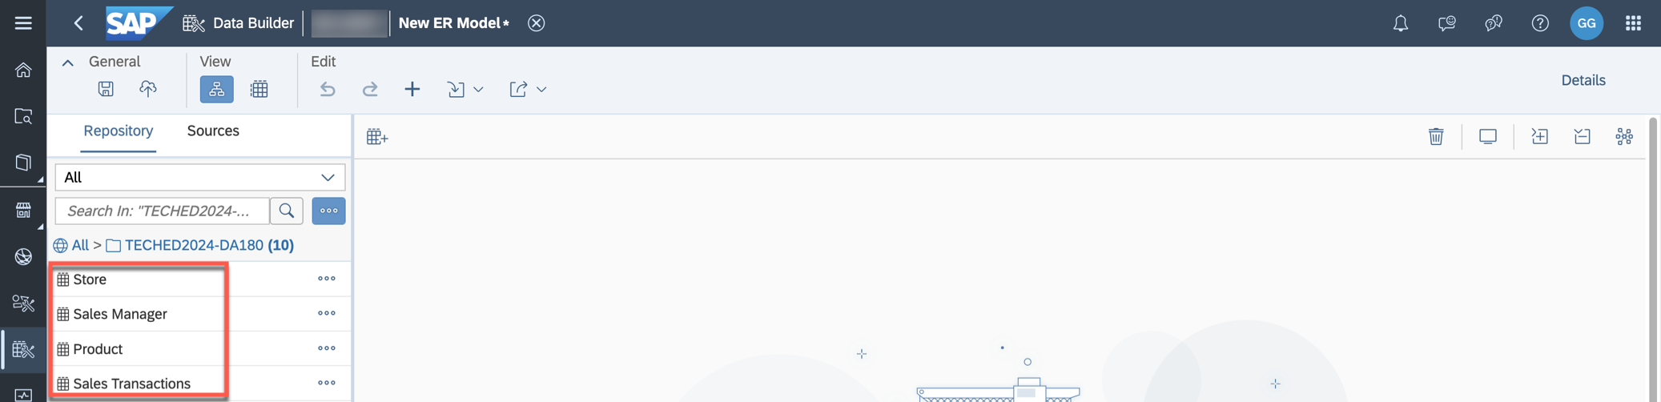

6. Now drag and drop the table ***Sales Transactions*** to the canvas.

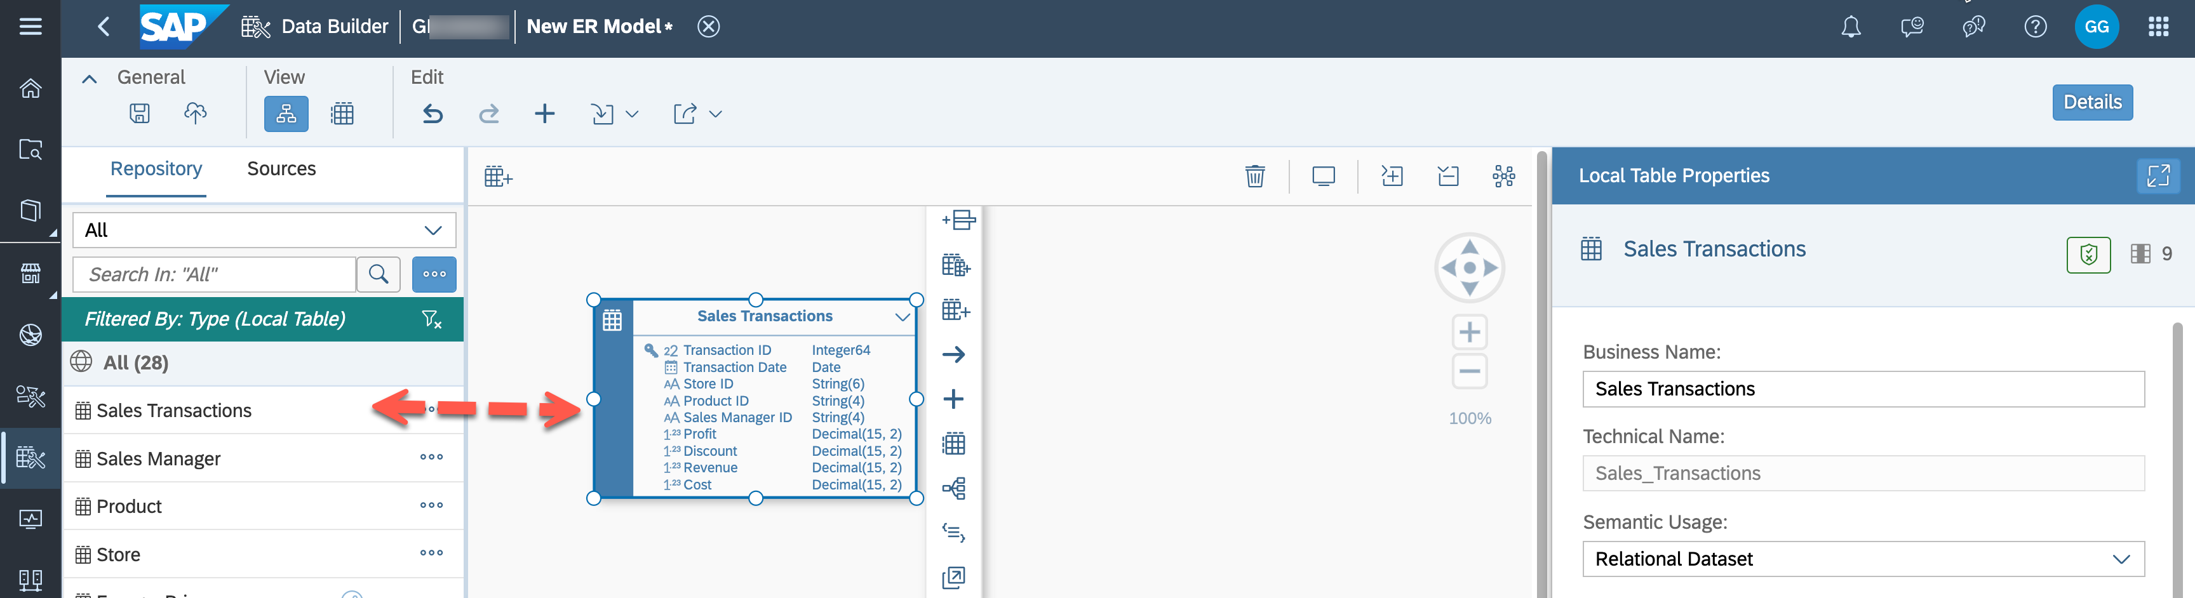

7. When you select the table ***Sales Transactions*** on the canvas, you are presented with various additional options. You could add a new column, create a new entity (view or table), create a new asssociation, add related entities, preview the data, analyze impact and lineage, modify the custom entity   
annotations or open the table in the table editor.

8. Now drag and drop the table ***Store*** to the canvas next to the table ***Sales Transactions***.

9. Select the table ***Sales Transactions***.

10. Use the ***"->"*** symbol to create a new association by clicking on it and holding onto the icon.

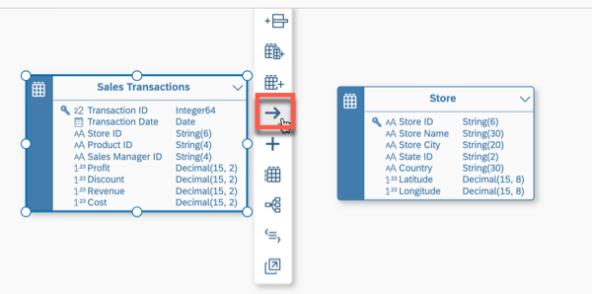

11. Drag the ***arrow icon*** to table ***Store*** to create a new association between the table ***Sales Transactions***  and the table ***Store***.

2 / 7

README.md 2025-04-15

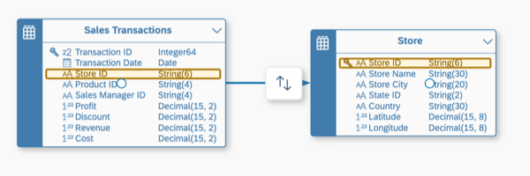

12. The ***Association Properties*** panel defines the mapping of the columns for the association. Ensure that the join between the table ***Sales Transactions*** and ***Store*** is based on column ***Store ID (STORE_ID)***. The system suggests this based on matching columns, but you can also add / remove these joins manually.

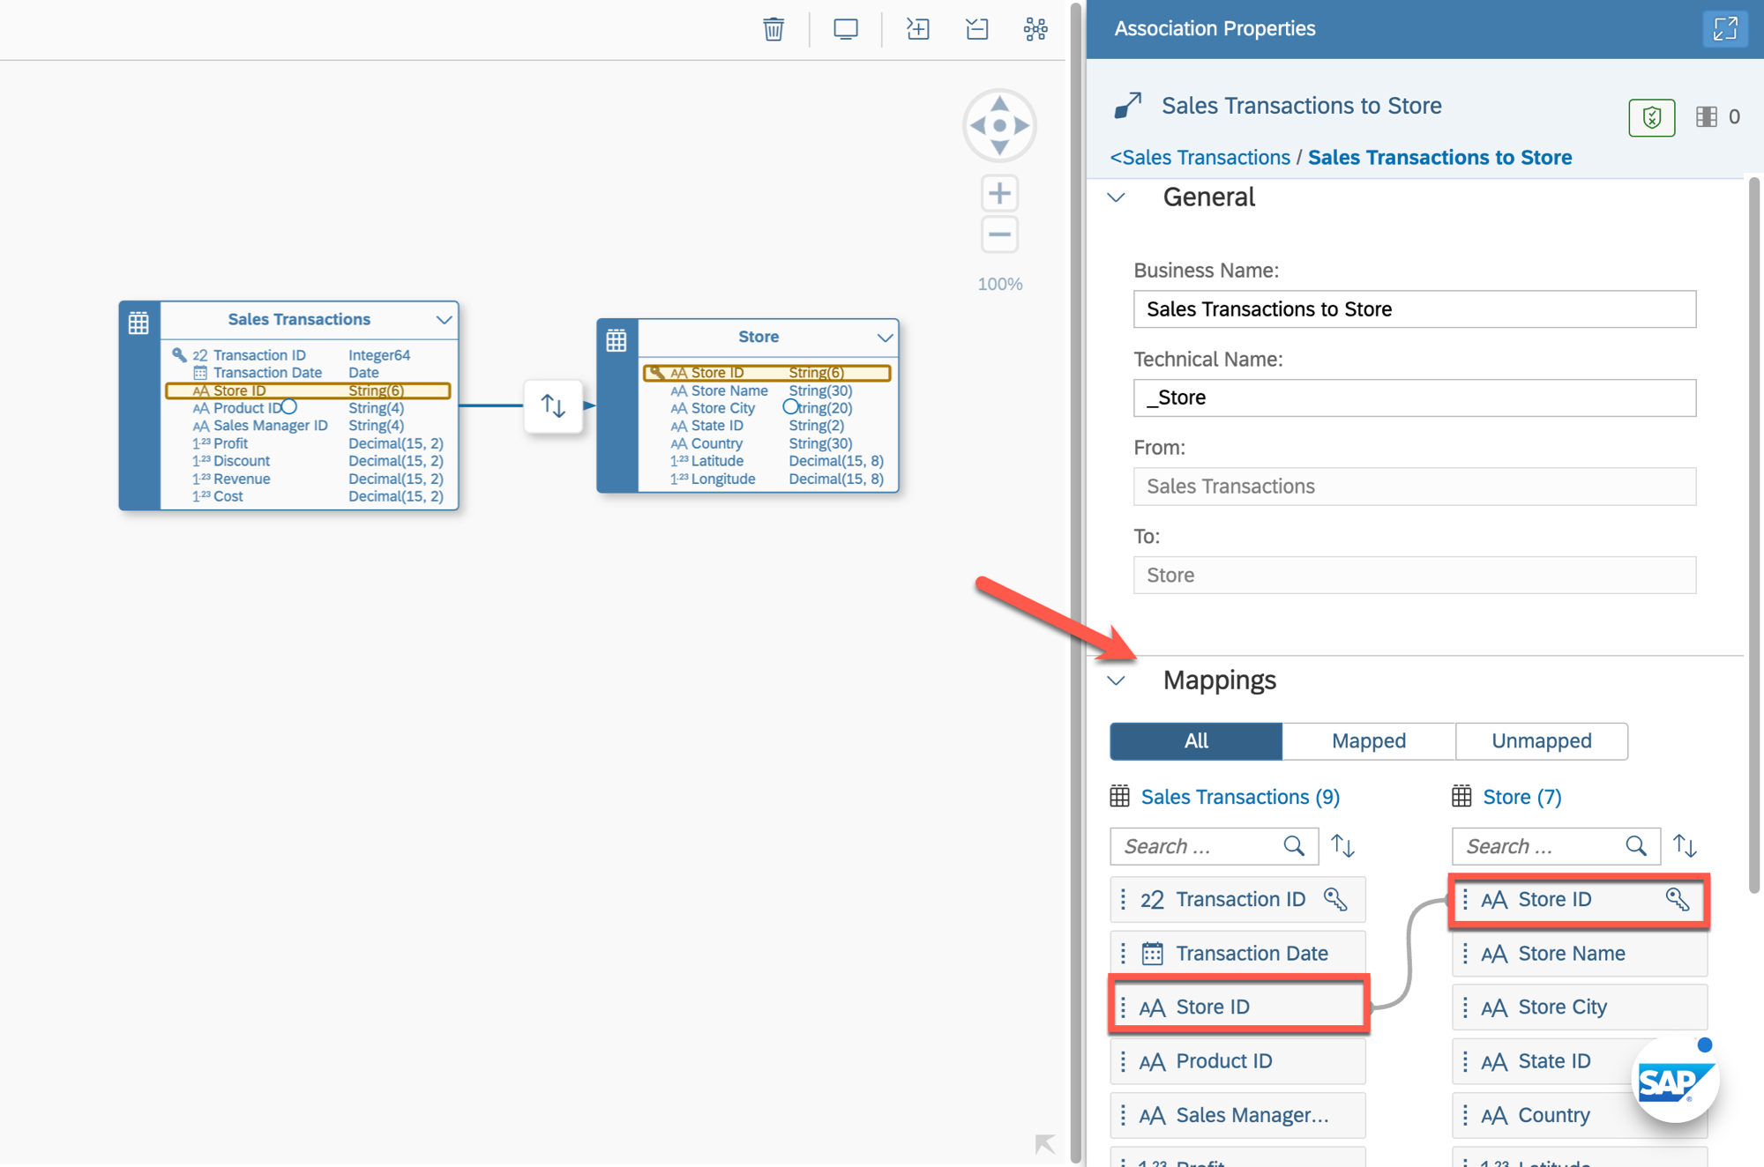

13. Now drag the table ***Product*** onto the canvas.

14. Select the table ***Sales Transactions*** on the canvas. Drag and drop the ***arrow symbol*** to the table ***Products*** to create a new association between the table ***Sales Transactions*** and table ***Product***. Ensure

3 / 7

README.md 2025-04-15

that the join is based on the ***Product ID (Product ID)*** column.

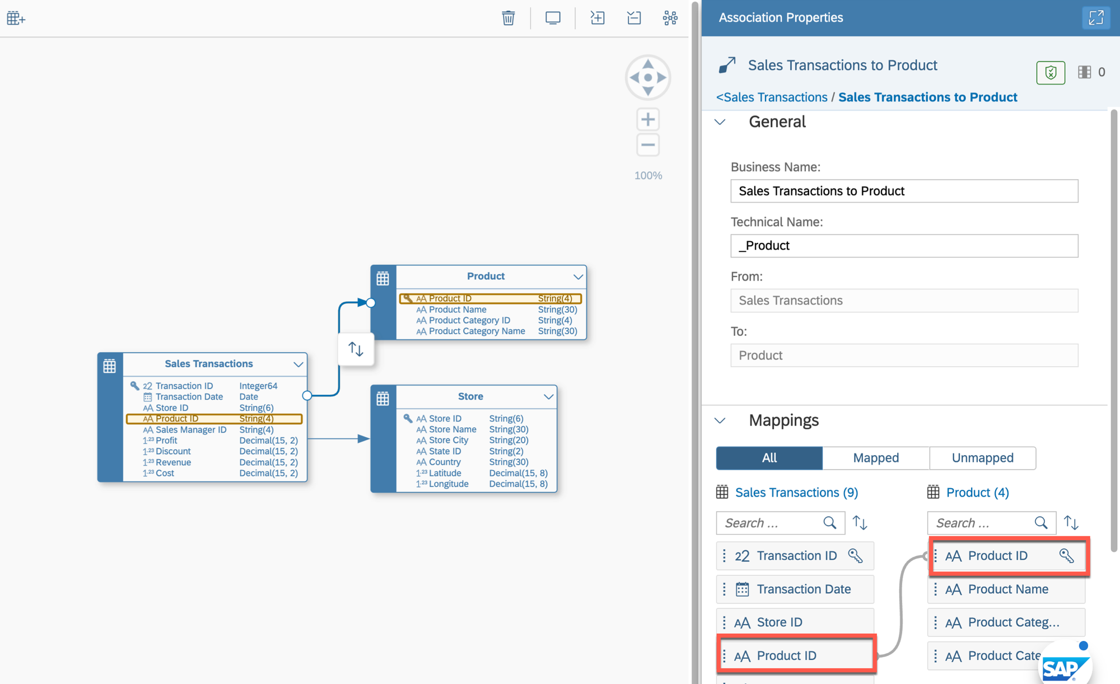

15. Now drag the table **Sales Manager** onto the canvas.

16. You can use the option ***Auto Layout*** in the toolbar to arrange all entities.



17. Create a new association between the tables **Sales Transactions** and **Sales Manager**. Ensure that the join is based on the Sales Manager ID (Sales Manager ID) column.

4 / 7

README.md 2025-04-15

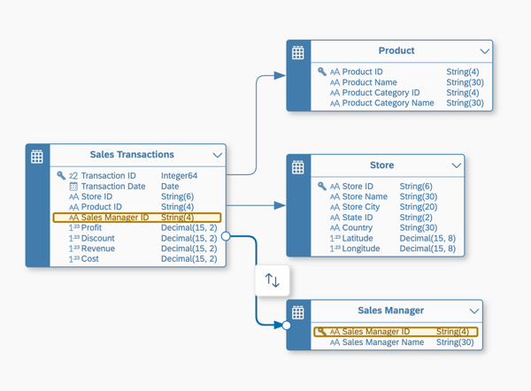

18. We want to associate our sales transactions with the time data created in the space so that we can later drill down and up in hierarchies (for example setting the granularity to day or quarter). On the left hand side, search for "Time Dimension Day". Select the dimension of your space (not the one shared). You can verify that by clicking the three dots ***...*** and ***Show Info*** afterward.

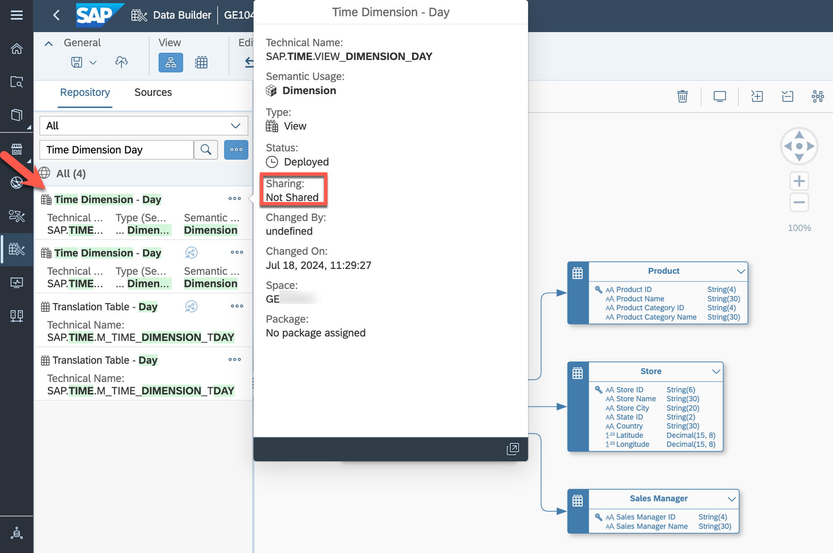

19. Drag the identified view ***Time Dimension – Day*** to the canvas.

5 / 7

README.md 2025-04-15

20. Select the table ***Sales Transactions*** on the canvas.

21. Select the ***arrow symbol*** and drag and drop the arrow to the view ***Time Dimension - Day*** to create a new association between the table ***Sales Transactions*** and the view ***Time Dimension - Day***.

22. In the panel on the right-hand side (section ***Mappings***), create a join between the columns ***Transaction Date*** and ***Date***.

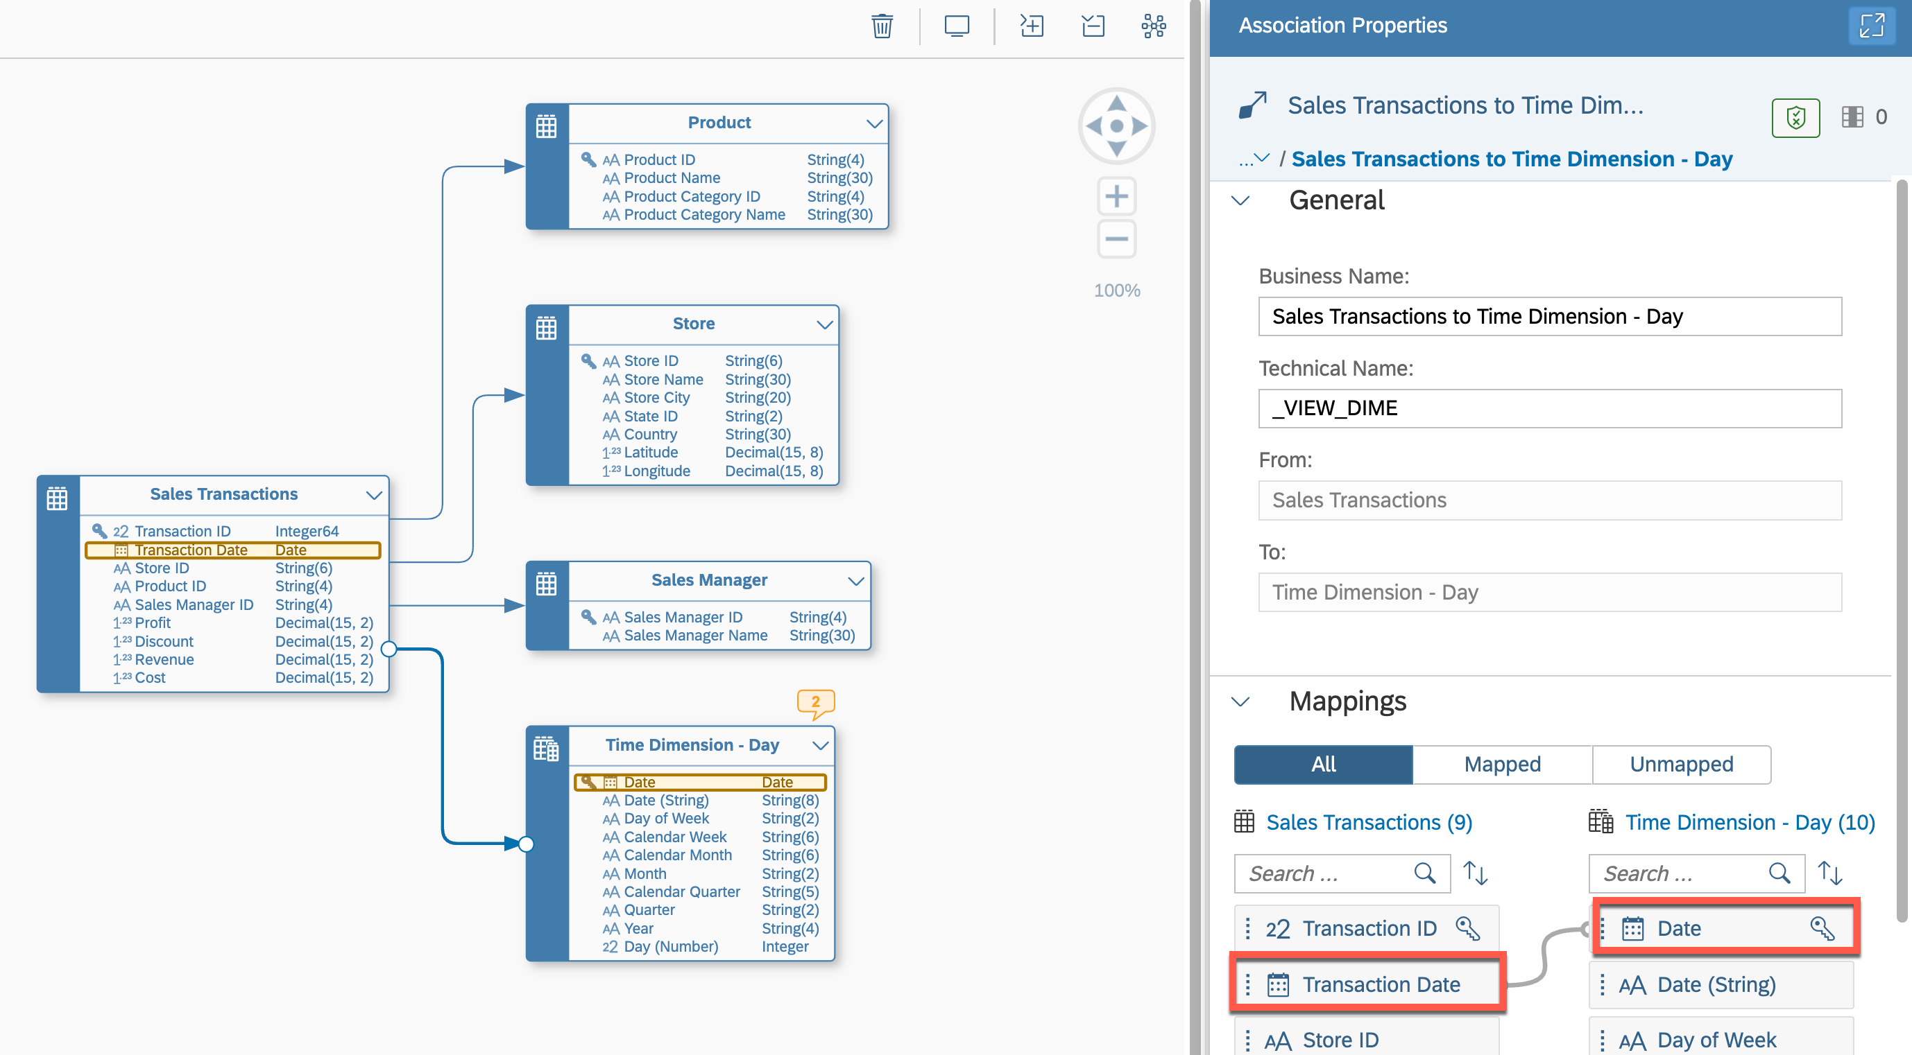

6 / 7

README.md 2025-04-15

23. Your Entity-Relationship Model should look like the image shown below.

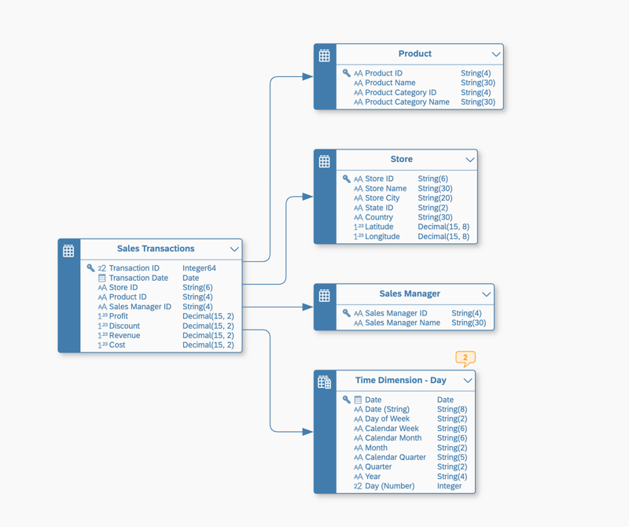

24. Save the changes to your Entity-Relationship Model by using the ***Save option*** in the General menu.

25. Enter the following details:

|  |  |
| --- | --- |
|  | Business Name - Sales Model - Entity-Relationship Model Technical Name - Sales_ER_Model  Click ***Save*** and ***Save Anyway*** (the warning is not relevant). Deploy the model. |

Summary

You've now created the Entity-Relationship Model to arrange the tables and the time dimension view in relation to one another. You could have also defined the associations in the individual table/view editors, but the E/R Model provides the advantage modifying multiple entities at the same time and seeing them in relation to each other. We will make use of the defined relations the next steps.

Continue to - Exercise 05: Uploading Data

7 / 7

README.md 2025-04-15

Exercise 4 - Importing Tables

|  |  |  |
| --- | --- | --- |
|  | **Important:** |  |

|  |
| --- |
| This exercise is only required in case you ***did not*** create the tables in Exercise 02 - Prepare Your Data |

|  |
| --- |
| (optional) and the Entity-Relationship Model for our sample model manually in Exercise 03 - Creating |

|  |
| --- |
| the Entity-Relationship Model (optional) and prefer to import them. |

The file for this exercise is Sales_ER_Model.json and the file is part of the ZIP file you downloaded. We will now import the table definitions in form of a JSON file by importing a Entity-Relationship Model. 1. Log On to your SAP Datasphere tenant.

2. Select the menu option ***Data Builder*** on the left-hand side.

3. Create a new folder to organize the entities you will create in this jump-start session. Enter TECHED2024-DA180 as business name and confirm. A new folder is displayed in the object list.



4. Select the option ***New Entity–Relationship Model***.

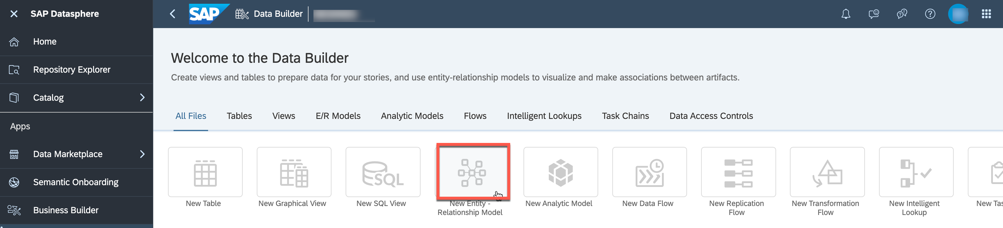

5. In the E/R Model editor, select the ***Import*** icon and click on ***Import Objects from CSN/JSON File***.

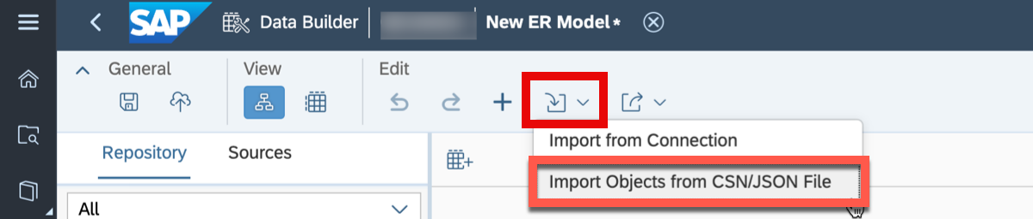

6. Select the file ***“Sales_ER_Model.json”***  
7. Click ***Next***.

1 / 5

README.md 2025-04-15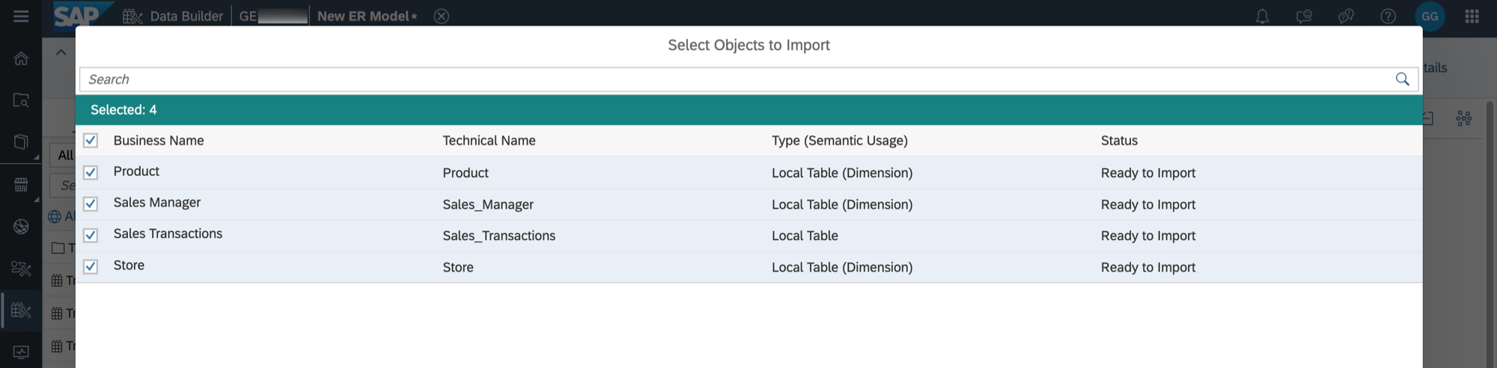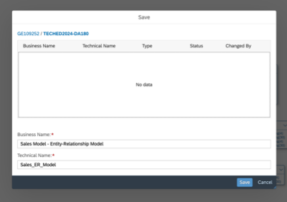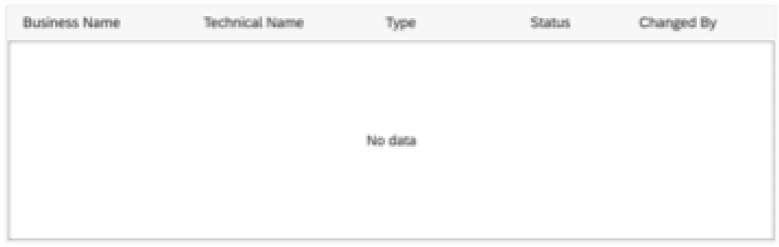

8. Select all entities for import.

9. Click ***Import CSN File***.

10. You will receive a message about the import being completed and the tables will be shown on the canvas arranged as an Entity-Relationship Model.

11. Save the changes to your Entity Relationship model using the **Save** option in the upper left corner.

12. Select the folder TECHED2024-DA180 and enter the following details.

|  |  |
| --- | --- |
|  | Business Name: **Sales Model - Entity-Relationship Model** Technical Name: **Sales_ER_Model**  Click ***Save***. |

 We want to associate our sales transactions with the time data created in the space so that we can later drill down and up in hierarchies (for example, setting the granularity to day or quarter). On the left-hand side, search for **Time Dimension - Day**. Select the dimension from your space (the one that is **Not Shared**). You can verify this by clicking the three dots (**...**) and then selecting **Show Info** afterward.

2 / 5

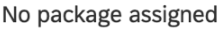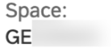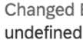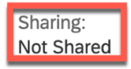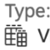

|  |  |
| --- | --- |
| README.md | 2025-04-15 |





|  |  |
| --- | --- |
|  | Drag the identified view ***Time Dimension – Day*** to the canvas. |

 Select the table ***Sales Transactions*** on the canvas.

 Select the ***arrow symbol*** and drag and drop the arrow to the view ***Time Dimension - Day*** to

create a new association between the table ***Sales Transactions*** and the view ***Time Dimension -***

***Day***.

 In the panel on the right-hand side (section ***Mappings***), create a mapping between the columns

***Transaction Date*** and ***Date***.

3 / 5

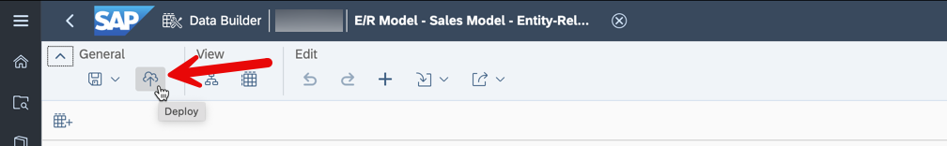

|  |  |  |
| --- | --- | --- |
| README.md | You can use the option ***Auto Layout*** in the toolbar to arrange all entities. | 2025-04-15 |
|  |



 Your Entity-Relationship Model should look like the image shown below.



 Save the changes to your Entity-Relationship Model by using the ***Save option*** in the ***General***  menu. Select ***Save Anyway*** (the warning is not relevant).

 Deploy the model using the ***Deploy*** icon in the menu bar.

Summary   
As part of the deployment of the Entity-Relationship Model, the underlying tables are also imported and deployed.

When you navigate to the ***Data Builder*** screen, you should now see:

 A set of four tables (three dimensions and one relational dataset)

 One Entity-Relationship Model   
 4 / 5

README.md 2025-04-15

Continue with Exercise 05: Uploading Data

5 / 5

README.md 2025-04-15

Exercise 5 - Uploading Data

In this exercise, we will populate the tables created in the previous steps, ensuring we have data for analysis.

These exercises use data from CSV files to allow for easy repetition in any SAP Datasphere tenant. To explore the various connectivity options of SAP Datasphere, refer to [the details available here](https://help.sap.com/docs/SAP_DATASPHERE/9f804b8efa8043539289f42f372c4862/bffbd58c15784a62af0520f171018ded.html) or explore the connections available in the app ***Connections*** (click on the corresponding icon on the left side). The files for this exercise are part of the ZIP file you downloaded at the beginning. We will now upload the CSV files into the corresponding tables.

1. In your SAP Datasphere tenant select the menu option ***Data Builder*** on the left-hand side.

2. Click on your folder TECHED2024-DA180.

3. Click on the table ***Sales Transactions***.

4. Select the menu option ***Upload Data from CSV File*** in the toolbar.

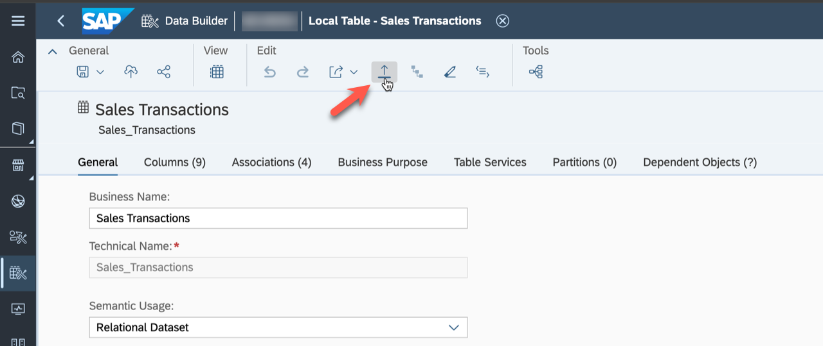

5. Click ***Choose File***.

6. Navigate to where you unzipped the download.   
7. Select the file Sales Transactions.csv.

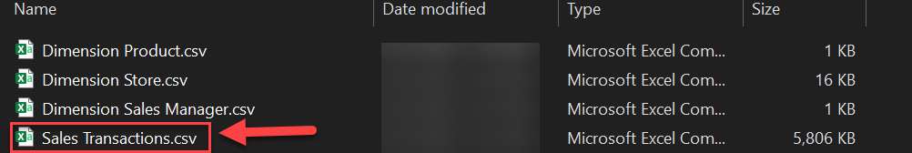

8. Ensure the option ***Delete Existing Data Before Upload*** checkbox is ticked. 9. Ensure the option ***Use first row as column header*** checkbox is ticked.

10. Ensure the option ***Insert missing string value as*** is set to ***NULL***. 11. Ensure the ***CSV Delimiter*** option is set to ***Auto-Detect***.

1 / 3

README.md 2025-04-15

12. Ensure that all columns of the table have a mapped column from the CSV file.

13. Click ***Import***.

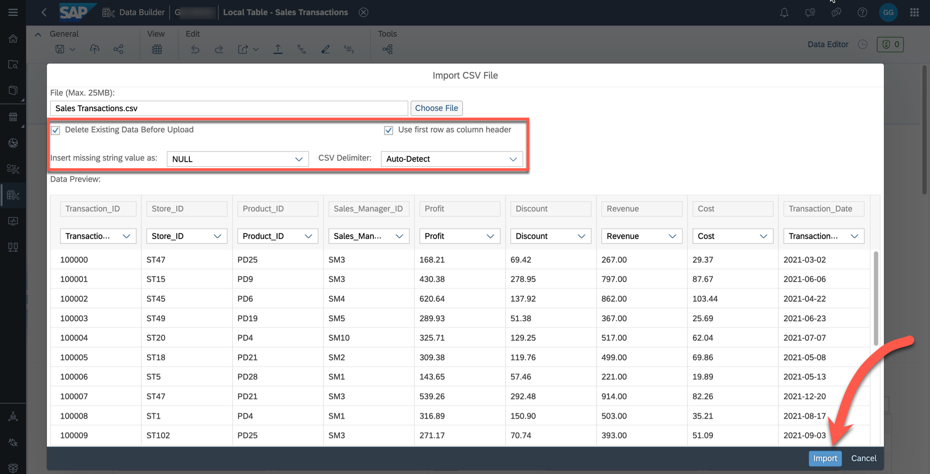

14. You should receive a message about the successful import of the information.

15. You can use the ***Data Preview*** to check the data loaded into the table.

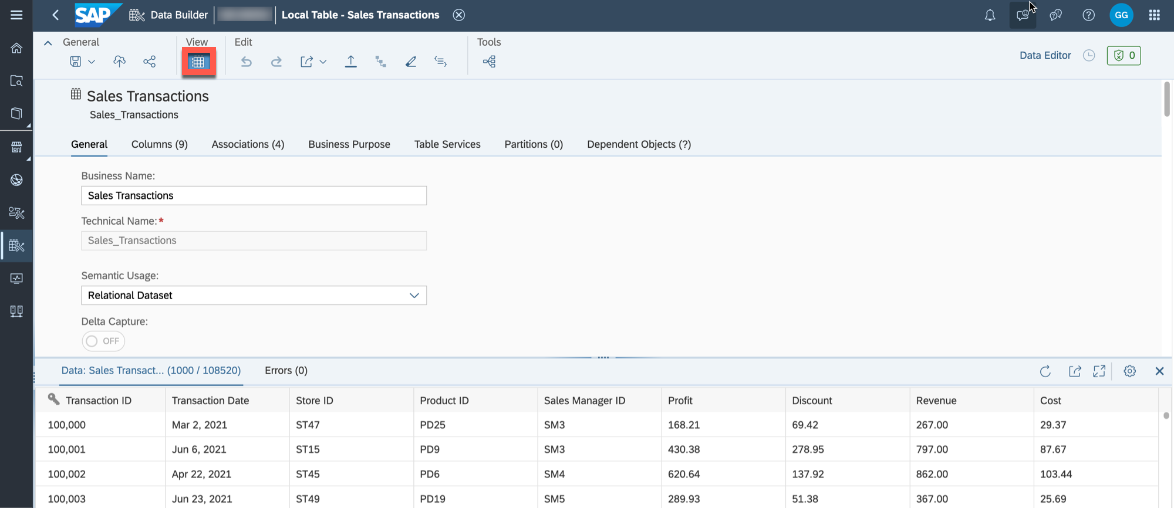

16. There is no need to save / deploy the table after you imported the data.

17. Continue and repeat steps 4–15 for the other tables. Each table has a corresponding CSV file included in the download.

Upload the data for the following tables:  
- ***Product*** (Dimension Product.csv)  
- ***Store*** (Dimension Store.csv)   
- ***Sales Manager*** (Dimension Sales Manager.csv)

Summary

Now you have imported all the data files and you can start to build the data model.

2 / 3

README.md 2025-04-15

Continue to - Exercise 06: Creating the Dimension

3 / 3

README.md 2025-04-15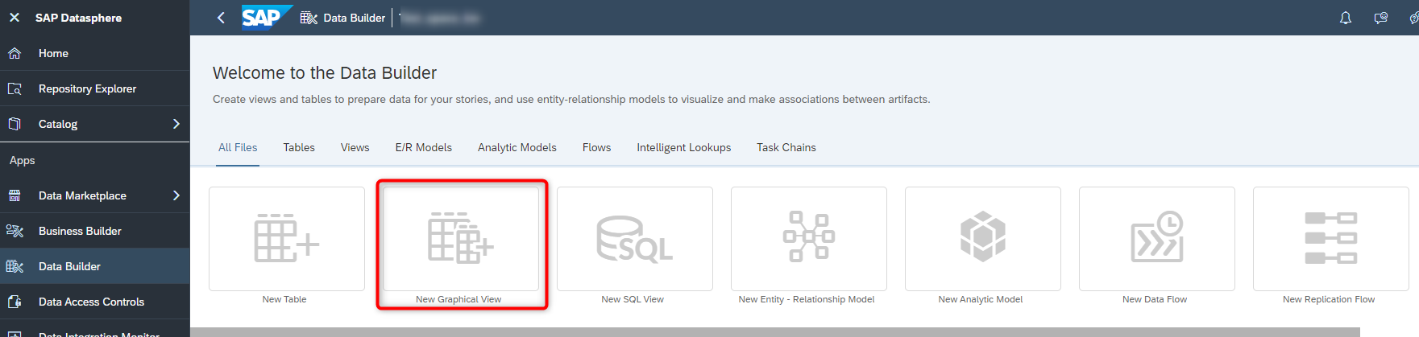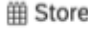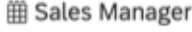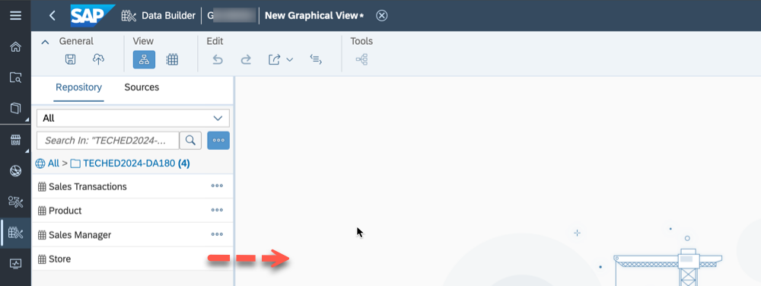

Exercise 6 - Creating the Dimension

In this exercise, we will create a new view of the semantic type dimension based on our previously created table. We will enhance this data by configuring a geographic enrichment so that we can visualize the store location on a geo map later in SAP Analytics Cloud.

1. Log On to your SAP Datasphere tenant.

2. Select the menu option ***Data Builder*** on the left-hand side.

3. Click ***New Graphical View***.

4. On the left-hand side you can decide between:

 ***Repository***: Here you have access to the local tables (imported data), Views, Intelligent Lookups and Shared Objects.

 ***Sources***: Here you have access to respective objects from your connections.

5. Ensure you select the option ***Repository*** and open the folder TECHED2024-DA180.

6. You are presented with the list of tables, which we created previously. Drag and drop the table ***Store*** to the canvas.

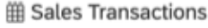

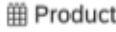

7. You automatically will – in addition to the table you dragged to the canvas – receive the output view, in the screenshot called View 1:   
8. Navigate to the ***View Properties*** window by clicking on the View 1 in the canvas.

1 / 6

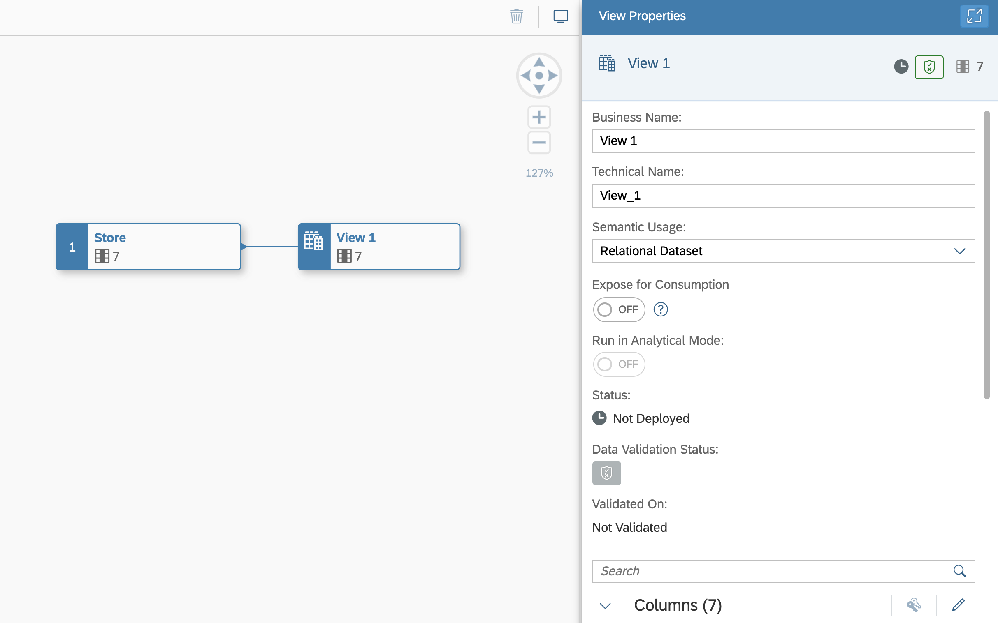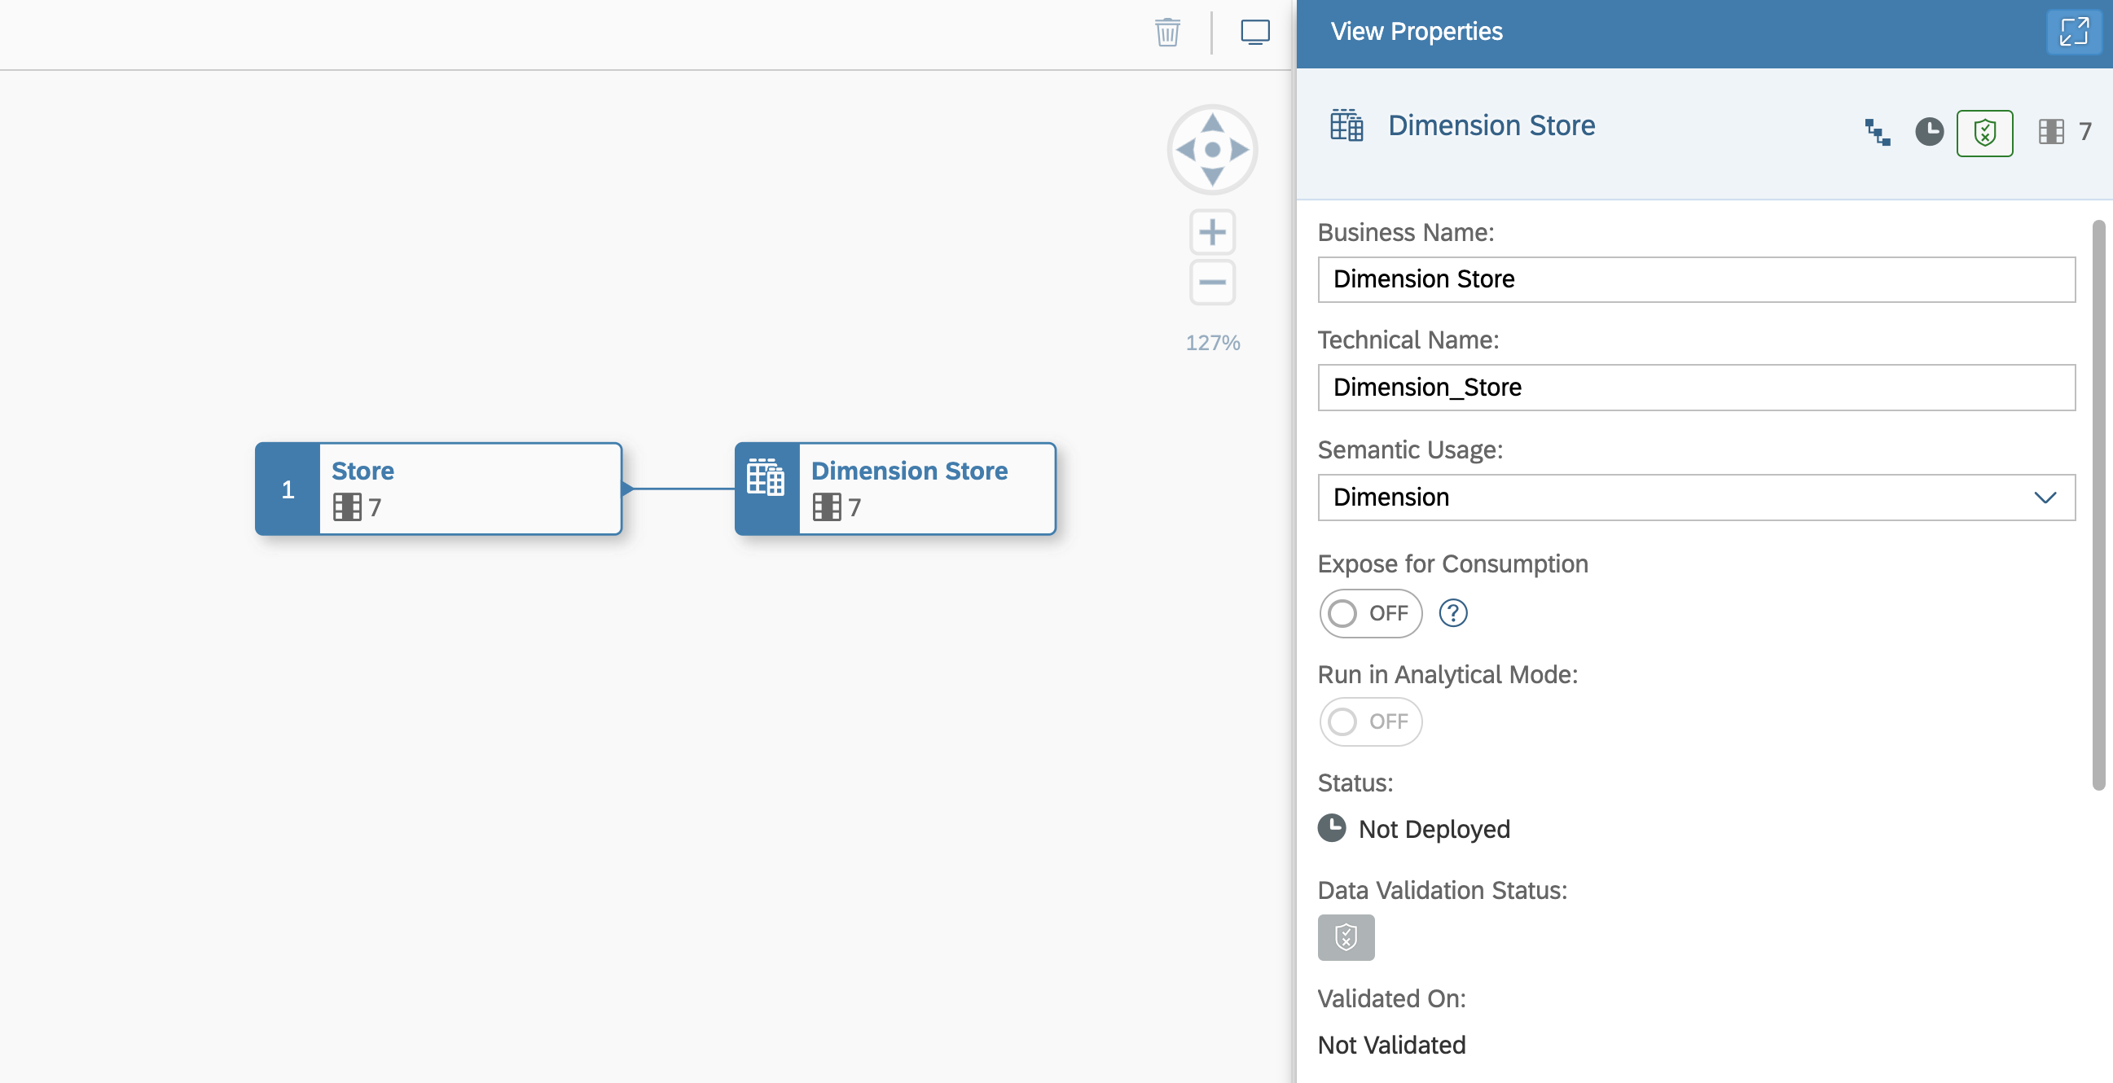

|  |  |
| --- | --- |
| README.md | 2025-04-15 |

9. Here you can configure properties for the view:

|  |  |
| --- | --- |
|  | ***Business Name***: Dimension Store  ***Technical Name***: Dimension_Store  ***Semantic Usage***: Dimension |

10. Now click on the table ***Store*** on the canvas.

11. When you select the table on the canvas, you have the following options (top to bottom)

 You can add filter on top of the source entity.

2 / 6

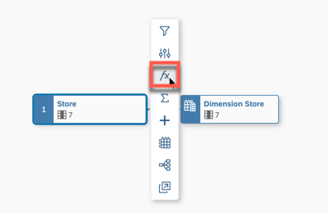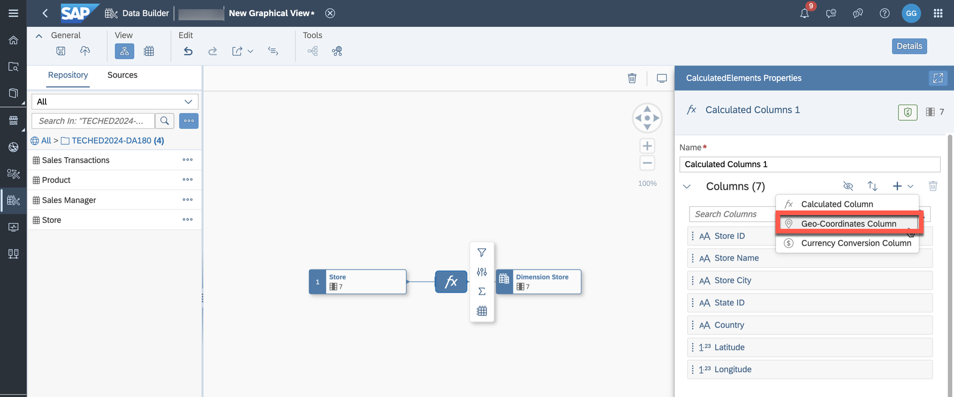

README.md 2025-04-15

 You can rename or hide columns as part of a projection.

 You can add Calculated Columns.

 You can add an Aggregation View.

 You can add additional tables / views based on suggested joins, which are based on your Entity Relationship model.

 You can preview the data.

 You can open the Impact & Lineage Analysis.

 You can open the table in the editor in another browser tab.

12. Use the option to add a new calculated column. This option also includes the ability to configure the

geographic enrichment.

13. Now click on the new node ***fx*** on the canvas.

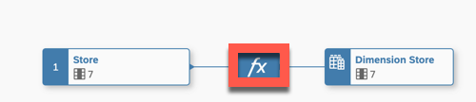

14. Navigate to the properties on the right-hand side.

15. Click on the ***+*** sign and select the option ***Geo-Coordinates Column***.

3 / 6

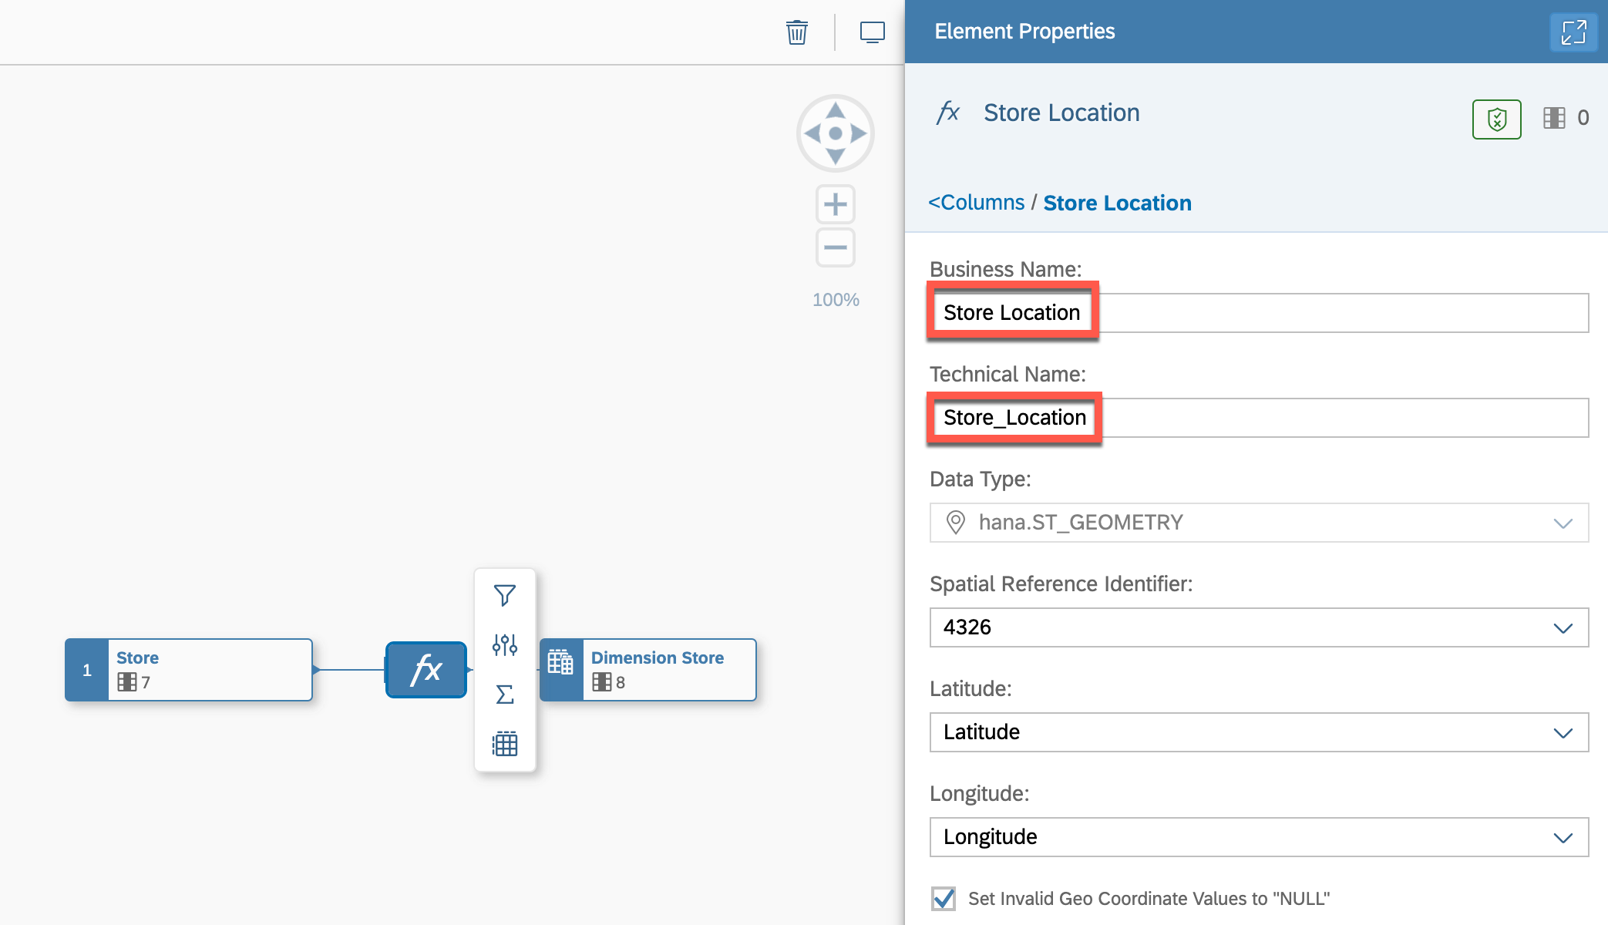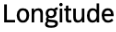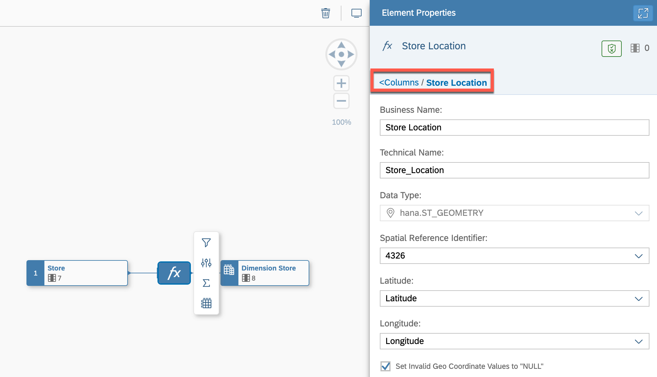

README.md 2025-04-15

16. You are presented with the properties for the new column. Configure the following details:

 ***Business Name***: Store Location

 ***Technical Name***: Store_Location

 ***Latitude***: Latitude

 ***Longitude***: Longitude

17. After you configured the details, click on the ***<Columns*** option in the properties window to go back.

18. Select the final output node for the graphical view of semantic type dimension. 19. Navigate to the properties on the right-hand side.

4 / 6

README.md 2025-04-15

20. Navigate to the ***Attributes*** area.

21. Use the pencil icon (top right area) to open the details for the Attributes.

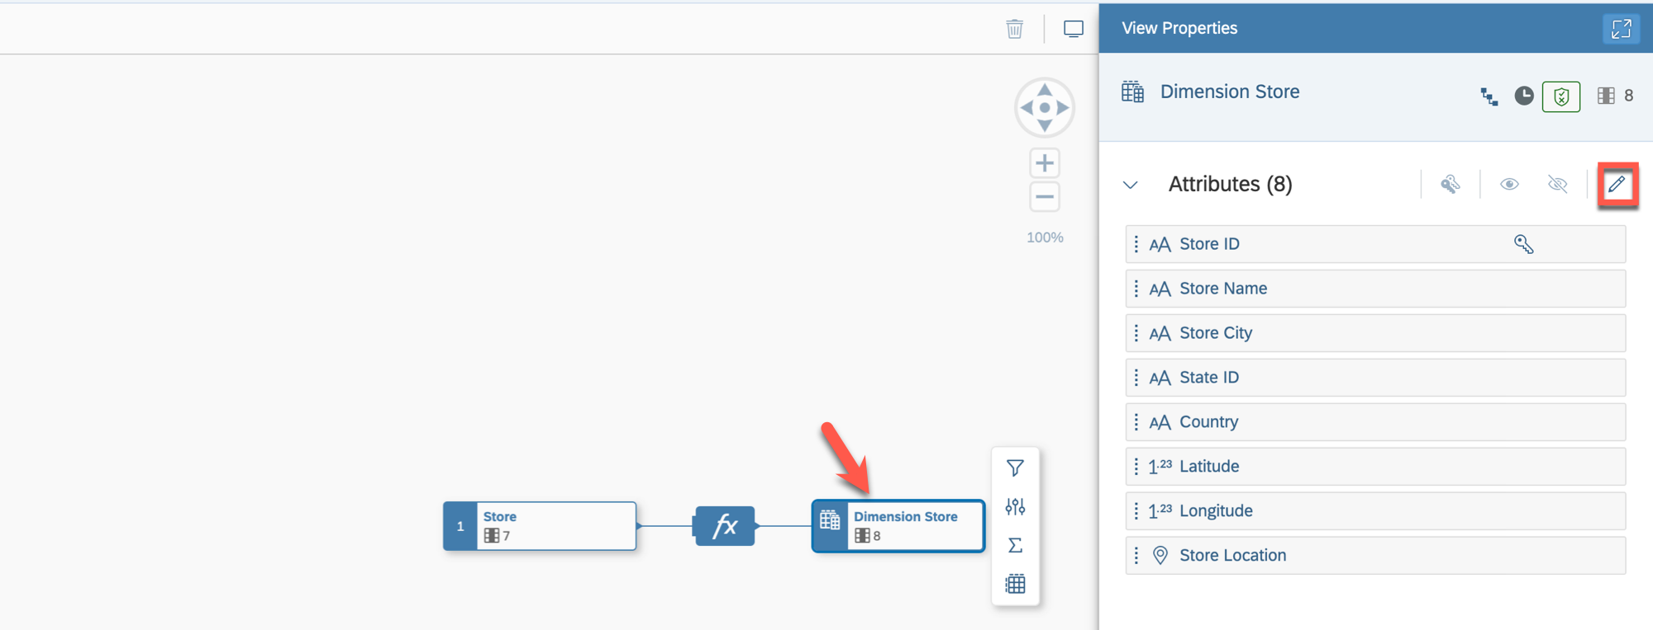

22. Ensure that the semantic type for the attribute ***Store Name*** is set to ***Text***.

23. Set the ***Label (Text / Association)*** column for the line item ***Store ID*** to ***Store Name***.

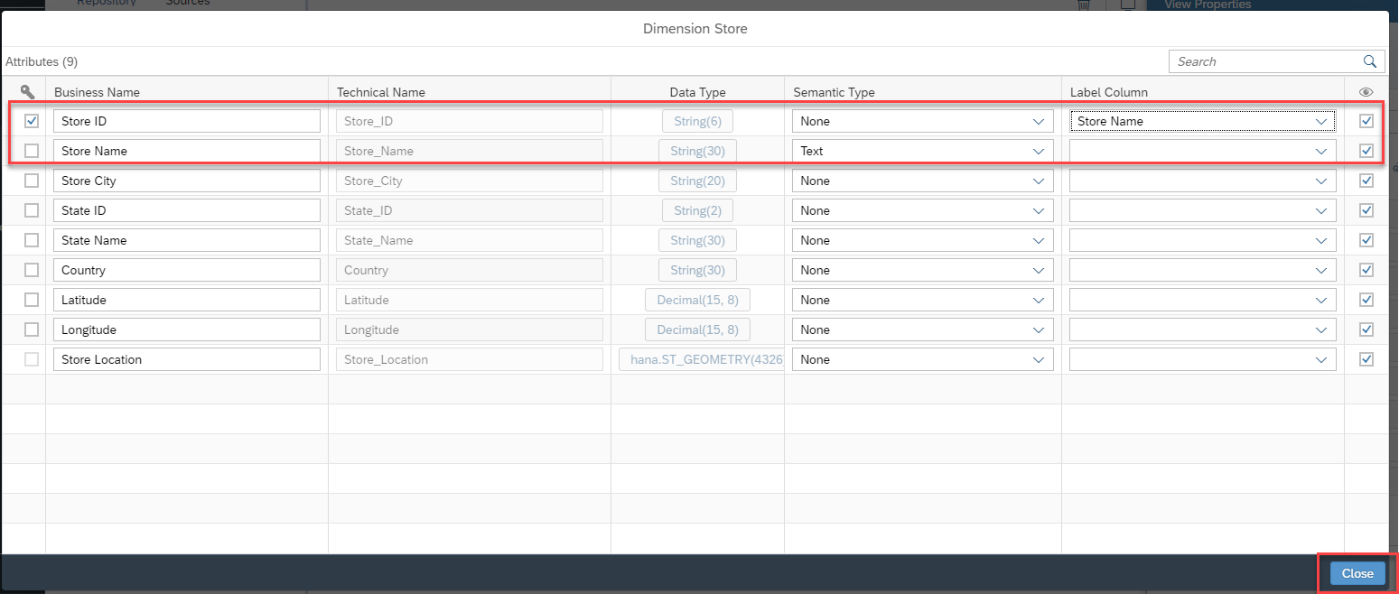

24. Click ***Close***.

25. In the toolbar in the ***General*** menu, use the option to save your view in the folder TECHED2024-DA180. 26. After saving your dimension view, ensure you deploy the view.

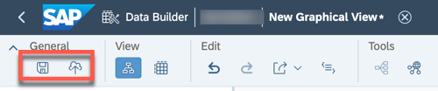

Summary   
You've now created your dimension view ***Dimension Store***, including the added geo-coordinates column ***Store Location***, which is required for using visualizations on geo maps within SAP Analytics Cloud.

5 / 6

README.md 2025-04-15

Continue to - Exercise 07: Creating the View

6 / 6

README.md 2025-04-15

Exercise 7 - Creating the View & Analytic Model

|  |  |
| --- | --- |
|  | Detour: SAP Datasphere - Views & Analytic Models |

A view in SAP Datasphere provides you with several benefits:

 No-code/low-code using the graphical editor as well as SQL and [SQLscript](https://help.sap.com/docs/hana-cloud-database/sap-hana-cloud-sap-hana-sqlscript-reference/what-is-sqlscript) editor,

 Foundation of data modeling on top of remote or local tables or views,

 Choose the semantic usage (e.g., Fact or Dimension) - enabling specific functionality and behavior depending on the semantic usage chosen,

 Define unions and joins, rename and remove columns, add calculations and filters.

A view in SAP Datasphere allows you to leverage local tables, remote tables, or views and combine those into a new view. Transformations defined in a Graphical or SQL View are executed during runtime when a view is accessed, for example, via the data preview option or as part of an Analytic Model. By default, views are not persisted, but there is the option to run and schedule snapshot replications.

Applying transformations to data is also possible in the entity ***Transformation Flow***. In contrast to views, transformation flows load data from one or more sources and persist the result in a target table. This integration entity can detect delta changes when reading data from a local table that is enabled for delta.

An Analytic Model in SAP Datasphere provides the following benefits:

 Builds the analytical foundation to make data ready for consumption in SAP Analytics Cloud or exposure through the public OData API,

 Allows multi-dimensional and rich analytical modeling,

 Provides data for analytical purposes to answer different business questions by reusing predefined measures, hierarchies, filters, input parameters, and associations,

 Offers many features like calculated & restricted measures, exception aggregation, non-cumulative measures, pruning, variable support, analytical preview, multi-lingual metadata, etc.

The sources for analytic models are views or tables of the semantic type ***Fact***, which can contain dimensions, texts, and hierarchies.

End of Detour

Start of the Exercise

In this exercise, we will create a view for the sales transaction table, which will serve as the base for the Analytic Model that can then be consumed in SAP Analytics Cloud.

The advantage of defining a view as a wrapper for the source table is that the data model becomes more flexible for future changes. By decoupling the view containing the semantics from the source object, it becomes possible to switch the source of the view from a local table to a remote table from a remote system.

1. Log On to your SAP Datasphere tenant.

2. Select the menu option ***Data Builder*** on the left-hand side.

1 / 9

README.md 2025-04-15

3. Click ***New Graphical View***.

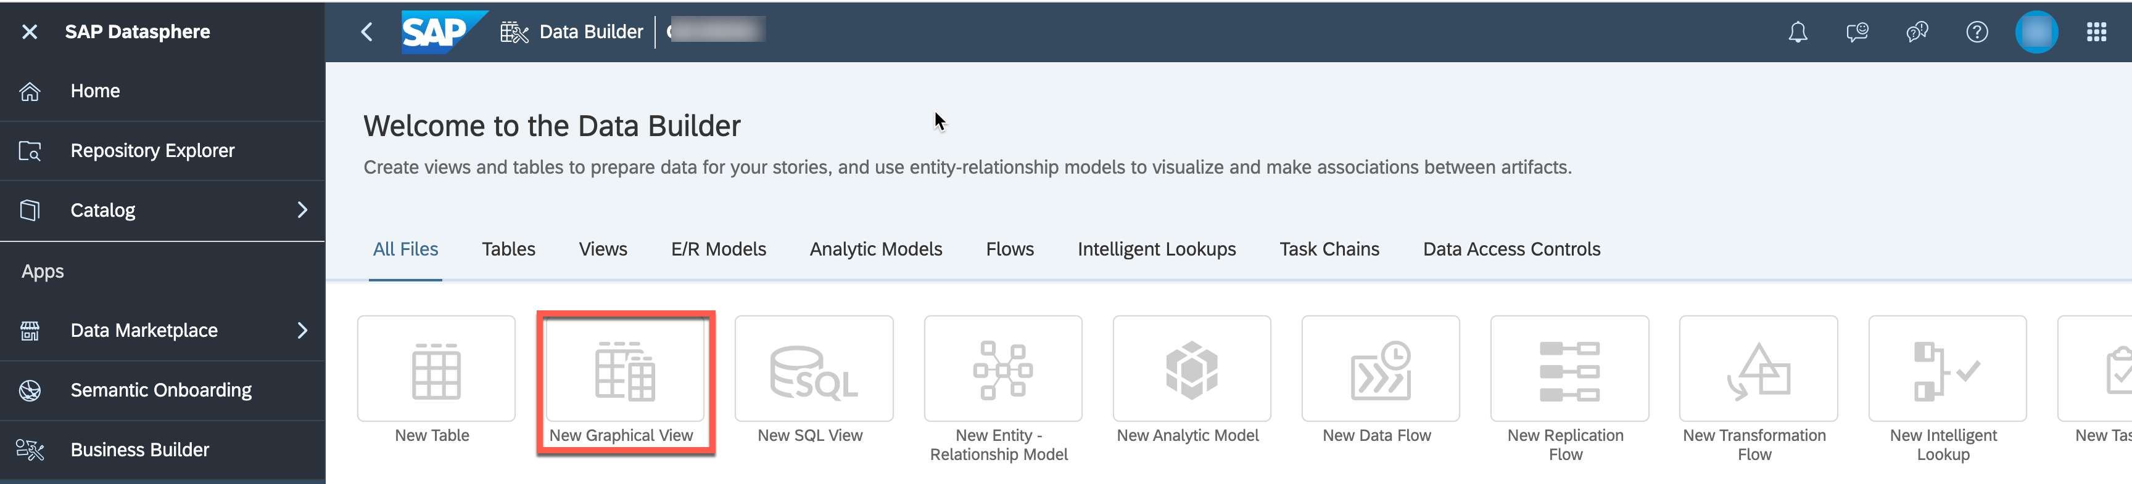

4. On the left-hand side you can decide between: - ***Repository***: Here you have access to the local tables (imported data), views, Intelligent Lookups and Shared Objects. - ***Sources***: Here you have access to the respectie objects from your connections.

5. Ensure you select the option ***Repository***.

6. Open the folder TECHED2024-DA180.

7. You are presented with the list of tables, which we created previously.

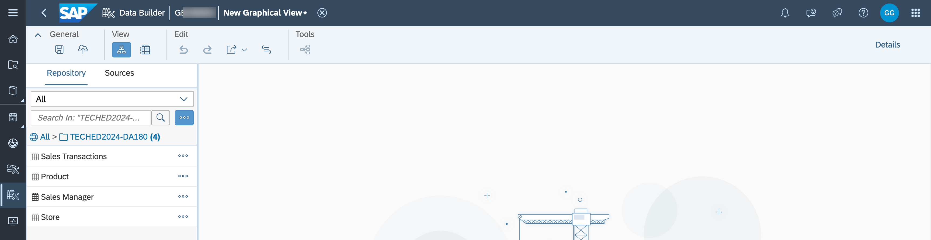

8. Drag and Drop the table ***Sales Transactions*** to the canvas.

9. When you drag the table to the canvas, you'll automatically get an output view as well. In this example, it's called View 1.

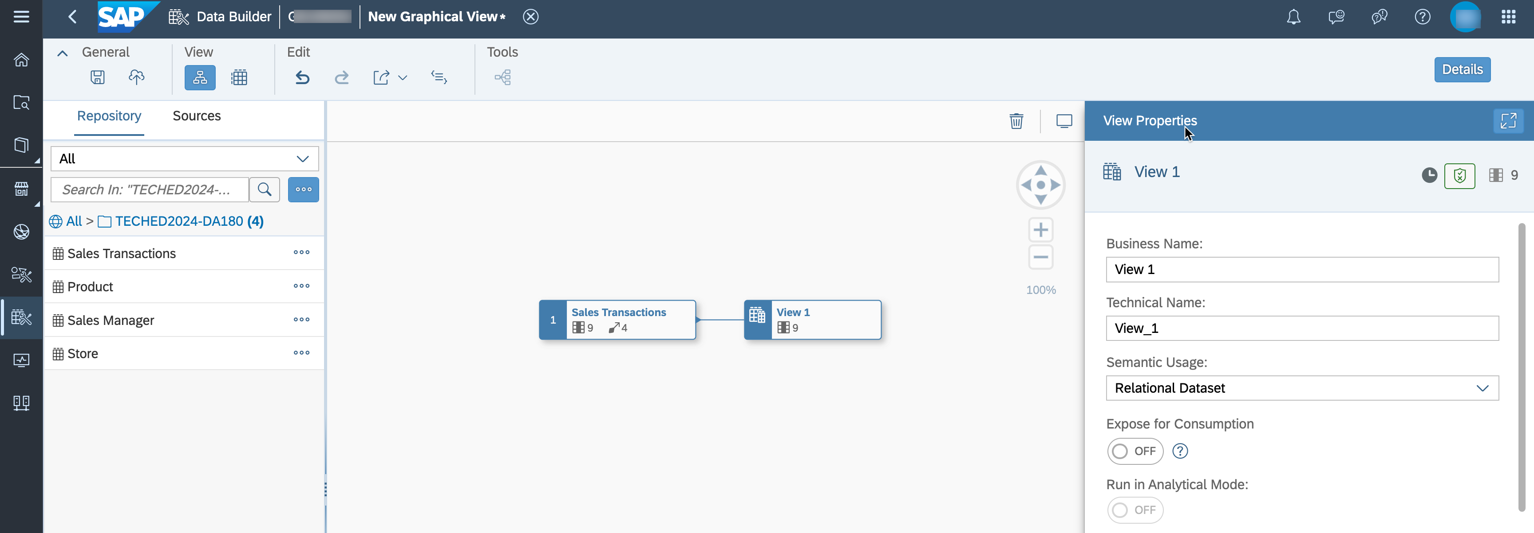

10. Ensure the option ***Details*** (top right corner) is enabled. Otherwise, click on the output view that was added, in our example View 1.

11. Navigate to the ***Properties*** window.

2 / 9

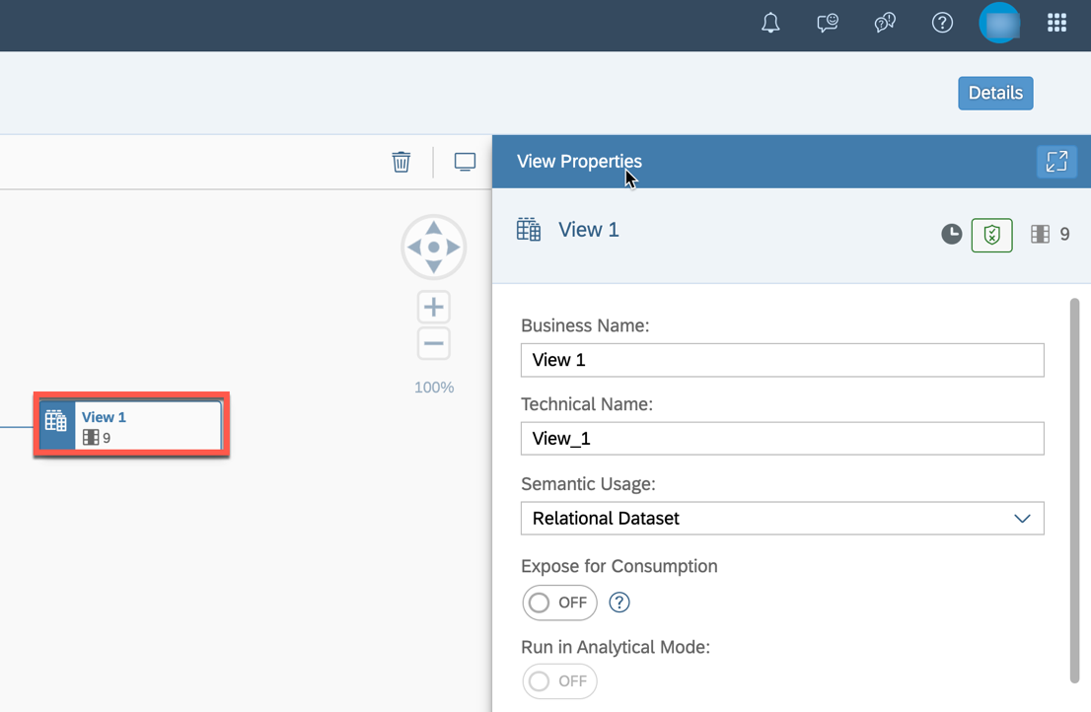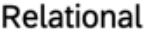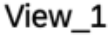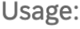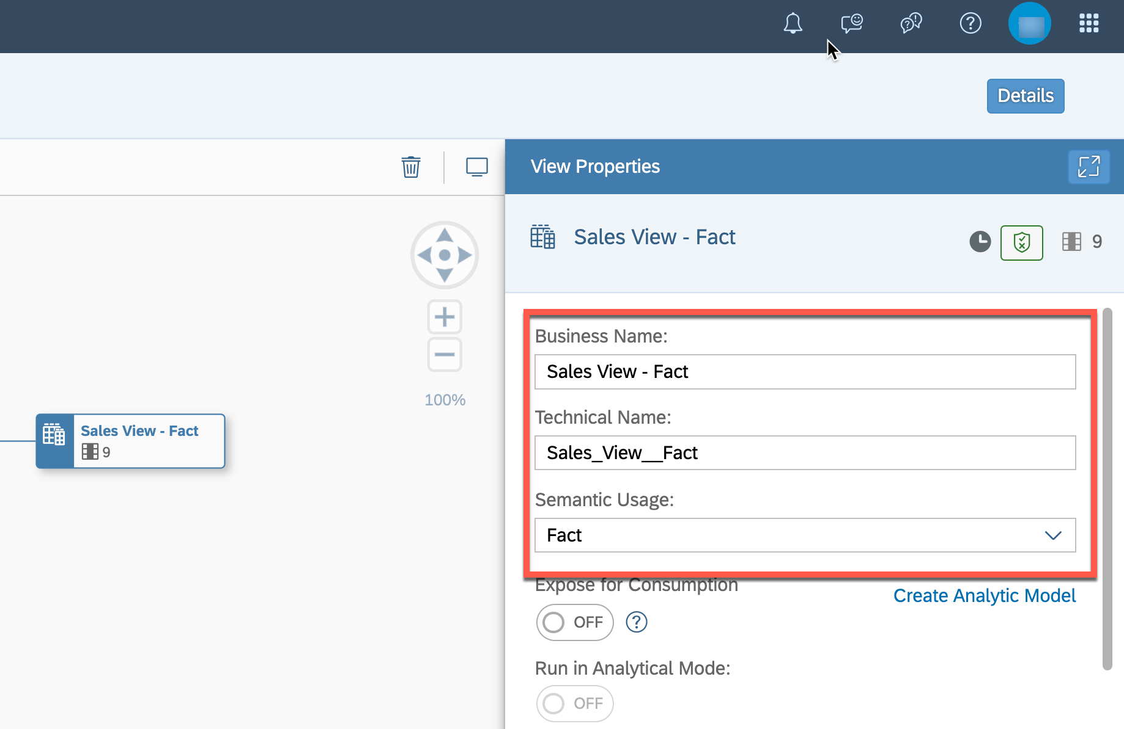

|  |  |
| --- | --- |
| README.md | 2025-04-15 |

12. Here you should configure properties for the view:

|  |  |
| --- | --- |
|  | ***Business Name***: Sales View – Fact  ***Technical Name***: Sales_View__Fact  ***Semantic Usage***: Fact |

13. In the panel on the right-hand side, scroll down to the ***Attributes*** section.

3 / 9

README.md 2025-04-15

14. The columns ***Profit***, ***Discount***, ***Revenue***, and ***Cost*** are measures (quantifiable values that refer to aggregatable fields of a model). Drag and drop these fields to the section ***Measures*** (multi-selection of measures is possible with keeping **CTRL** key pressed). You can also change the type by selecting the ***Change to Measure*** option.

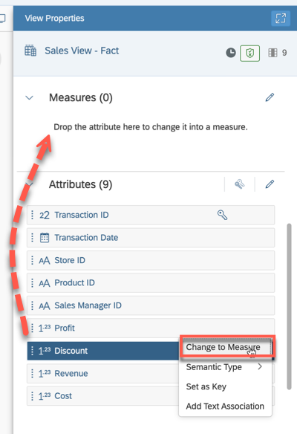

15. Verify that your graphical view has four measures.

4 / 9

README.md 2025-04-15

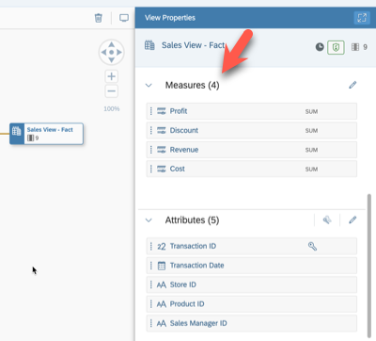

16. Scroll down to the section ***Associations***. Click the ***+*** icon to add a new association. As the source of the view has associations itself, you can copy those instead of creating them again (indicated by the arrow symbol on the root view node). Select ***Copy from Source***.

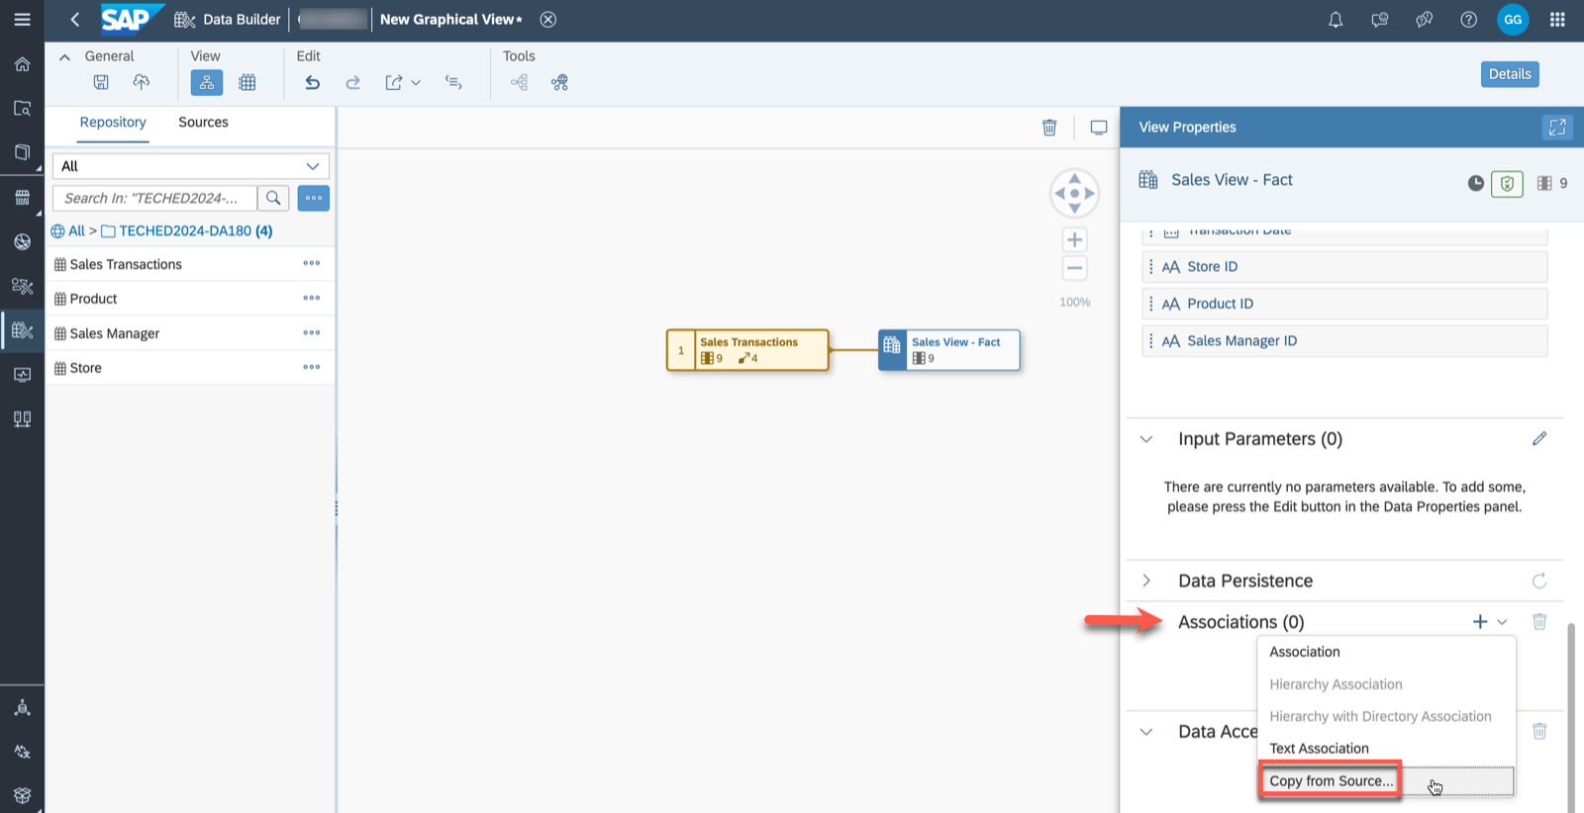

17. Select the available source associations for ***Product ID***, ***Sales Manager ID*** and ***Transaction Date***. Click ***Create***.

5 / 9

README.md 2025-04-15

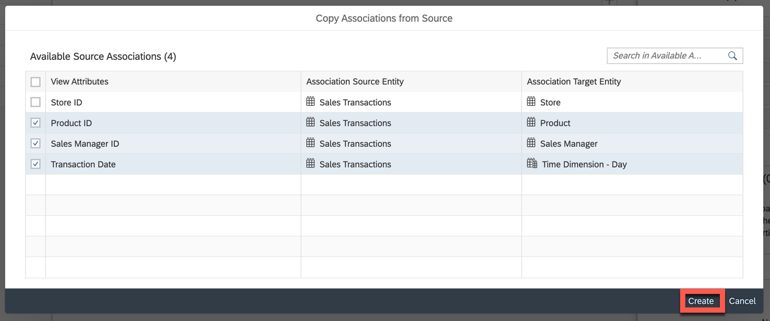

18. As we created a new dimension view to add a column containing geographic coordinates, create a new association by selecting ***Association*** after clicking on the **"+"** icon next to the Associations section. 19. Choose ***Dimension Store*** (View - Dimension) from the folder TECHED2024-DA180, and click on ***Select***.

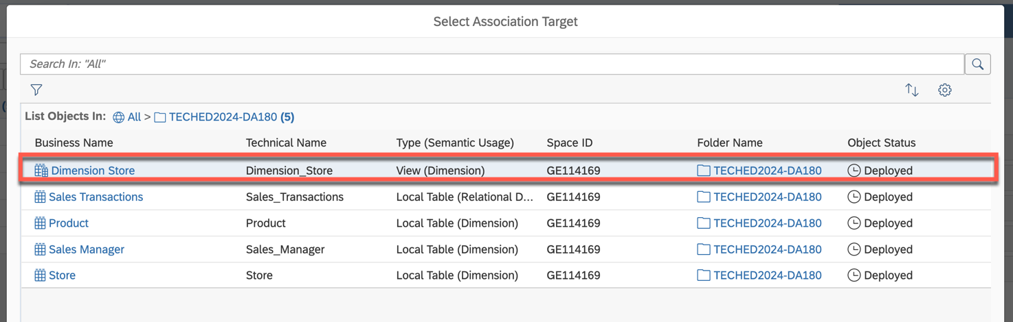

20. Verify that the mapping is done correctly on the column ***Store ID***.

6 / 9

README.md 2025-04-15

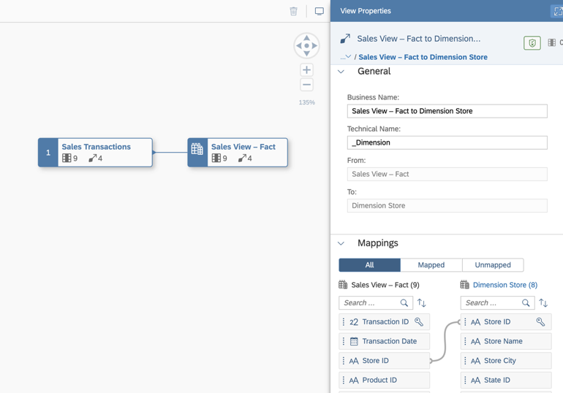

21. Save the view in the folder TECHED2024-DA180. You will be asked to confirm and ***Save*** the Business Name and Technical Name.   
22. Deploy your view.

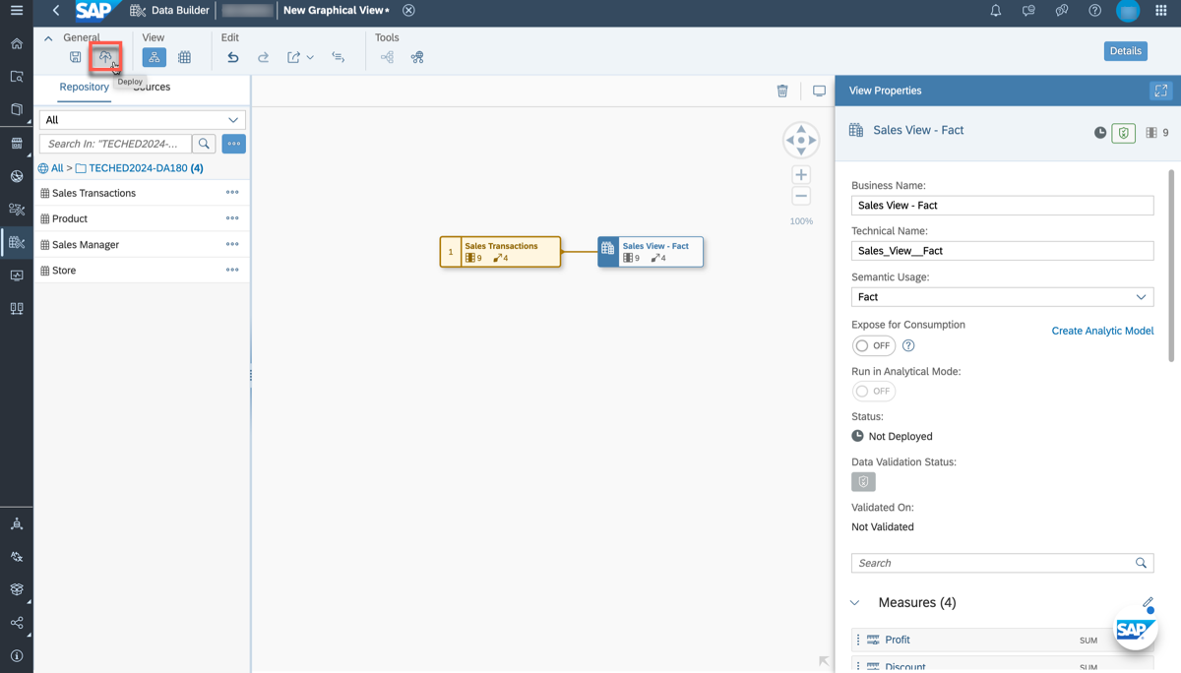

23. Once the view has been successfully deployed, you can create your Analytic Model by selecting the according option on the right-hand side.

7 / 9

README.md 2025-04-15

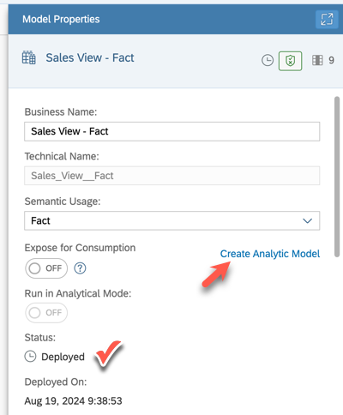

24. You are now within your Analytic Model as depicted below. You are able to see the sales fact view and

its associated dimensions that you added previously.

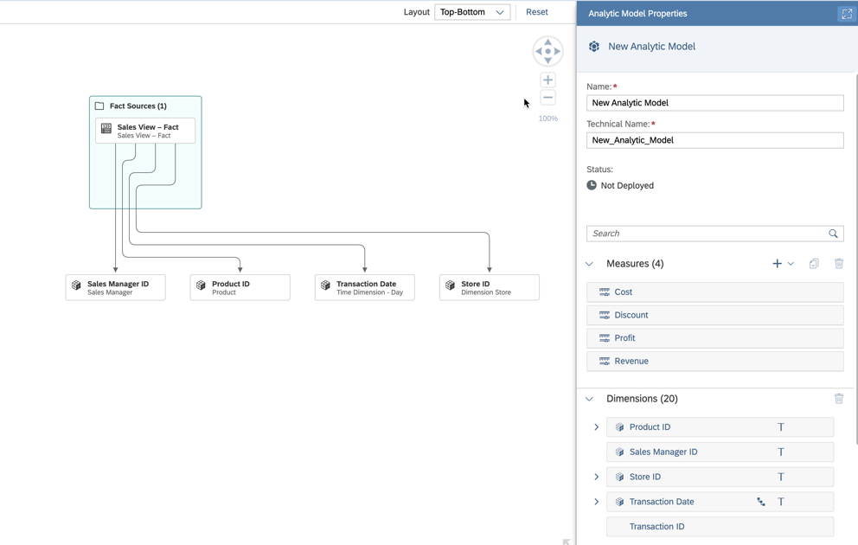

8 / 9

README.md 2025-04-15

25. ***Save*** and ***Deploy*** your Analytic Model with the business name ***Sales - Analytic Model*** (the technical

name is generated). Select the folder TECHED2024-DA180.

Summary

You have now created and deployed your first fact-based view and Analytic Model. The Analytic Model can

now be consumed within SAP Analytics Cloud to answer different business questions.

Continue with - Exercise 8 - Top 10 Revenue Generating Products

9 / 9

README.md 2025-04-15

Exercise 8 - Top 10 Revenue Generating Products

In this exercise, we will create a story in SAP Analytics Cloud (SAC), which allows us to analyze and identify the top 10 revenue generating products.

1. Log On to your SAP Analytics Cloud tenant.

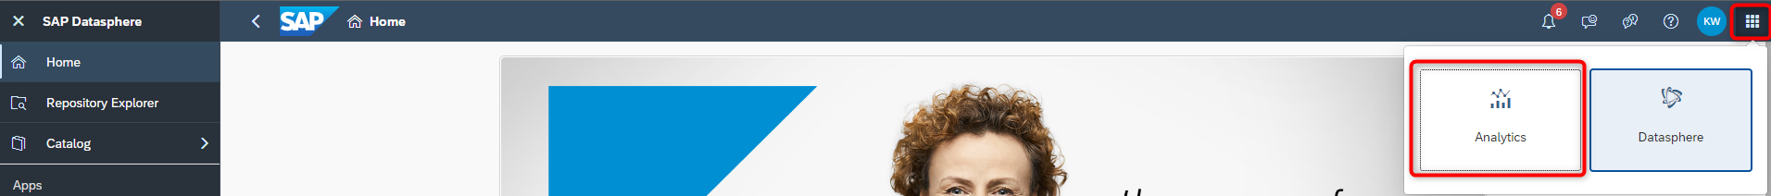

|  |  |
| --- | --- |
|  | **Note:** The system might prompt you to sign in again. Use the same username and password for |

|  |
| --- |
| SAC as you do for Datasphere. |

2. Select the menu ***Stories*** in the left-hand panel.   
3. Select the option ***Canvas*** to create a new story.

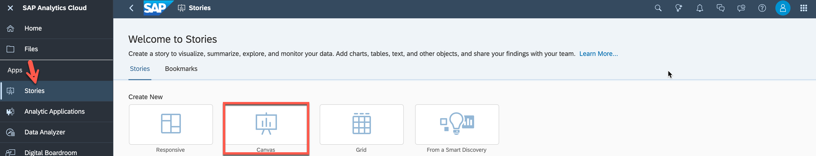

4. Select ***Optimized Design Experience*** when asked which design mode to use. Click ***Create***.

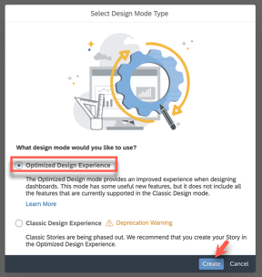

5. Under ***Widgets***, select and drag ***Chart*** onto the canvas.

1 / 11

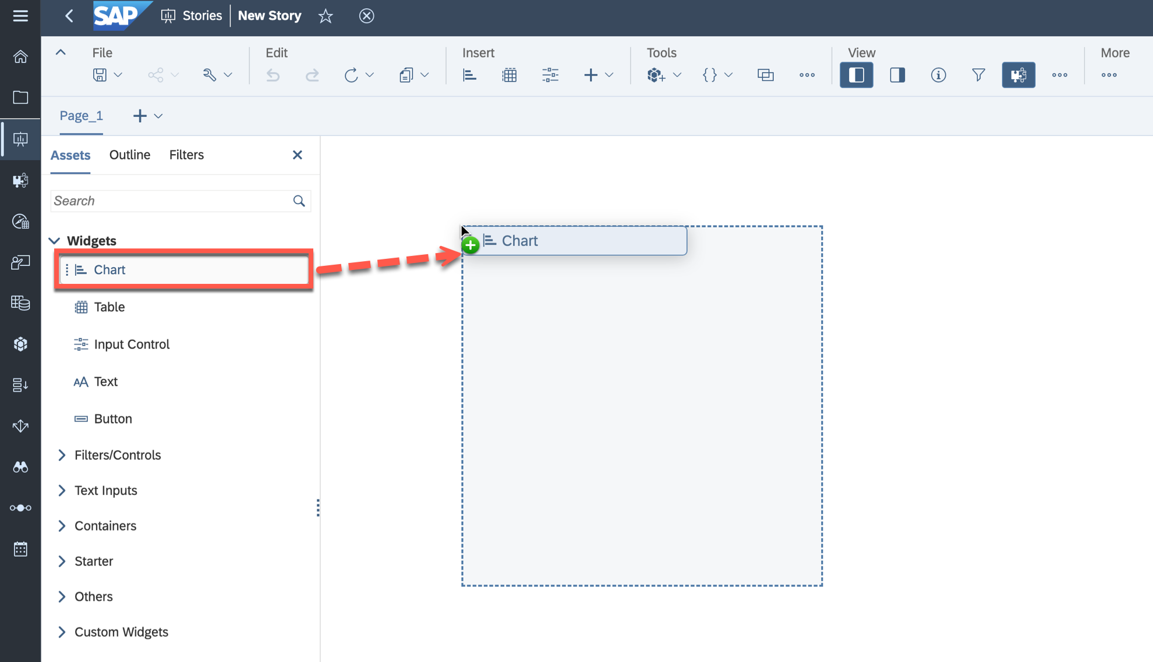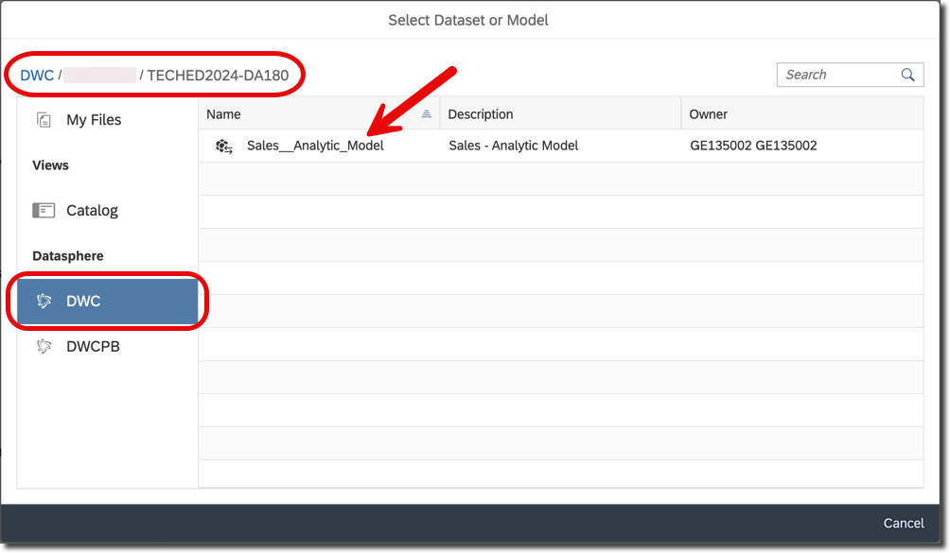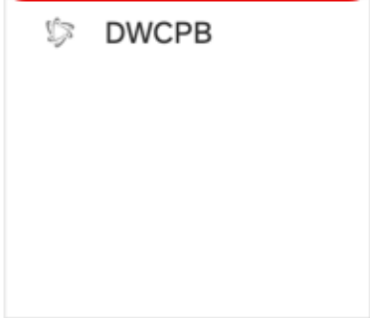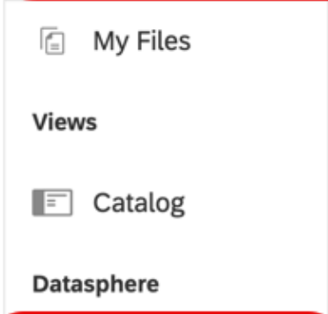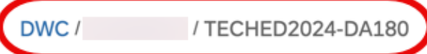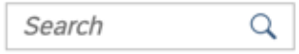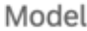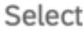

|  |  |
| --- | --- |
| README.md | 2025-04-15 |

6. To select the model that you want to reference in your story:

|  |  |
| --- | --- |
|  | Select DWC as the connection on the left panel.  Select your space, e.g., GE123456, and the folder TECHED2024-DA180. For our first example, select your Sales - Analytic Model. |

7. Now select the newly created empty chart on the canvas.

8. Navigate to the ***Builder*** panel on the right-hand side.

2 / 11

README.md 2025-04-15

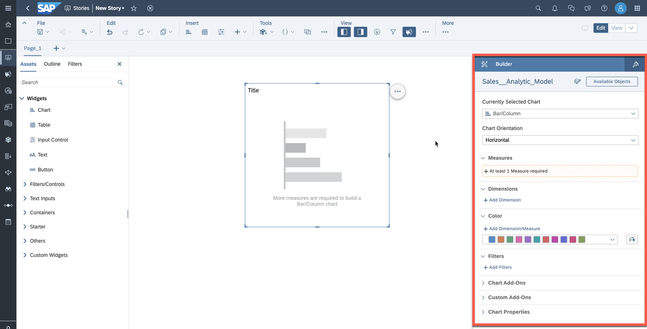

9. Click ***Add Dimension*** as part of the Dimensions section.

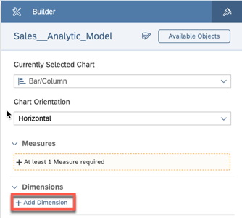

10. Select ***Transaction Date*** and ***Product ID***. Afterwards, click anywhere outside the view for dimensions selection to return to the chart settings.

3 / 11

README.md 2025-04-15

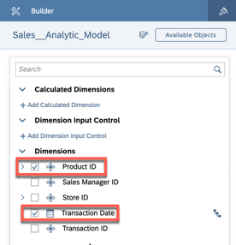

|  |
| --- |
| Ensure the ***Transaction Date*** is positioned first within the dimensions section overview. |

11. Add a measure by clicking on the ***At least 1 Measure required*** section.

12. Select the measure ***Revenue***. Afterwards, click anywhere outside the view for measure selection to

return to the chart settings.

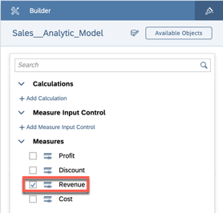

13. Click on the Filter icon for the dimension ***Transaction Date***.

4 / 11

README.md 2025-04-15

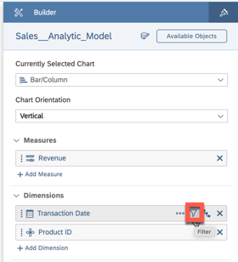

14. Select the option ***Filter by Member***.

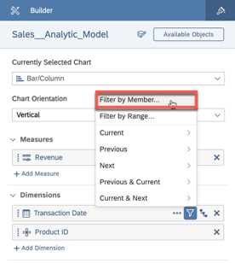

15. Open the list of members and select the year 2022. Click ***OK***.

5 / 11

README.md 2025-04-15

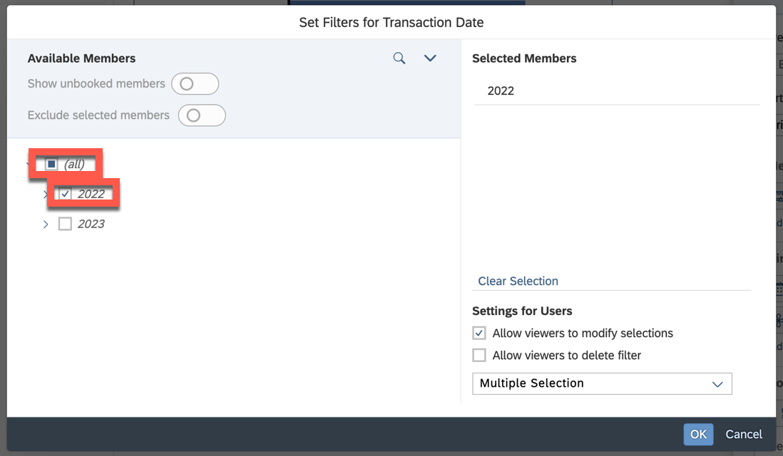

16. Open the ***More Actions*** menu (***...***) for the chart (top right corner of chart). Within the menu, go to ***Rank***

> ***Top N Options*** > Update value to 10. Click ***Apply***.

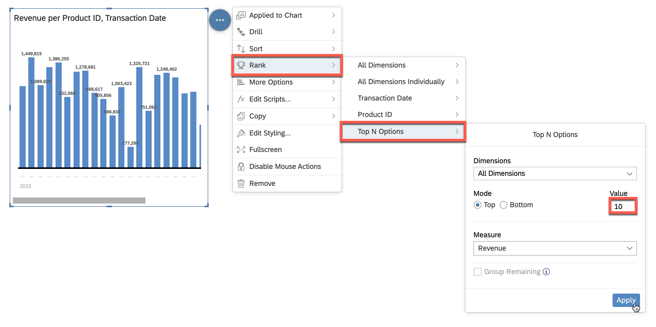

17. Update Chart Orientation to ***Horizontal*** in the Builder Panel.

6 / 11

README.md 2025-04-15

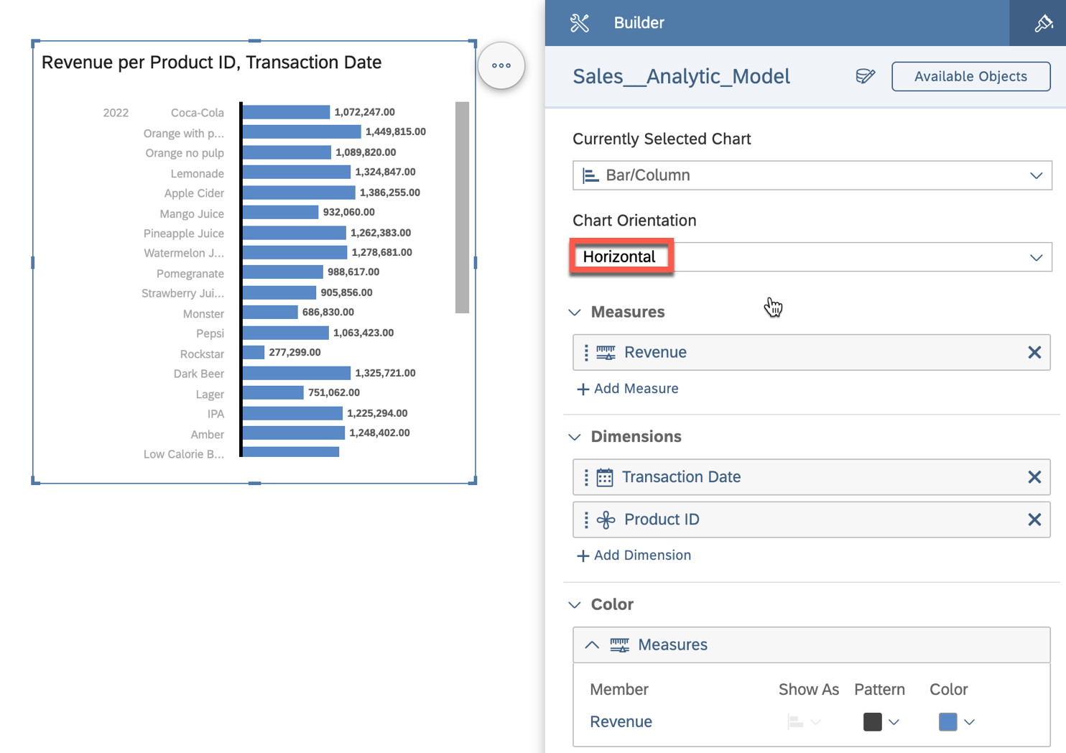

18. You can adjust the size of the chart by clicking and dragging the brackets outward or inward. Additionally, you can move the y-axis to ensure the full product name is displayed.

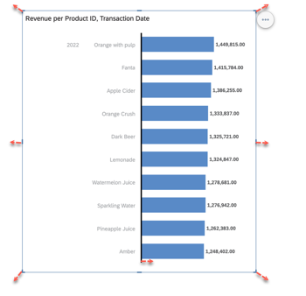

19. Your chart should look like this. Note that only the description of the product is displayed, based on the configuration in ***Display Options*** for ***Product ID***.

7 / 11

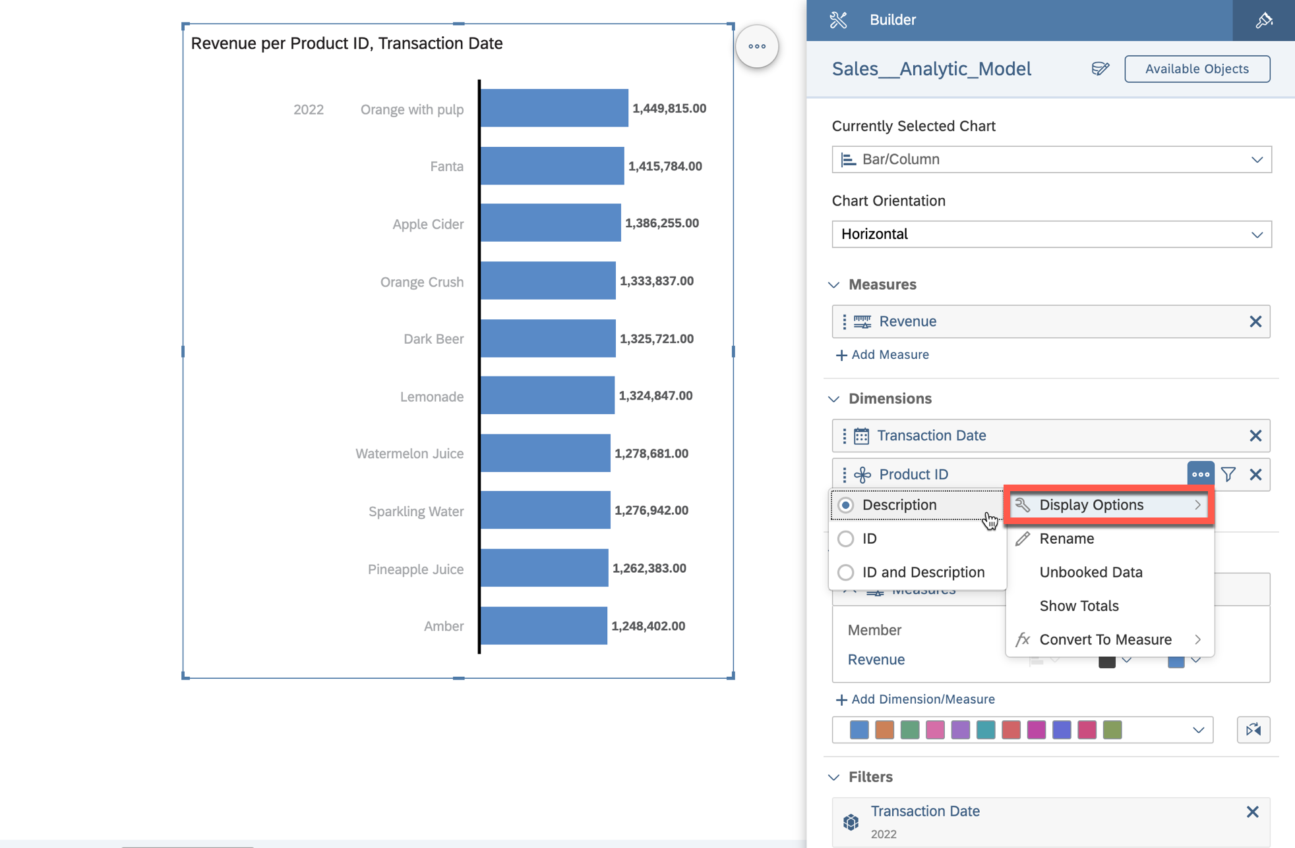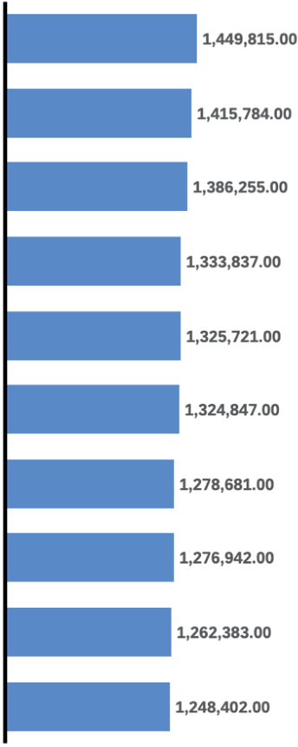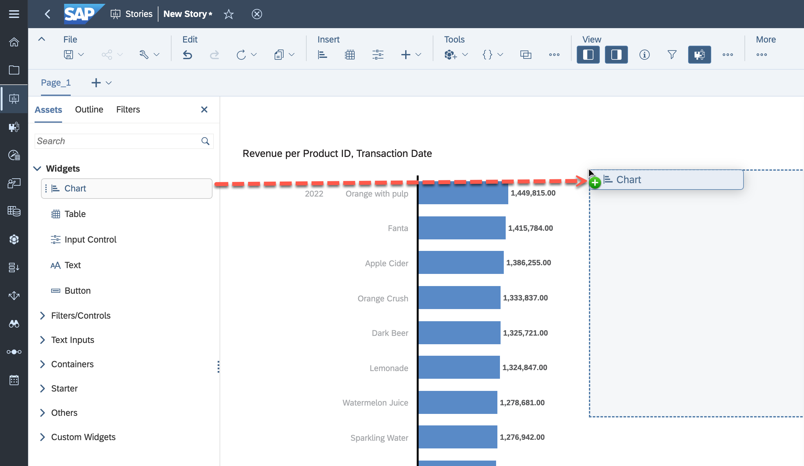

|  |  |
| --- | --- |
| README.md | 2025-04-15 |

20. We want to visualize the change in revenue over time using an additional chart. Drag a new chart onto

the canvas to get started.

21. Set the following settings:

|  |  |
| --- | --- |
|  | Select ***Line*** as Currently Selected Chart.  The measure for ***Left Y-Axis*** is ***Revenue***.  Select ***Transaction Date*** as ***Dimension***.  Filter ***Product Category ID (Member)*** to ***Juices***. |

8 / 11

README.md 2025-04-15

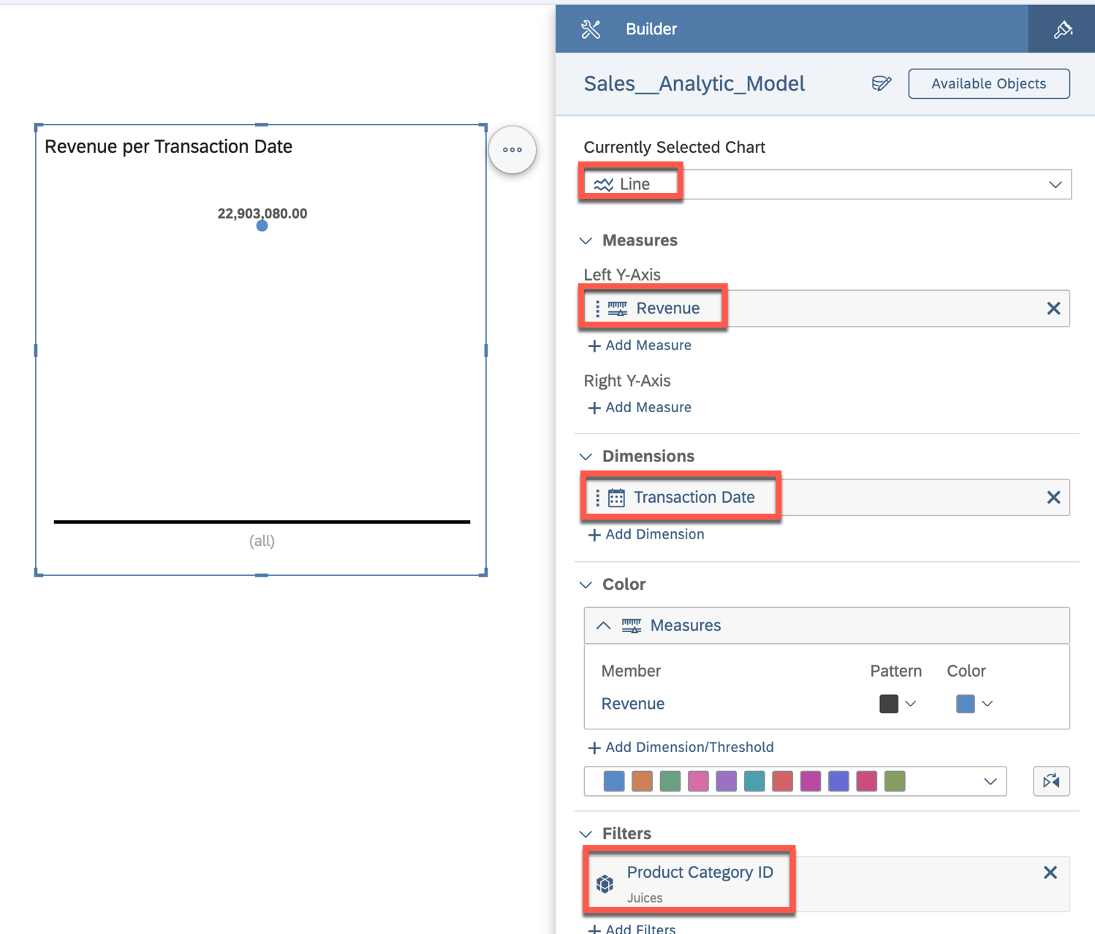

22. Use the time hierarchy defined for ***Transaction Date*** to perform a quarter-based analysis. Set the hierarchy to ***Year, Quarter, Month, Day*** by clicking on ***Change Hierarchy***. Adjust the level to ***Level 3*** so that the revenue is displayed per quarter.

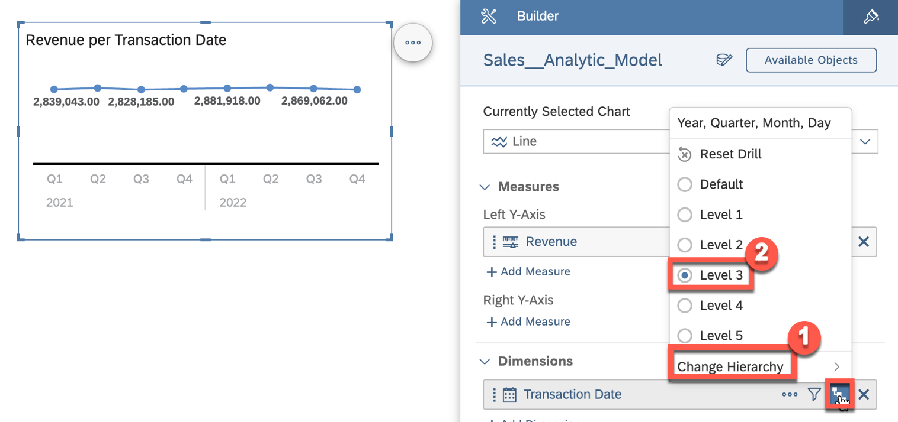

23. You can now modify the style of your story and add elements, headings, or adjust chart titles. If you select ***+*** (***Insert*** section), you will see options to insert standard shapes or other entities, such as

9 / 11

README.md 2025-04-15

dynamic text.

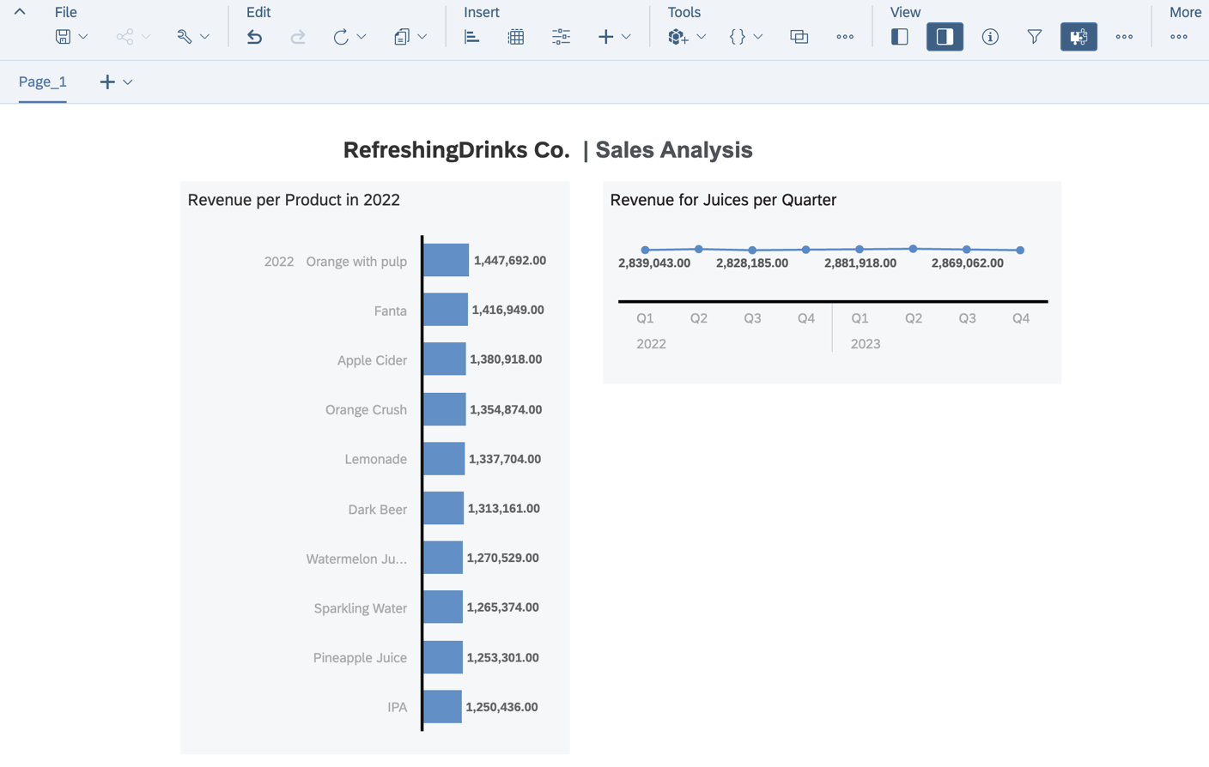

24. In the ***File*** menu, select the option ***Save*** to save your story. 25. Create a folder that matches your space name, e.g., ***GE123456***.

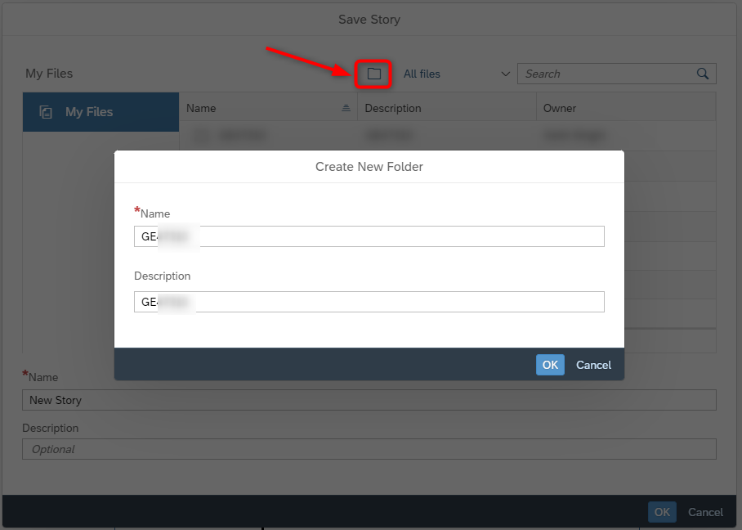

10 / 11

README.md 2025-04-15

26. Select the folder ***GE123456***. Enter a name and a description, such as ***Revenue Analysis - Products***.

27. Click ***OK***.

Summary

You've now created your first SAP Analytics Cloud story based on the data model you built earlier.

Continue to - Exercise 09: Revenue by Geography

11 / 11

README.md 2025-04-15

Exercise 9 - Geographic Revenue Distribution

In this exercise, we will set up a story in SAP Analytics Cloud that allows us to visualize the measures on a geographic map.

1. Log On to your SAP Analytics Cloud tenant.



|  |  |
| --- | --- |
|  | **Note:** The system may ask you to sign in again. Use the same user name and password for SAC as |

|  |
| --- |
| for Datasphere. |

2. Select the menu ***Stories*** in the left-hand panel.   
3. Select the option ***Canvas*** to create a new story.



4. Select ***Optimized Design Experience*** when asked which design mode to use. Click ***Create***.



5. Under ***Others***, select and drag the ***Geo Map*** onto the canvas.

1 / 10

README.md 2025-04-15

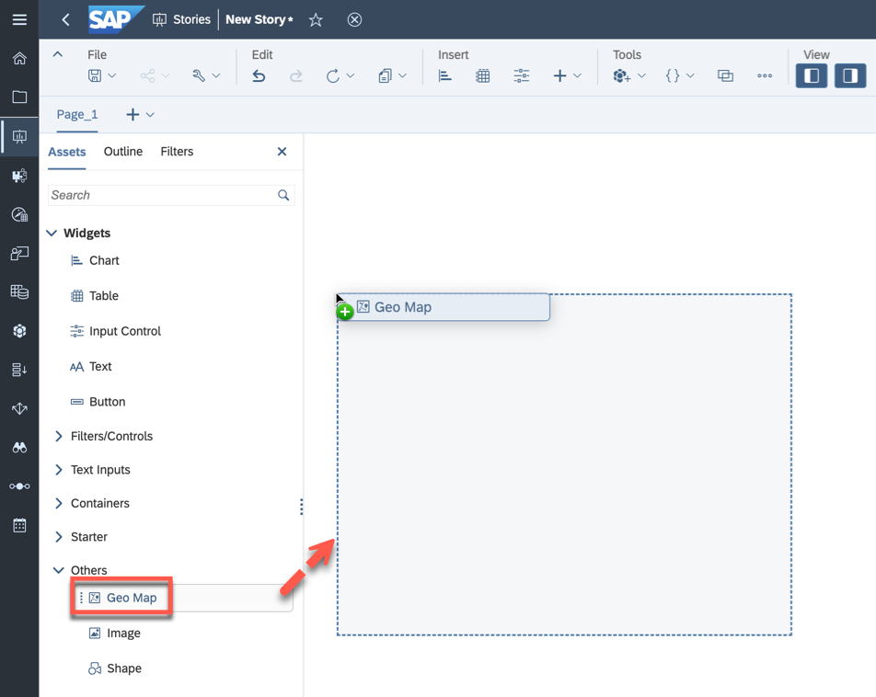

6. Resize the map so that it uses the complete canvas. You can accomplish this by opening the ***More***  menu (***...***) and selecting ***Fullscreen***.

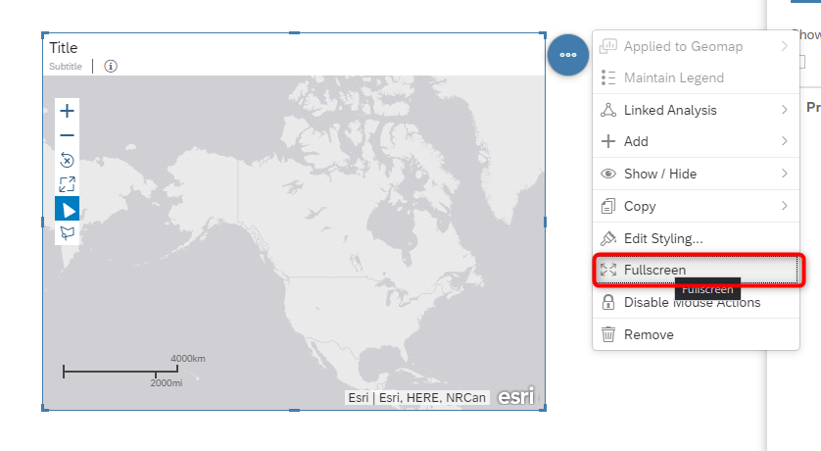

7. In the Builder panel on the right-hand side, select the option ***Add Layer*** for the Content Layer option.

2 / 10

README.md 2025-04-15

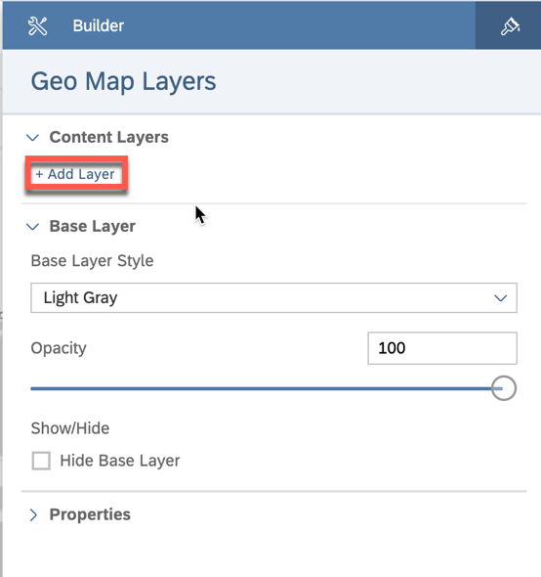

8. Click on the model icon to choose your data model.

3 / 10

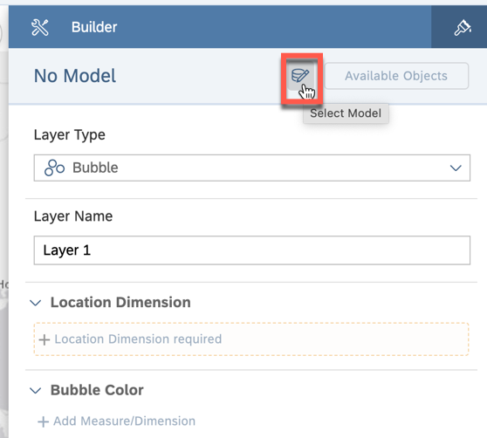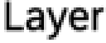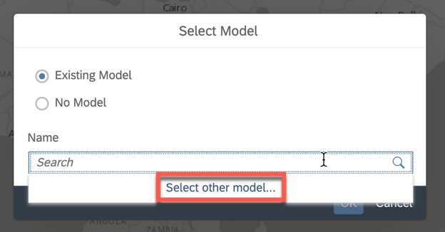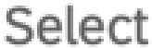

|  |  |
| --- | --- |
| README.md | 2025-04-15 |

9. Click within the search field and choose ***Select other model*** option.

10. To select the model that you want to reference in your story:

|  |  |
| --- | --- |
|  | Select DWC as the connection on the left panel.  Select your space, e.g., GE123456, and the folder TECHED2024-DA180. |

4 / 10

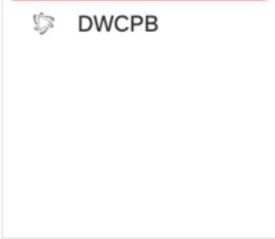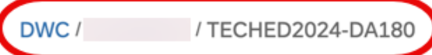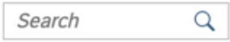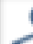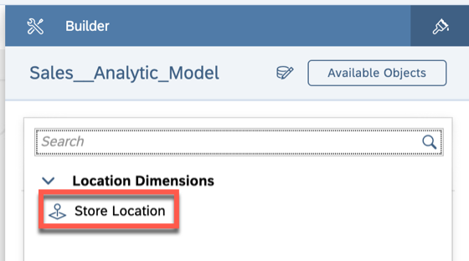

|  |  |  |
| --- | --- | --- |
| README.md | For our first example, select your Sales - Analytic Model. | 2025-04-15 |
|  |
|  |

11. In the Builder panel, click on ***Location Dimension Required*** for the ***Location Dimension*** area. 12. Select the option ***Store Location***. This is the store location dimension we created previously based on the longitude and latitude values for the store dimension.

13. Click on ***Add Measure*** for the Bubble Size.   
14. Select measure ***Revenue***.

5 / 10

README.md 2025-04-15

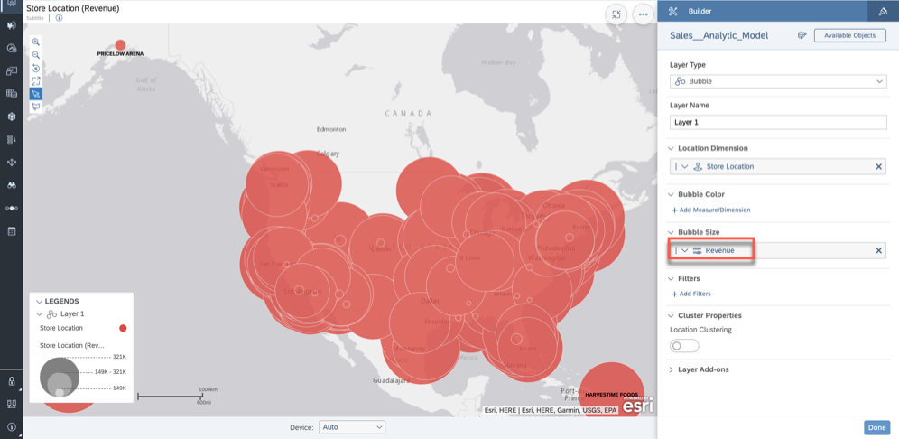

15. Click ***Add Measure / Dimension*** for the Bubble Color   
16. Select measure ***Profit***.

17. Now open the details for the measure ***Profit*** as part of the Bubble Color. 18. Open the list of color ***Palette***.

6 / 10

README.md 2025-04-15

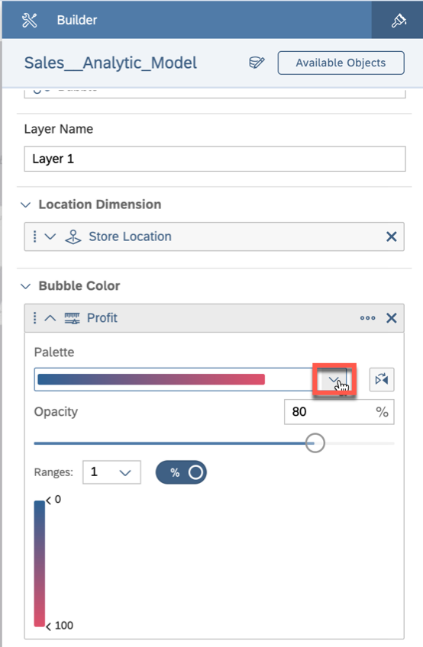

19. Select the second entry from the ***continuous*** category (red to green).

7 / 10

README.md 2025-04-15

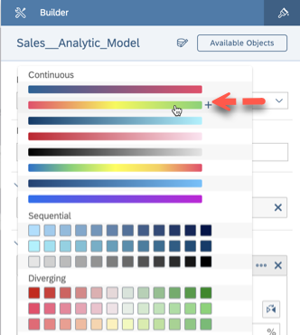

20. Now open the details for the ***Bubble Size*** definition (Revenue). 21. Set the size to 35%.

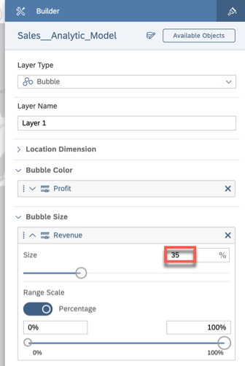

22. Click ***Done*** to save your Layer.

8 / 10

README.md 2025-04-15

23. Your map should look like this.

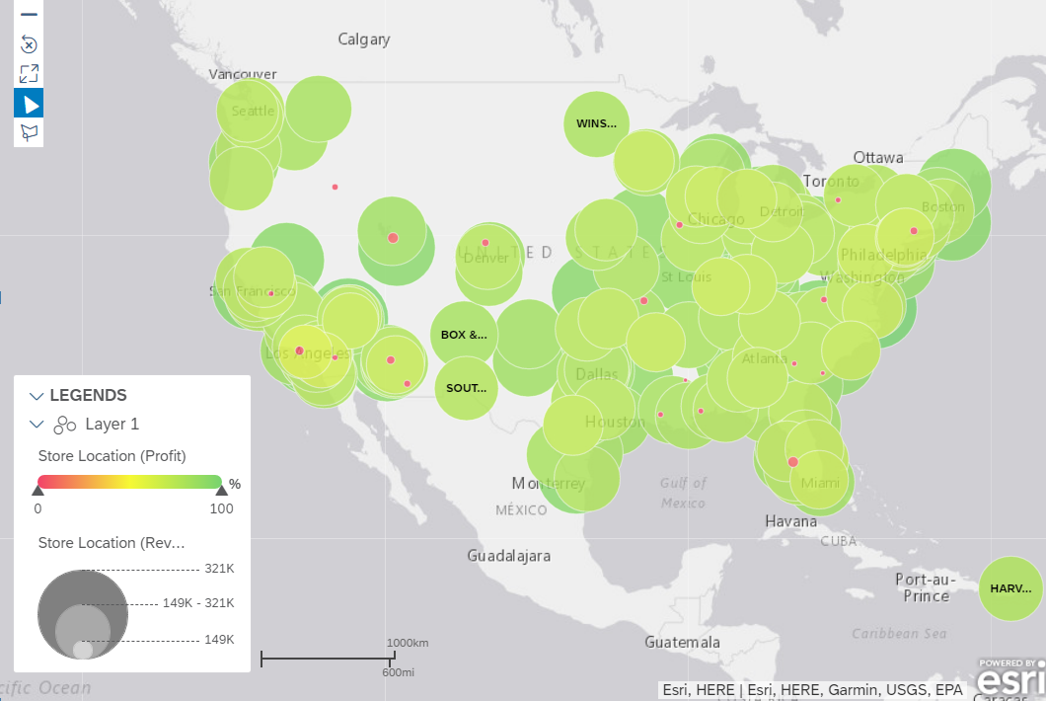

24. In the File menu, select ***Save*** to save your story.

25. Select the folder that matches your assigned user number, like GE123456.

26. Enter a name and description, like ***Geographic Revenue Distribution***. 27. Click ***Save***.

9 / 10

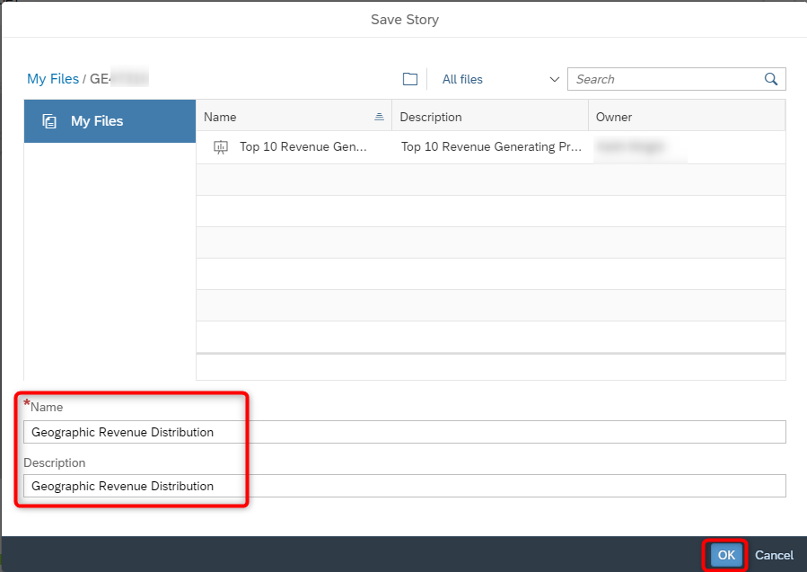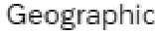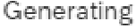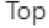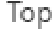

|  |  |
| --- | --- |
| README.md | 2025-04-15 |

Summary

You've now created your second story in SAP Analytics Cloud using the preconfigured connection to your

data models in SAP Datasphere.

You can continue with one of the *optional* exercises:

|  |  |
| --- | --- |
|  | Exercise 20: Identify Top-Performing Sales Managers with Just Ask Exercise 21: Create Row-Level Permissions based on External Hierarchy) Exercise 22: Explore the Analytic Model  Exercise 23: Create a Transformation Flow) |

10 / 10

README.md 2025-04-15

Exercise 20 - Identify Top-Performing Sales Managers with Just Ask

|  |  |  |  |
| --- | --- | --- | --- |
|  | | |  | | --- | | **Note:** This is an OPTIONAL exercise. | |
|  | Detour: SAP Analytic Cloud - Just Ask | |

Just Ask is the natural language query feature powered by artificial intelligence in SAP Analytics Cloud. It offers an easy and efficient way to ask questions about your data and provides fact-based answers in the form of tables and charts.

End of Detour

Start of Exercise

In this exercise, we will utilize Just Ask to query our data model by asking questions in everyday English. Our goal is to identify the best sales managers in our company.

1. Access the SAP Analytics Cloud tenant you got access to as part of the basic trial.

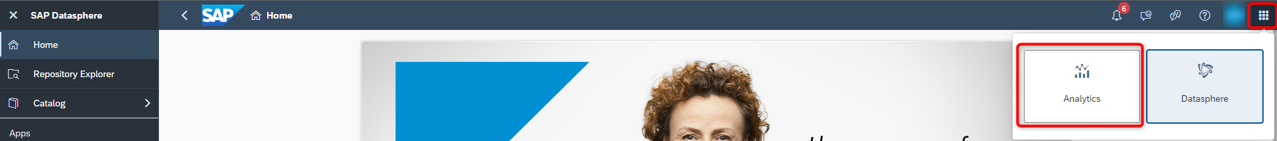

|  |  |
| --- | --- |
|  | **Note:** The system may ask you to sign in again. Use the same user name and password for SAC as |

|  |
| --- |
| for Datasphere. |

2. Select the menu ***Just Ask*** in the header.



3. Close the welcome guide, if opens.

1 / 6

README.md 2025-04-15

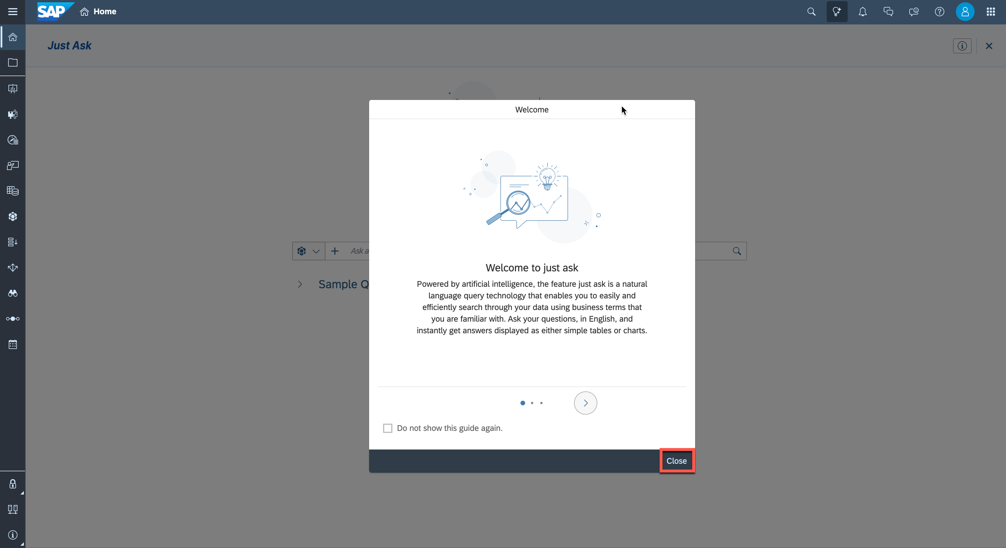

4. Click the model icon left to the search bar and select "Add Model to Search".

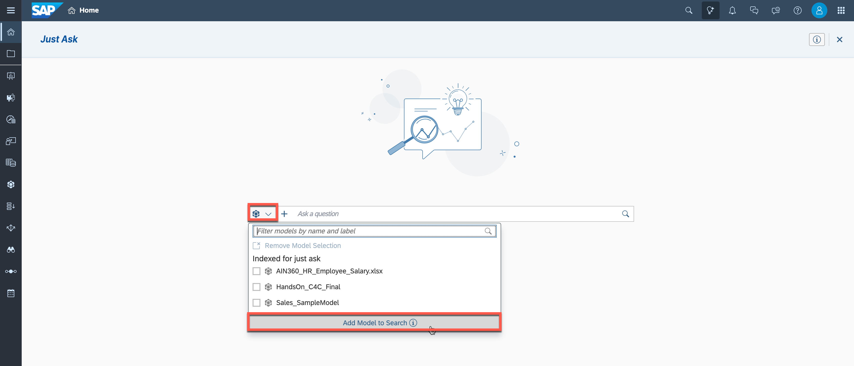

5. Select ***DSP*** as the connection on the left panel, choose your space, and click on the previously created

Analytic Model ***Sales__Analytic_Model***.

2 / 6

README.md 2025-04-15



6. The **Successfully Added** message will appear with the information that this model will only be available during the current sessions. Click ***OK***.

7. Now enter your question into the search bar: ***Who is the best sales manager based on revenue?***

To run the search, press enter or click on the magnifying glass symbol.

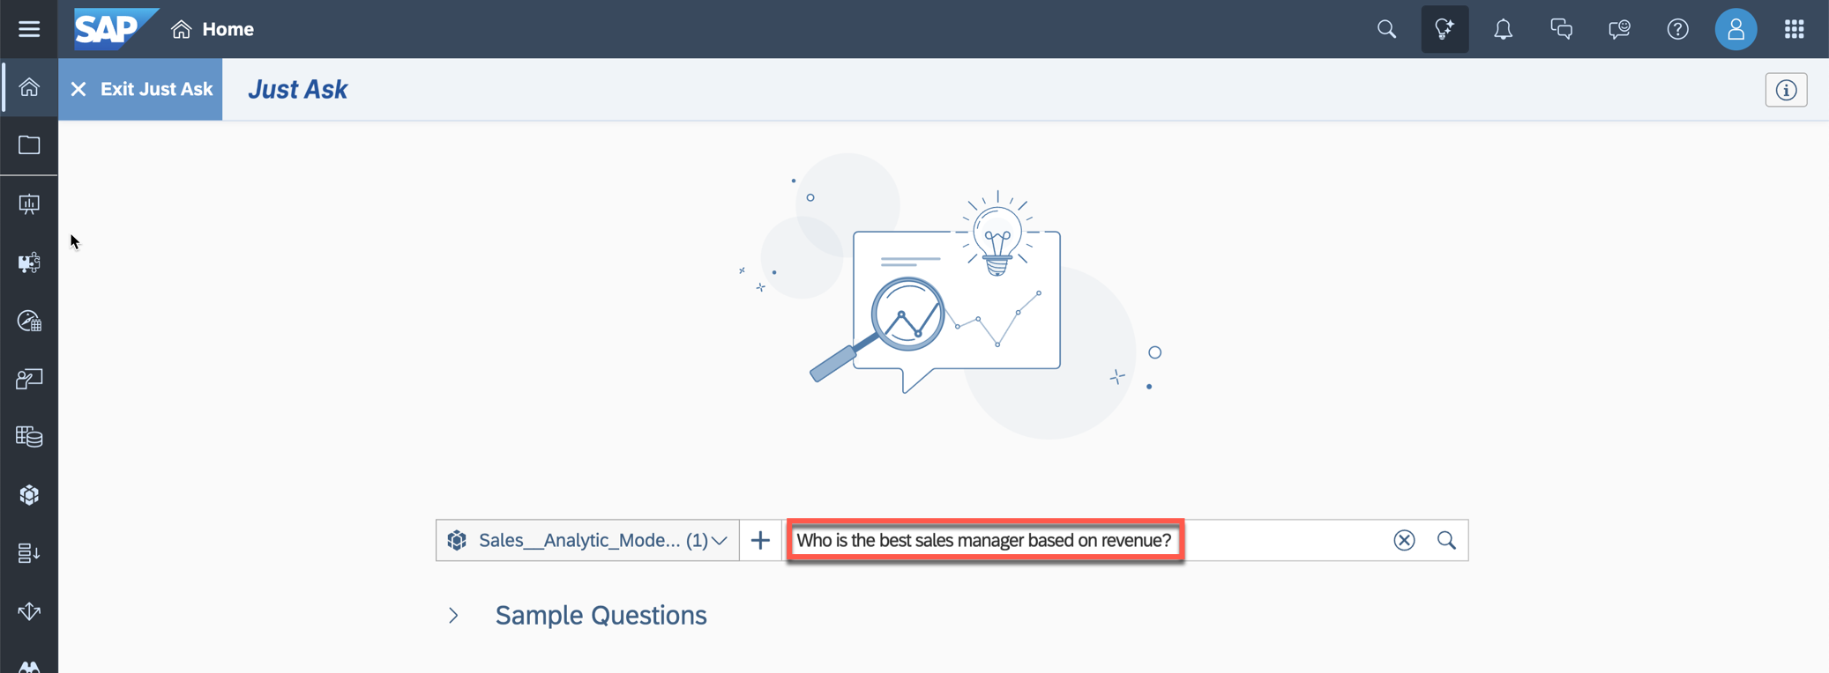

8. The search result is displayed as a card under the search field.

Kiran Raj is identified as the sales manager generating the most revenue. You can review the automatically applied settings, such as sorting and ranking, in addition to the correctly identified attribute and measure.

3 / 6

README.md 2025-04-15

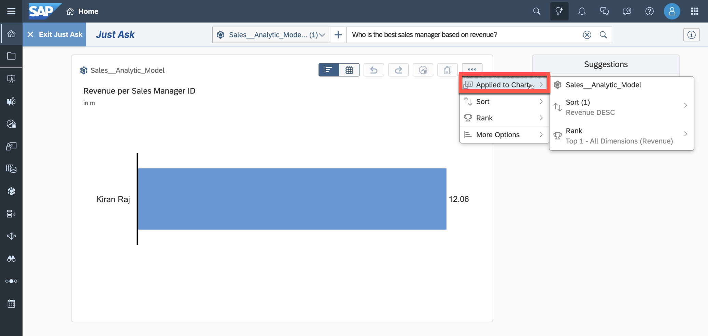

9. Compare him with the other sales managers. This time, the result should be displayed as a pie chart. Enter the following in the search bar on the top and search: ***Show revenue by sales manager as a pie chart*** .

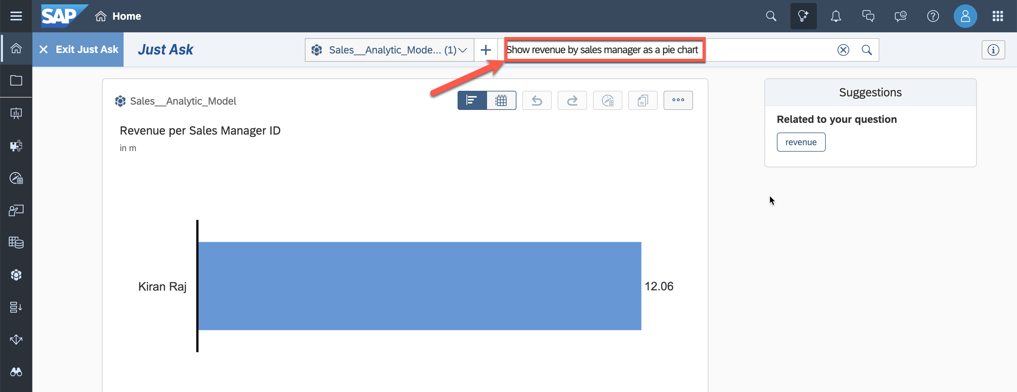

10. The pie chart below is displayed. Kiran Raj is responsible for 20% of the generated revenue.

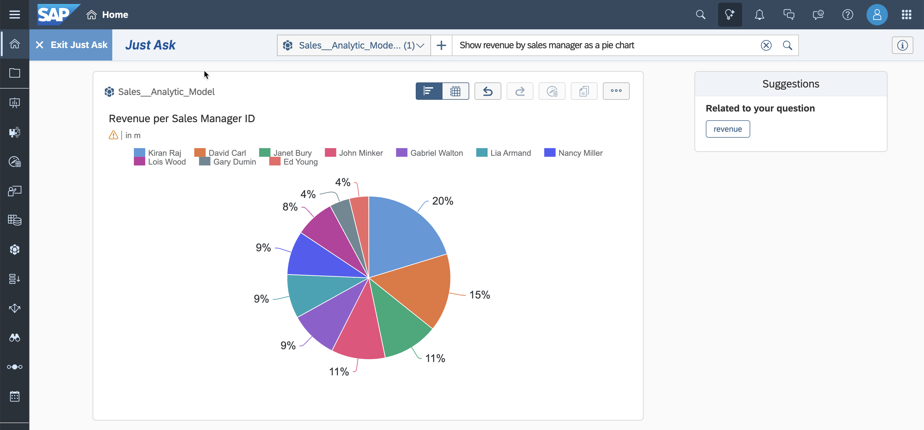

4 / 6

README.md 2025-04-15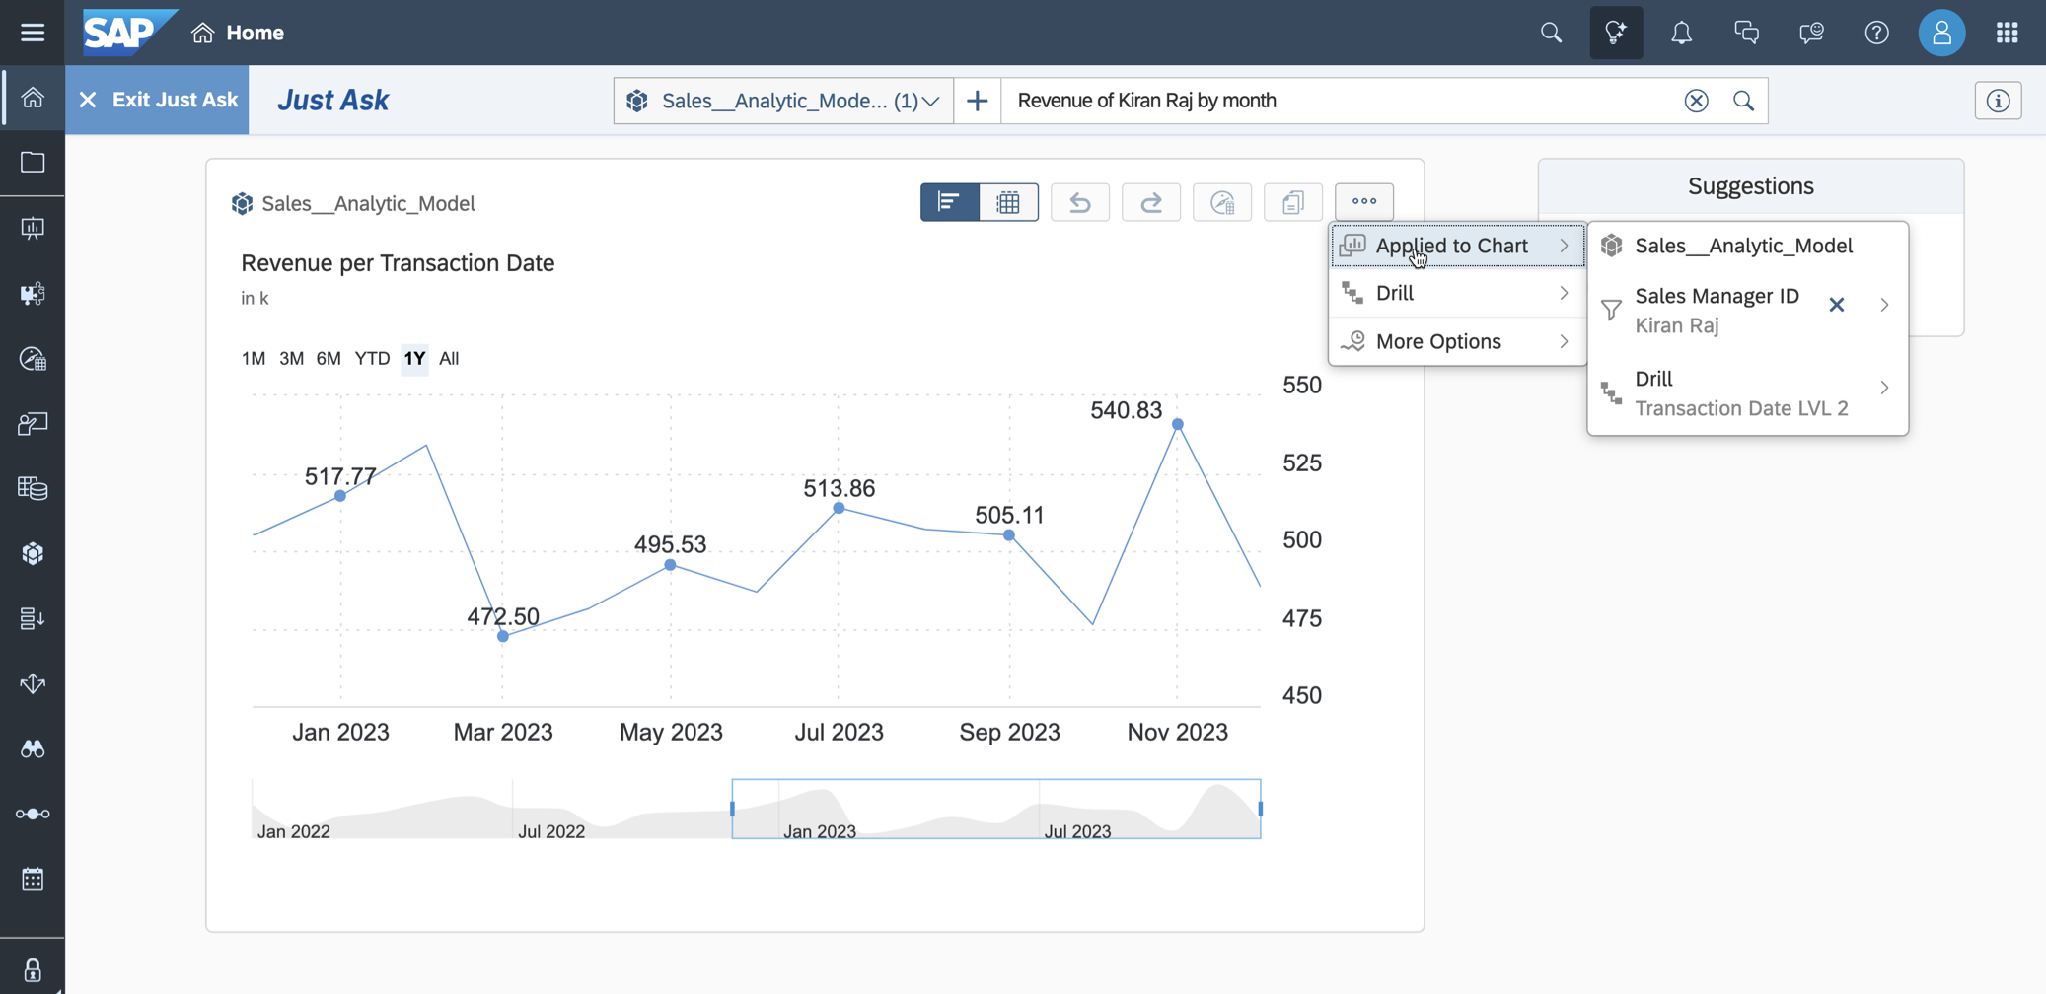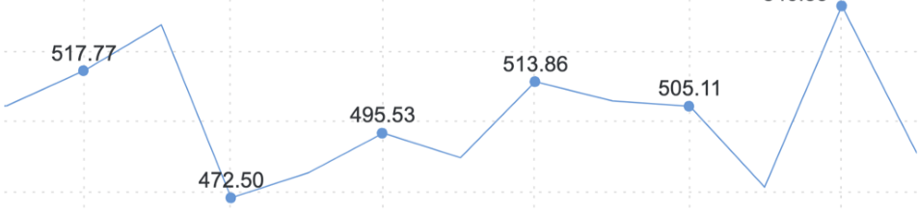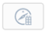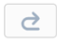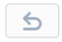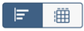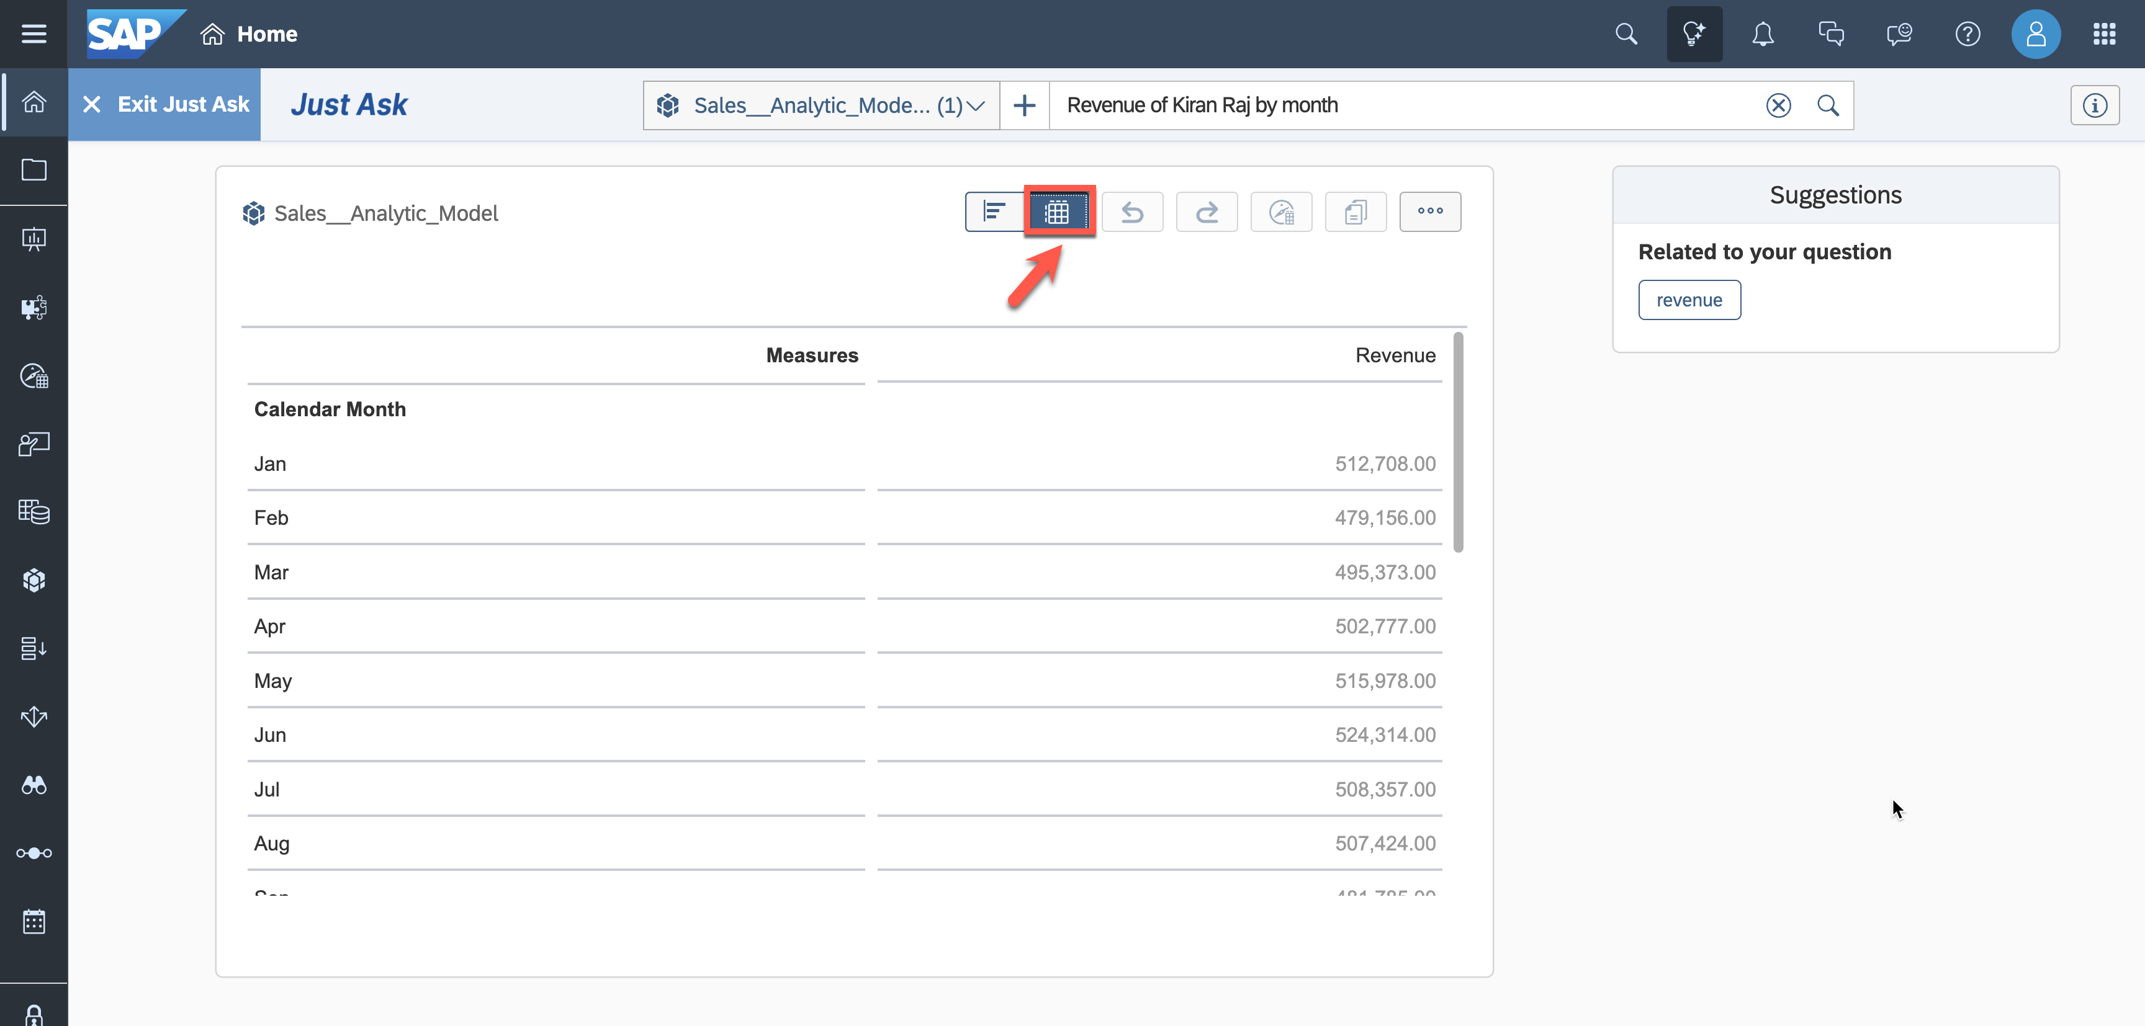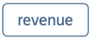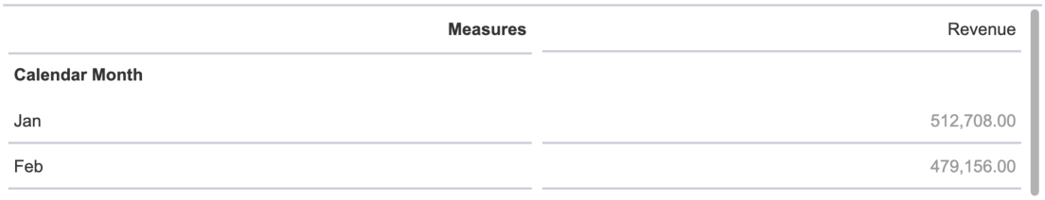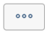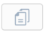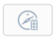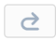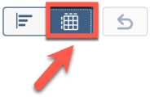

11. Can we see peaks for the revenue generated by Kiran Raj? Enter ***Revenue of Kiran Raj by month*** and search.

12. The chart visualizes the change of generated revenue. A filter is defined for sales manager and the drill level for the transaction date was adjusted to display months.

13. If you prefer to view the query result in a table format, you can change the display mode to a table.



Summary

Just Ask simplified and accelerated the process of finding answers to your reporting questions. Using the data model exposed by SAP Datasphere, you were able to obtain answers quickly without requiring any   
preconfigured data report.

You can continue with one of the *optional* exercises:

 Exercise 21: Create Row-Level Permissions based on External Hierarchy

 Exercise 22: Explore the Analytic Model

5 / 6

README.md 2025-04-15

 Exercise 23: Create a Transformation Flow

6 / 6

README.md 2025-04-15

Exercise 21 - Create Row-Level Permissions based on an External Hierarchy

|  |  |  |  |
| --- | --- | --- | --- |
|  | | |  | | --- | | **Note:** This is an OPTIONAL exercise. | |
|  | Detour: SAP Datasphere - Hierarchies and Data Access Controls | |

You can specify the following [types of hierarchies](https://help.sap.com/docs/SAP_DATASPHERE/c8a54ee704e94e15926551293243fd1d/218b7e6bd60846dda2f03b789b389cb0.html?locale=en-US):

1. **Parent-Child** - the hierarchy is recursive, may have any number of levels, and is defined by specifying a parent column and a child column within the dimension. For example, a departmental hierarchy could be modeled with the Parent Department ID and Department ID columns.

2. **Level-Based** - the hierarchy is non-recursive, has a fixed number of levels, and is defined by specifying two or more level columns within the dimension. For example, a time hierarchy could be modeled with the: Year, Quarter, Month, Week, and Day columns.

3. **[External Hierarchy](https://help.sap.com/docs/SAP_DATASPHERE/c8a54ee704e94e15926551293243fd1d/dbac7a862b3744d8a71d268644aac389.html?locale=en-US)** - the parent-child hierarchy information is contained in a separate entity, which needs to be associated with the dimension (see Create an External Hierarchy for Drill-Down).

4. **[Hierarchy with Directory](https://help.sap.com/docs/SAP_DATASPHERE/c8a54ee704e94e15926551293243fd1d/dbac7a862b3744d8a71d268644aac389.html?locale=en-US)** - your entity contains one or more parent-child hierarchies and has an association to a directory dimension containing a list of the hierarchies. These types of hierarchy entities can include nodes from multiple dimensions (for example, country, cost center group, and cost center) and are commonly imported from SAP S/4HANA Cloud and SAP BW (including SAP BW Bridge) systems.

**[Data access controls](https://help.sap.com/docs/SAP_DATASPHERE/be5967d099974c69b77f4549425ca4c0/a032e51c730147c7a1fcac125b4cfe14.html?locale=en-US)** allow you to apply row-level security to your objects. There are different options for specifying criteria to determine which user is allowed to access specific data. One option is to define access based on a hierarchy. Each user can only view records that match the hierarchy values they are authorized for in the permissions entity, along with any of their descendants. Only external hierarchies with a single pair of parent-child columns are supported.

End of Detour

Create a Parent-Child Hierarchy

1. Log On to your SAP Datasphere tenant.

2. Select the menu option ***Data Builder*** on the left-hand side.

3. Select the option ***New Table***.

4. Enter the following details:

 ***Business Name***: Hierarchy_ProductCategory

 ***Technical Name***: Hierarchy_ProductCategory

 ***Semantic Usage***: Hierarchy

1 / 10

README.md 2025-04-15

5. Warnings are displayed because no parent and child columns are defined yet to represent the hierarchy. The child column must be a key column, and both the parent and child columns must have the same data type.

6. Enter the following ***Attributes*** for the table:

|  |  |  |  |
| --- | --- | --- | --- |
| **Key:** | **Business Name:** | **Technical Name:** | **Data Type:** |
| X | Child Category | Child_Category | String (30) |
|  | Parent Category | Parent_Category | String (30) |

7. Ensure that ***Child Category*** is set as key.

8. Now select the column ***Parent Category*** as the parent and the column ***Child Category*** as the child. Notice that the validation icon in the upper-right corner turns green.

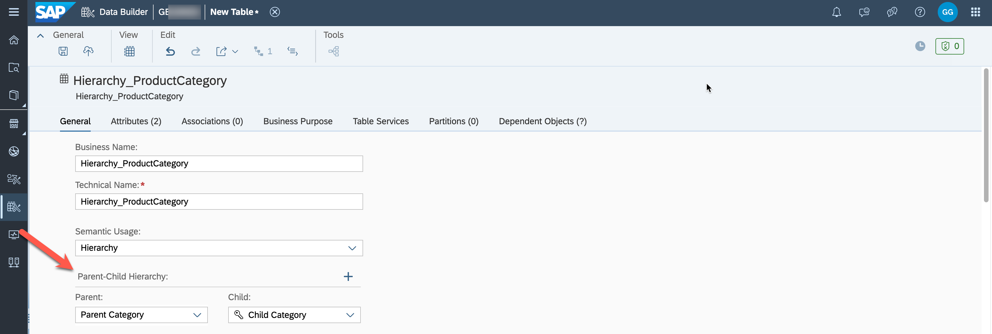

9. Save and deploy your hierarchy table in the folder TECHED2024-DA180.

|  |  |  |
| --- | --- | --- |
| 10. Download the |  | CSV file data_hierarchy_productcategories.csv and upload the data to the |

table.

2 / 10

README.md 2025-04-15

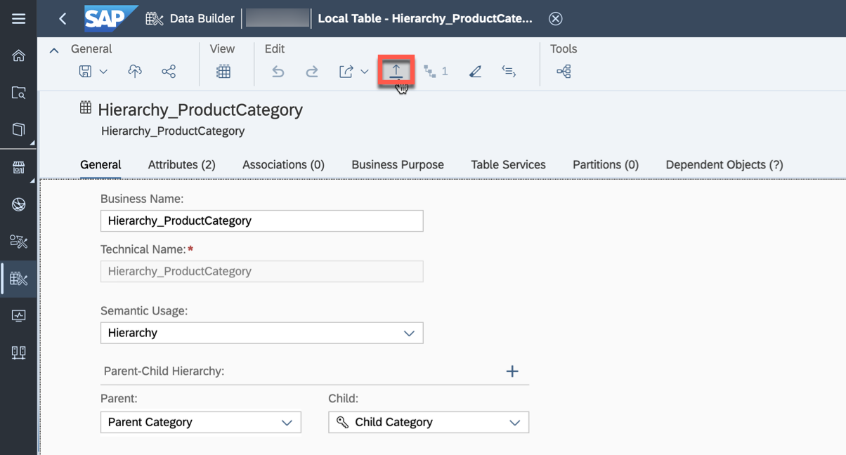

Make sure to map the columns from the CSV file to the corresponding columns in the table.

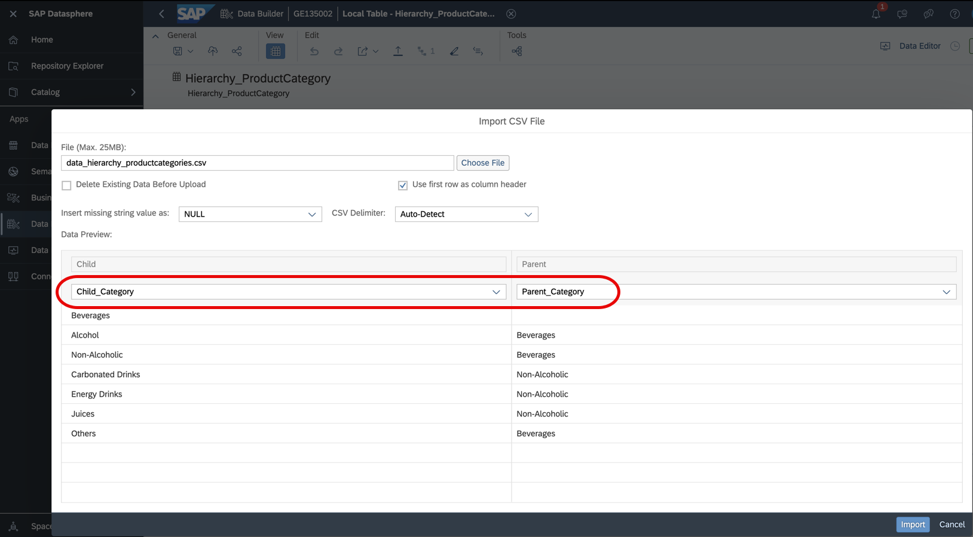

11. Verify the data in the data preview.

3 / 10

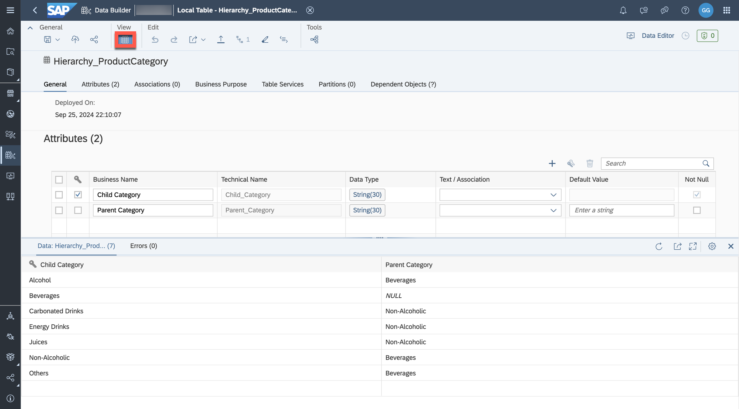

|  |  |
| --- | --- |
| README.md | 2025-04-15 |

Create a Permission Entity   
A permission entity (view or table) lists SAP Datasphere user IDs (in the form required by your identity provider) and assigns them to one or more criteria. In this example, you will define criteria for your own user so that you only see products belonging to the category or subcategories of non-alcoholic beverages. 1. Select the option ***New Table*** in the Data Builder.

2. Enter the following details:

 ***Business Name***: Permission Entity Product Category

 ***Technical Name***: PE_ProductCategory

 ***Semantic Usage***: Relational Dataset   
3. Enter the following columns:

|  |  |  |  |  |
| --- | --- | --- | --- | --- |
| **Key:** | **Business Name:** | **Technical Name:** | **Data Type:** | **Text/Association** |
| X | Record ID | Record_ID | Integer |  |
|  | User ID | User_ID | String (50) |  |
|  | Product Category | Product_Category | String (30) |  |

4. Verify your configuration.

4 / 10

README.md 2025-04-15

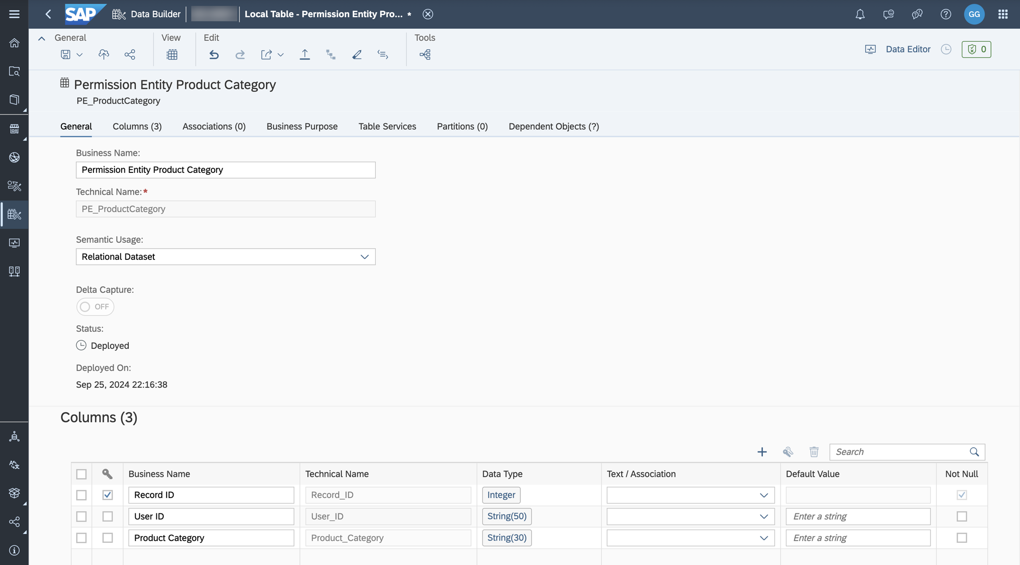

5. Save and deploy the table in the folder TECHED2024-DA180. 6. After the table is deployed, open the data editor to add records.

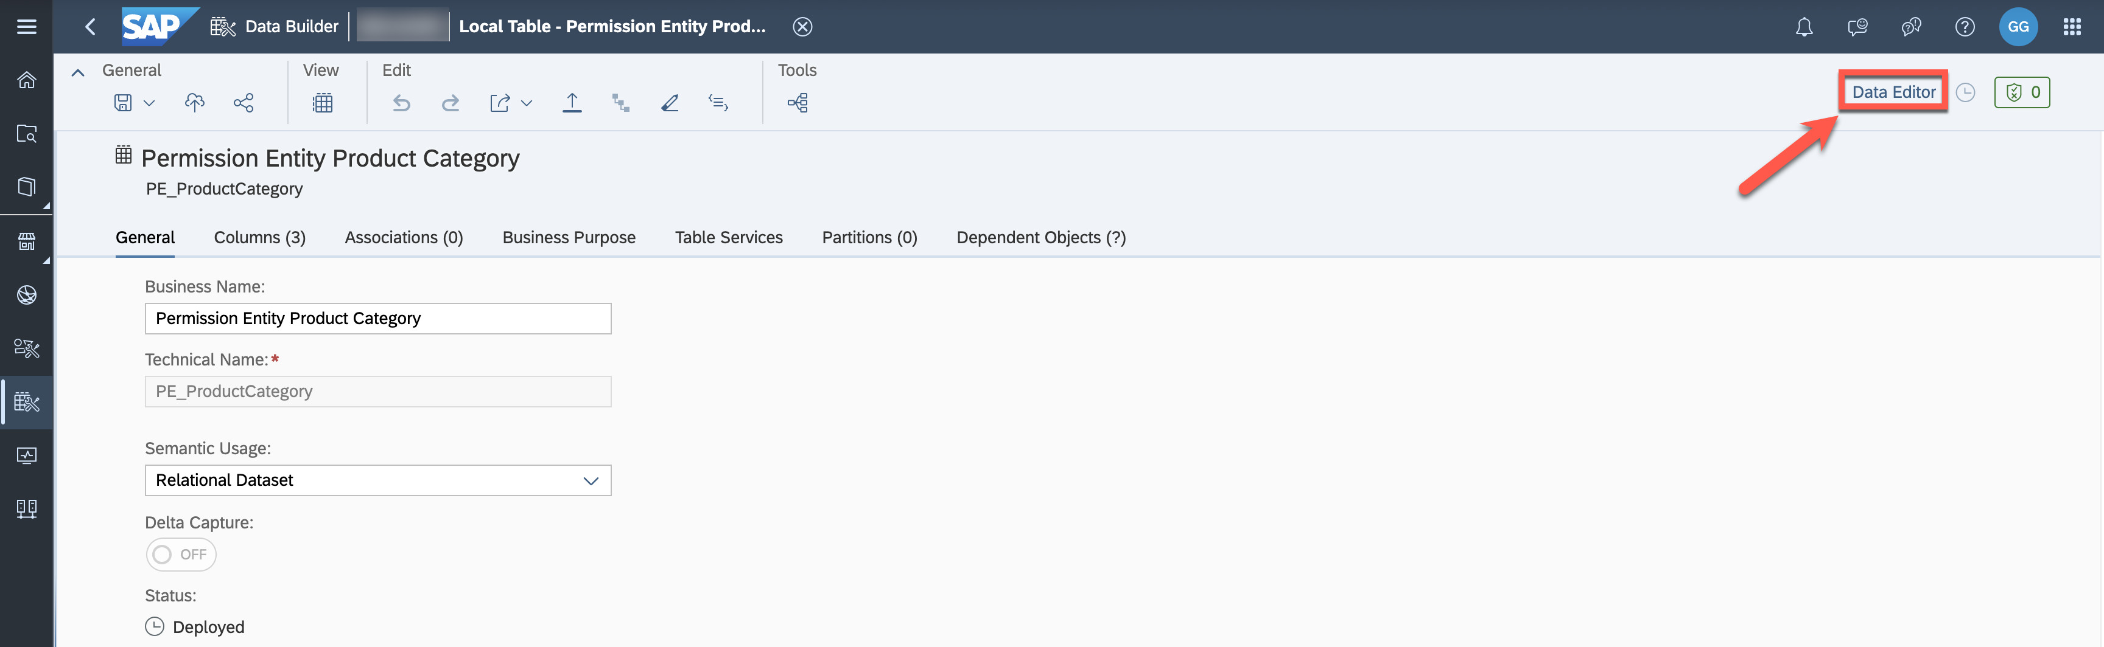

7. Add the following record to the table. Replace the first part of the email address below for the user ID with the name of your user (same as the space name). Alternatively, you can copy your email address by going to ***Profile*** in the upper-right corner and selecting ***Settings***, then ***User Account***.

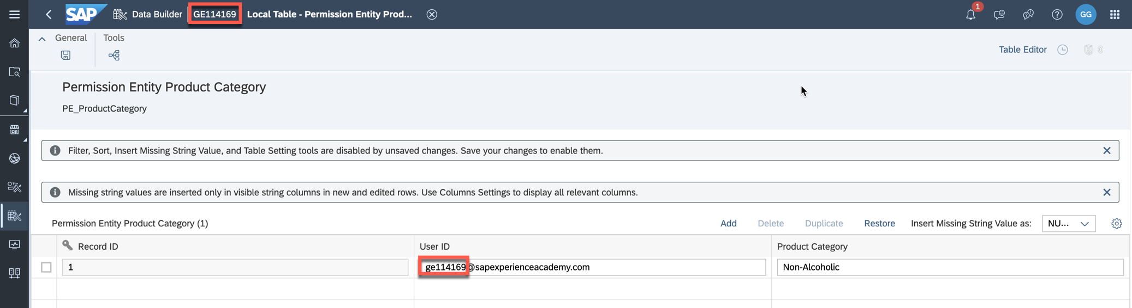

|  |  |  |
| --- | --- | --- |
| **Record ID** | **User ID** | **Product Category** |
| 1 | geXXXXXX@sapexperienceacademy.com | Non-Alcoholic |

5 / 10

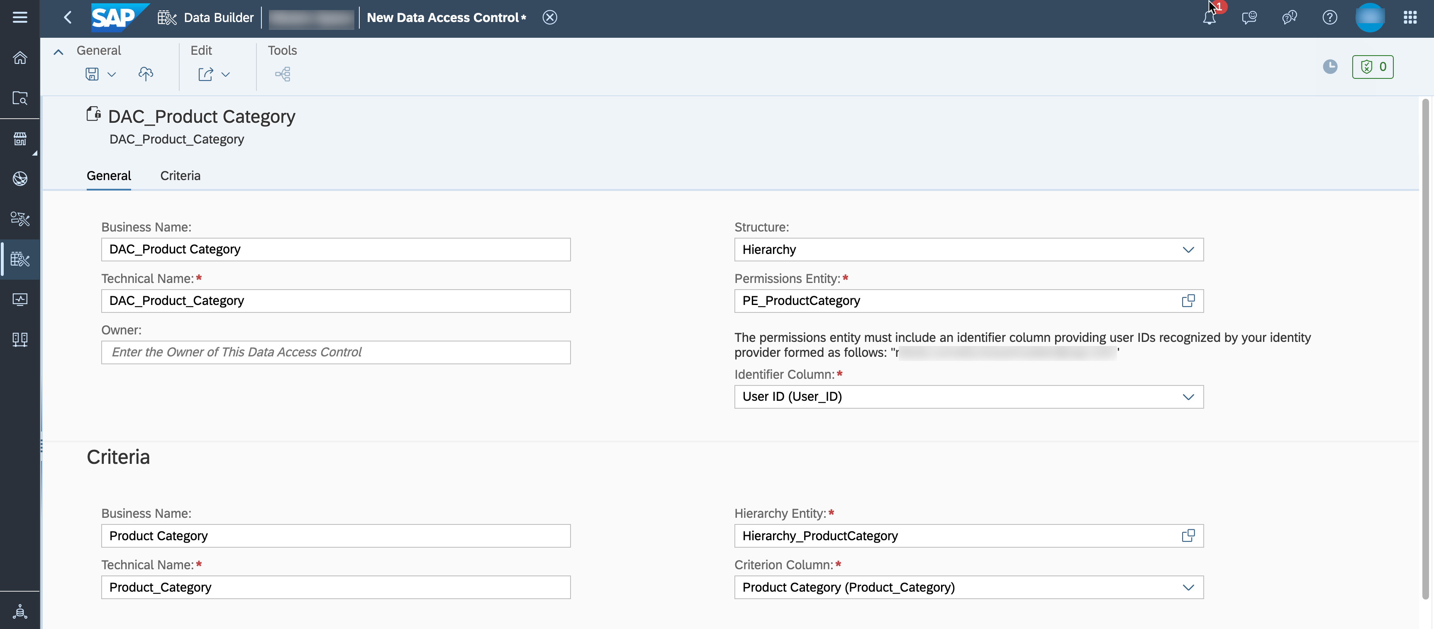

README.md 2025-04-15

8. Save the added record.

Create a Data Access Control Entity

We want to protect the data of our sales transactions based on this parent-child hierarchy. Reporting users

should only see sales for the product categories they have permissions to. Permissions will be defined for the

nodes ***Alcohol***, ***Non-Alcoholic***, and ***Others***.

1. In the side navigation area, select ***Data Builder*** and click ***New Data Access Control*** to open the editor.

2. Enter the following details in the ***General*** section and select the permission entity which you created in

the previous step:

 ***Business Name***: DAC Product Category

 ***Technical Name***: DAC_ProductCategory

 ***Structure***: Hierarchy

 ***Permission Entity***: PE_ProductCategory

 ***Identifier Column***: User ID

3. Enter the following details in the ***Criteria*** section and select the hierarchy table which you created in

the first step of this exercise:

 ***Business Name***: Product Category

 ***Technical Name***: Product_Category

 ***Hierarchy Entity***: Hierarchy_ProductCategory

 ***Criterion Column***: Product Category

4. Verify that your settings look like in the screenshot below:

5. Save and deploy your new Data Access Control entity in the folder TECHED2024-DA180.

Apply the Data Access Control Entity to a View

1. Open your previously created view ***Sales View – Fact*** (***Sales_View__Fact***).

6 / 10

README.md 2025-04-15

2. The attributes which are authorization-relevant need to be part of the fact view. Drag the table ***Product***  into the editor over the \***Sales Transactions** node. The join should be created autoamtically.

3. Set the Join Type to ***Left*** and the cardinality to Many (***Sales Transactions***) to Exactly One (***Product***). Map the columns ***Product ID***.

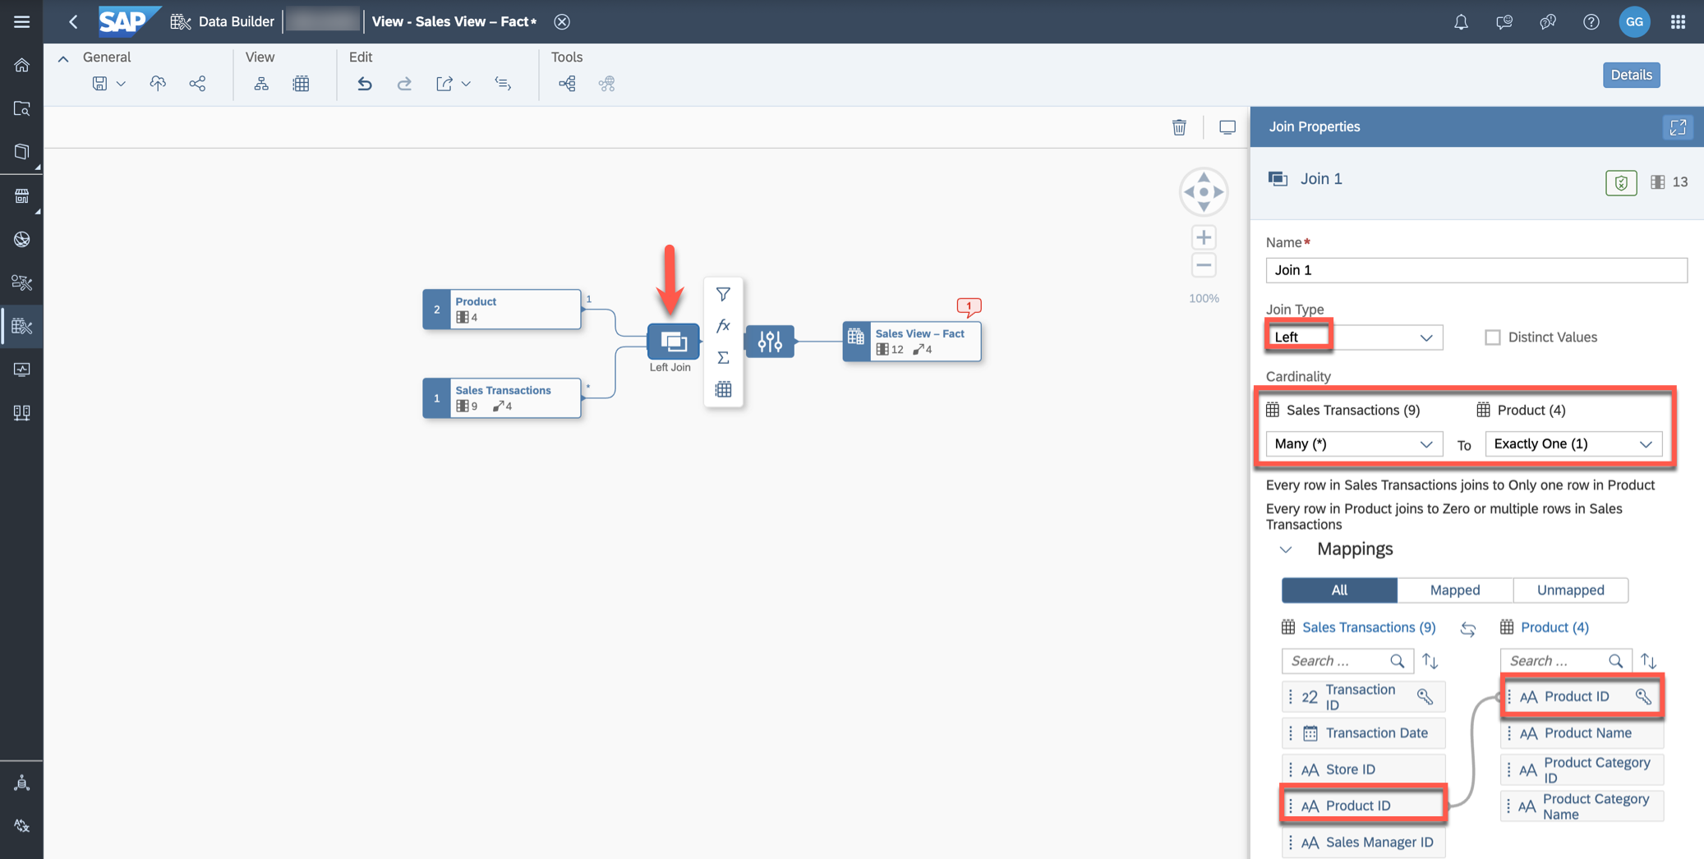

4. Open the Projection Node. The column ***Product ID*** of the table ***Sales Transactions*** is hidden while the column derived from the table ***Product*** (dimension) is visible.

We do not want to keep ***Product ID*** as a key, therefore exclude the column ***Product ID*** (Key from ***Products***) and restore ***Product ID*** (***Sales Transactions***).

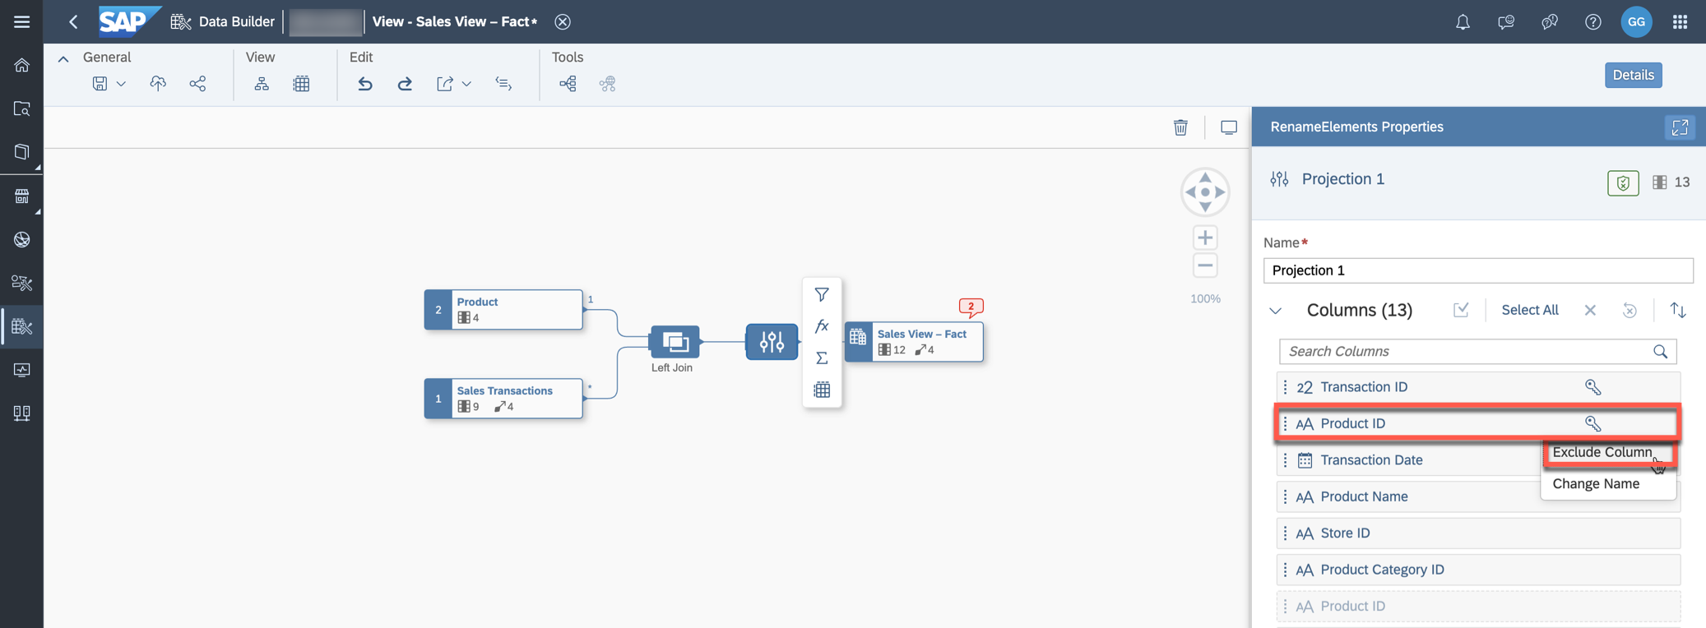

|  |
| --- |
| If you select the column in any diagram node you can trace the lineage back to the source. |

5. Open the node ***Sales View – Fact***. Go to the association which points to the dimension ***Product*** and redo the mapping (***Product ID*** to ***Product ID***) as this got lost because of the join introduced above.

7 / 10

README.md 2025-04-15

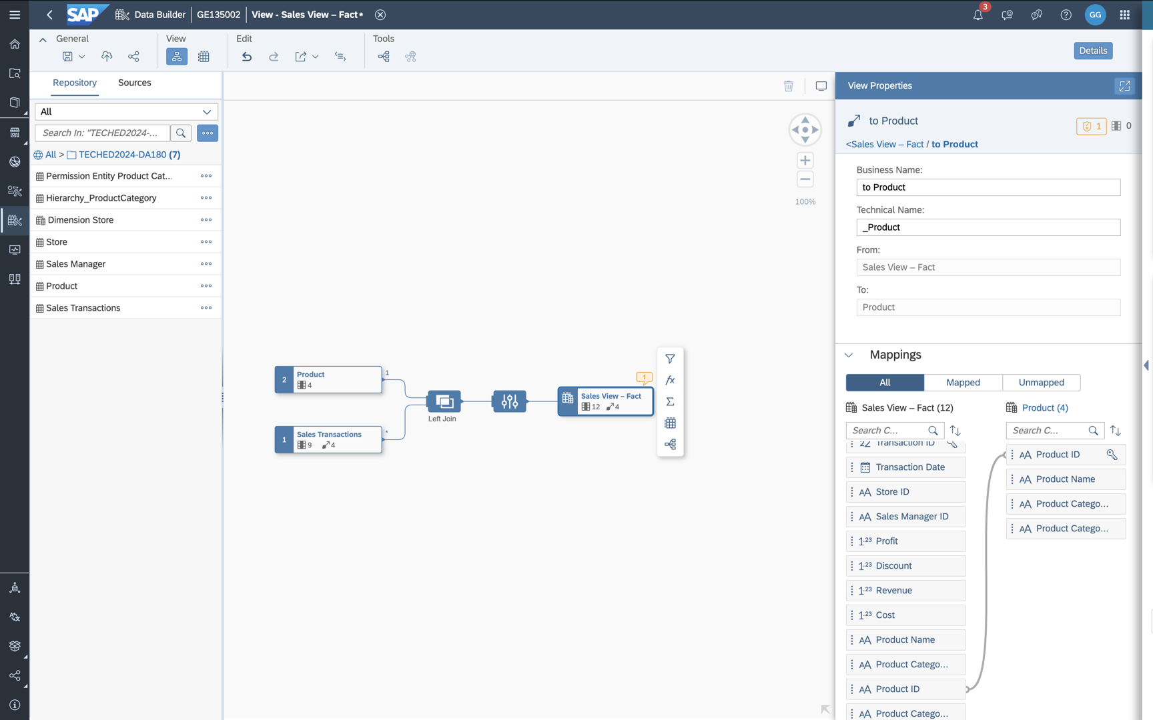

6. In the model properties, add a new Data Access Control.

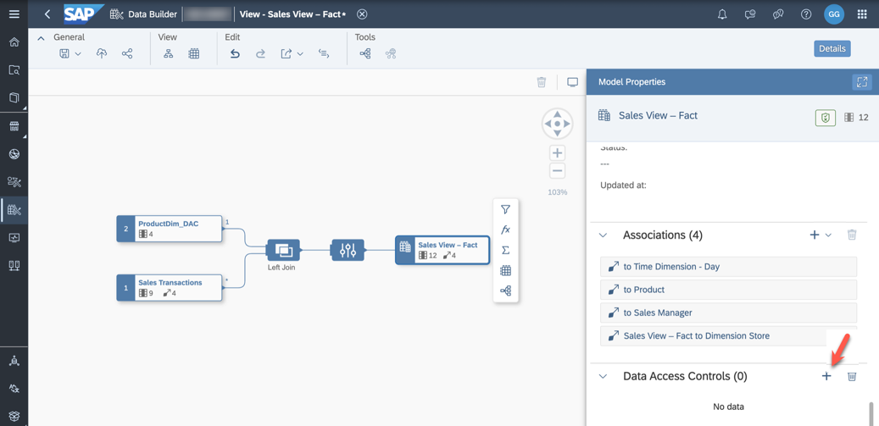

7. Select the previously created DAC ***DAC_ProductCategory*** (single click).

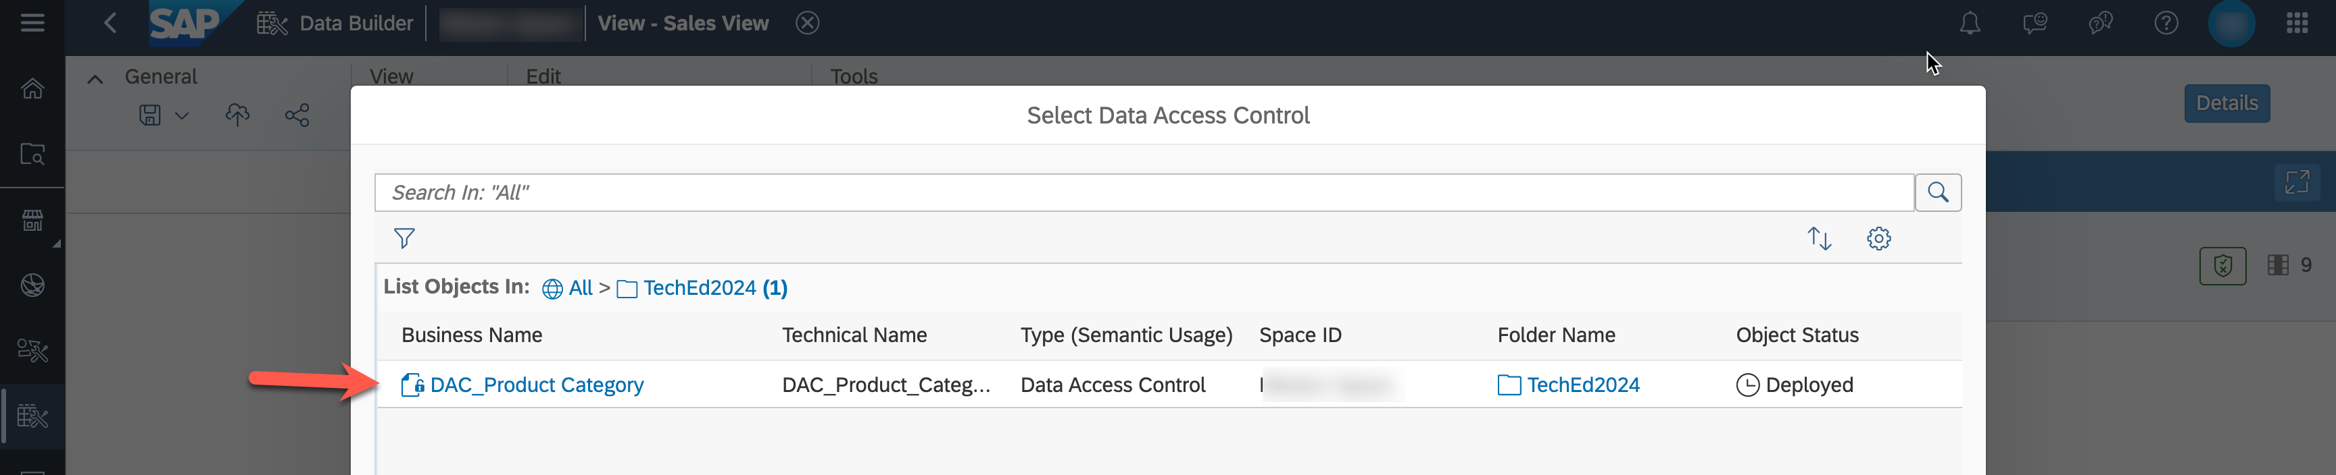

8. Map the two columns named ***Product Category Name*** (enter "Name" in the ***Search*** field). When you move your cursor over the columns, the complete name is displayed as tooltip.

8 / 10

README.md 2025-04-15

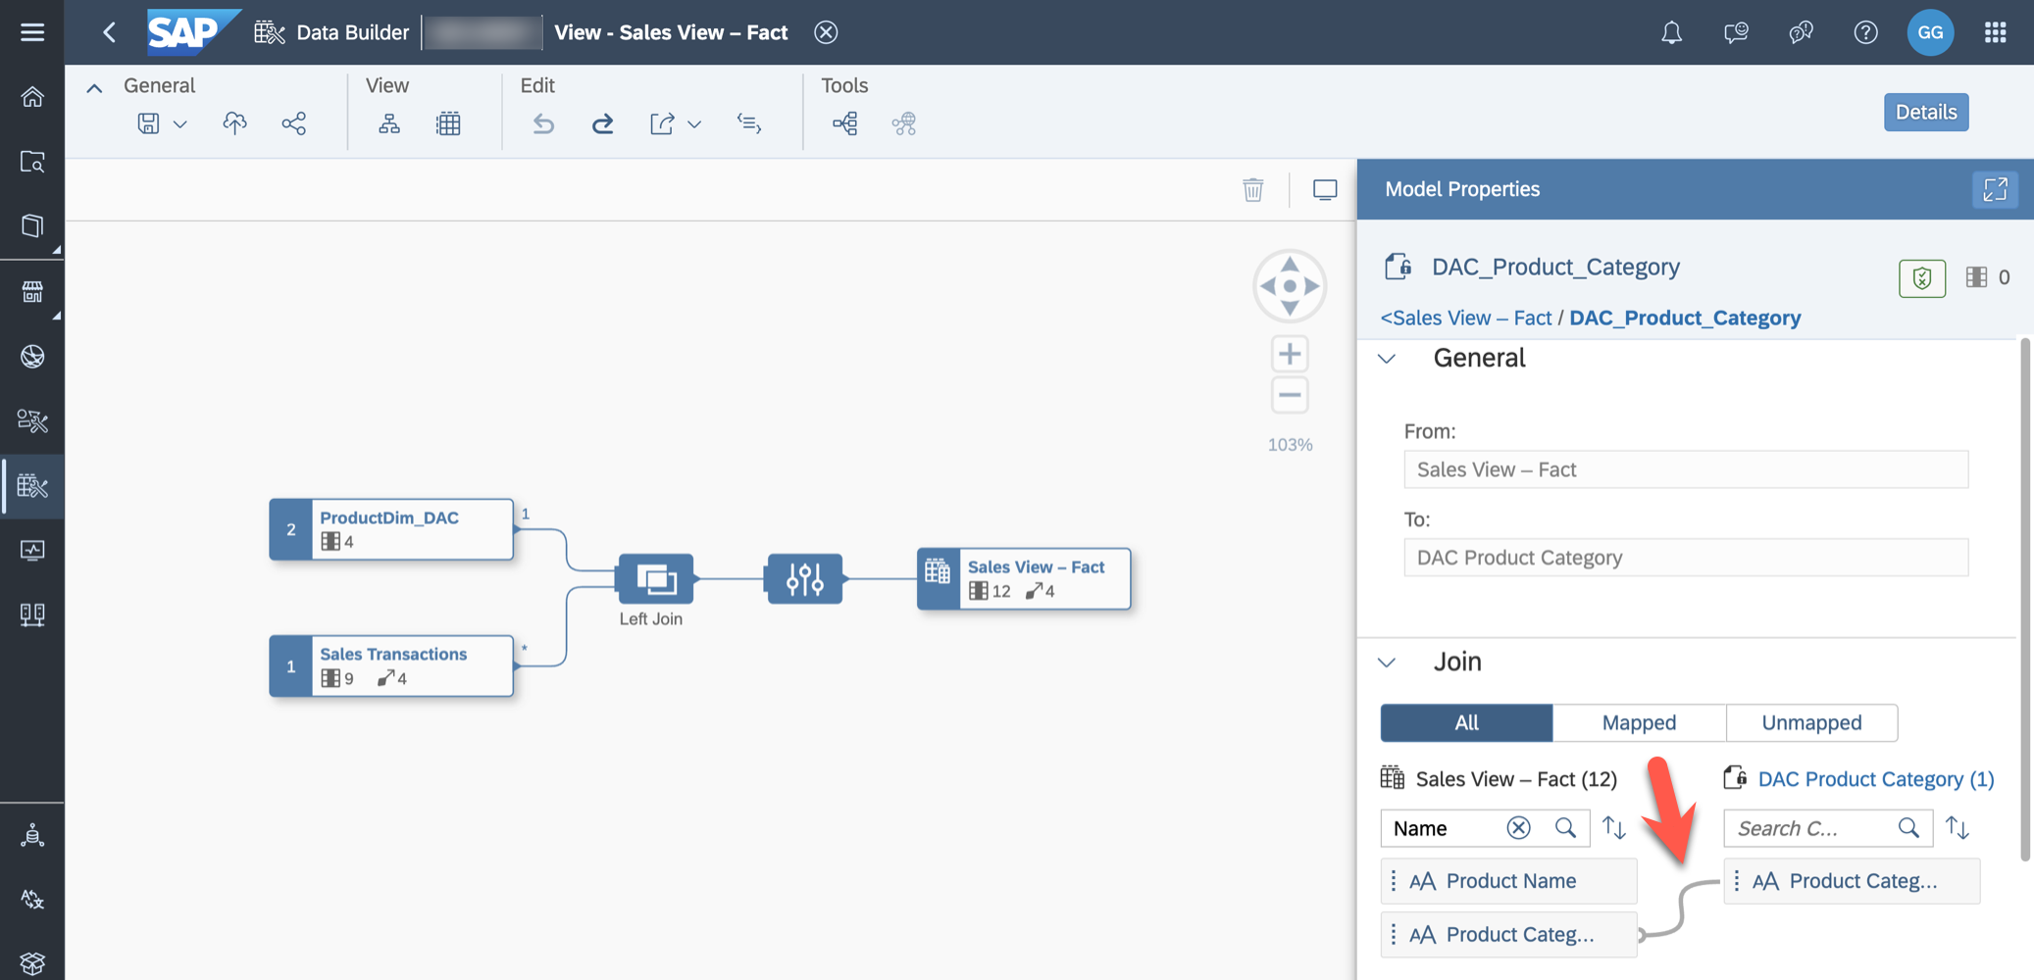

9. Set the Alias of the node ***Product*** to ***ProductDim_DAC***.

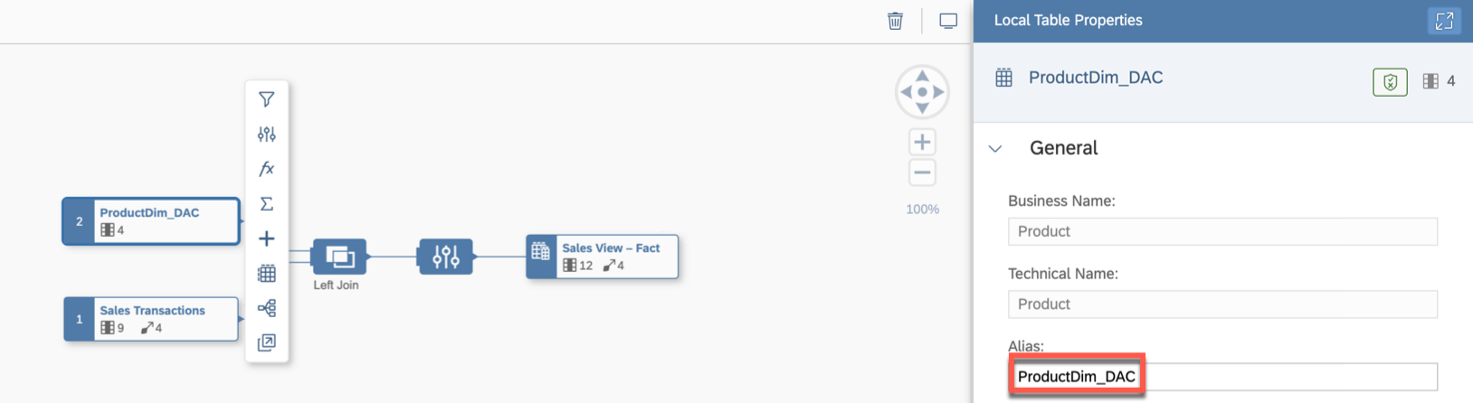

10. Save and deploy the view ***Sales_View - Fact***. If you see the validation message warning that an association has been changed, click ***Deploy Anyway***.

11. Open the data preview for the node ***Sales View – Fact*** and validate that you can only see sales for non- alcoholic data products.

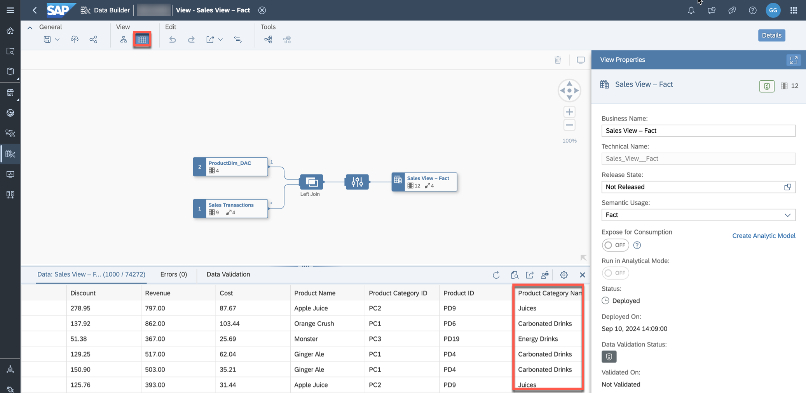

9 / 10

README.md 2025-04-15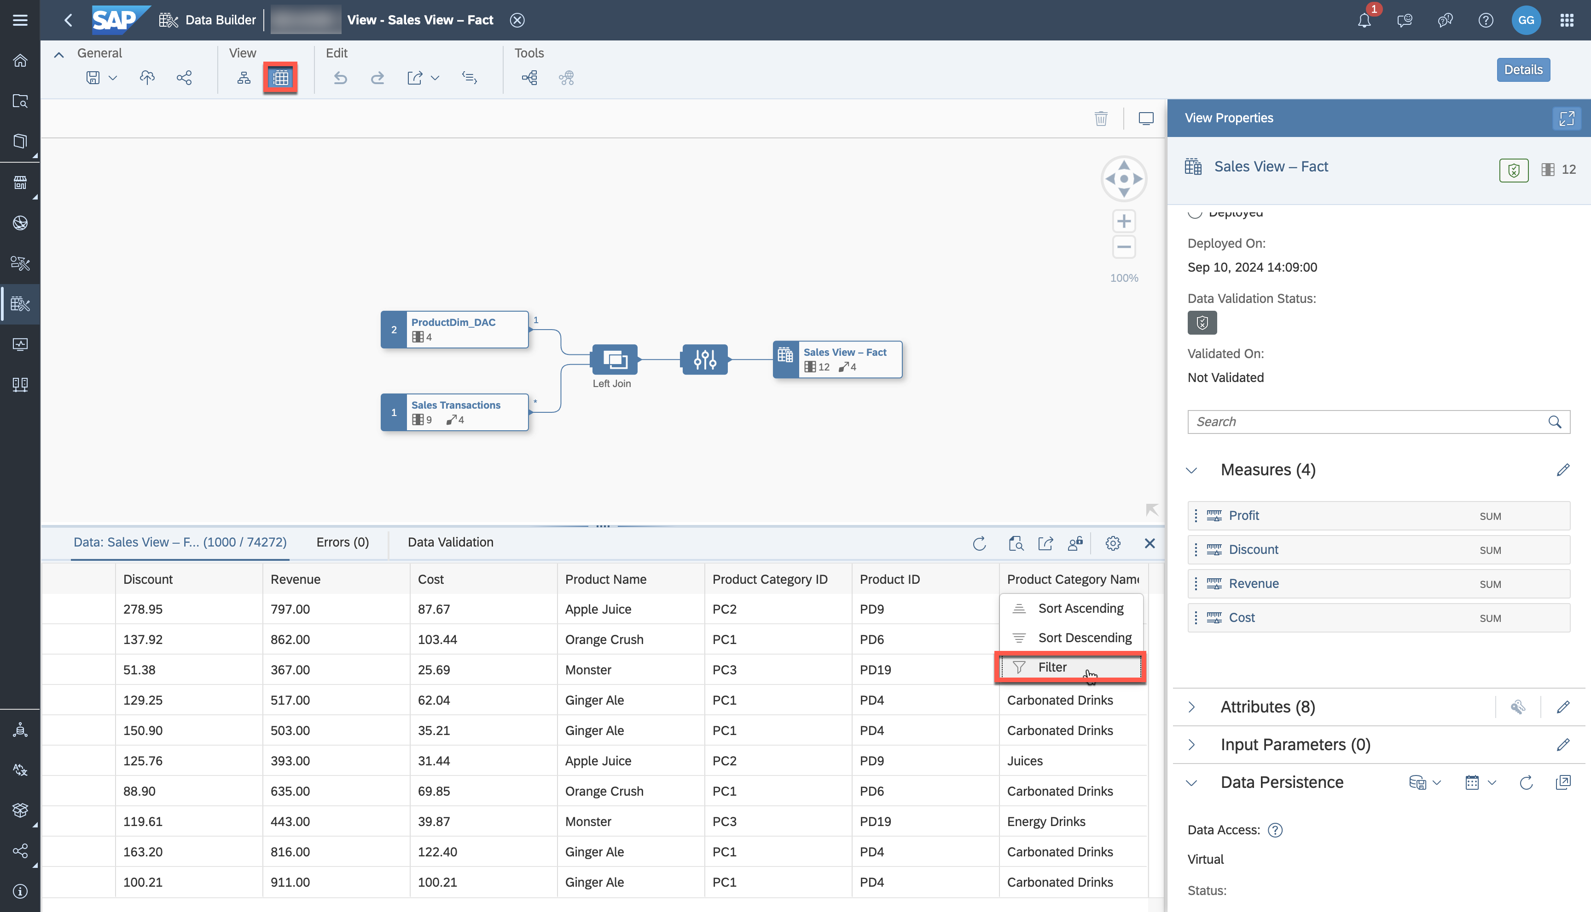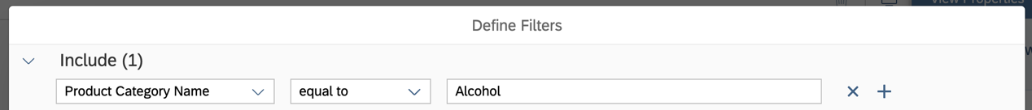

12. Add a filter for ***Product Category Name***.

13. Filter on records which contain values equal to ***Alcohol***. This search should not display any value.

|  |  |  |
| --- | --- | --- |
|  | **Important:** |  |

|  |
| --- |
| Please note that you will now only see a limited number of records due to the assigned data |

|  |
| --- |
| access control. You can modify the data record in the permission table ***PE_ProductCategory*** and |

|  |
| --- |
| replace the value in the column ***Product Category*** (Non-Alcoholic) with ***Beverages*** to see all |

|  |
| --- |
| records again when working through other exercises. |

14. You can open the previously created reports in SAP Analytics Cloud. You will only see the records that

your user is authorized to access.

Summary

You've now protected the transactional records of the fact view with a Data Access Control based on product

categories. If you want to recreate authorizations from the source system, you can import analysis

authorizations from SAP BW and SAP BW/4HANA.

You can continue with one of the optional exercises:

|  |  |
| --- | --- |
|  | Exercise 20: Identify Top-Performing Sales Managers with Just Ask Exercise 22: Explore the Analytic Model  Exercise 23: Create a Transformation Flow |

10 / 10

README.md 2025-04-15

Exercise 22 - Explore the Analytic Model

|  |  |  |  |
| --- | --- | --- | --- |
|  | | |  | | --- | | **Note:** This is an OPTIONAL exercise. | |
|  | Detour: SAP Datasphere - Analytic Model | |

Analytic models form the analytical foundation for preparing data for consumption in SAP Analytics Cloud. They enable the creation and definition of multi-dimensional models, providing data for analytical purposes to answer various business questions. Predefined measures, hierarchies, filters, parameters, and associations offer flexible and straightforward navigation through the underlying data.

In this exercise, you will learn how to use the data preview of the Analytic Model and create different types of new measures to enhance the existing model.

End of Detour

Start of the exercise

1. Log On to your SAP Datasphere tenant.

2. Select the menu option Data Builder on the left-hand side.

3. Open the previously created Analytic Model ***Sales - Analytic Model***.

4. To get an overview of the data model as a reminder, open the ***Impact and Lineage Analysis***.

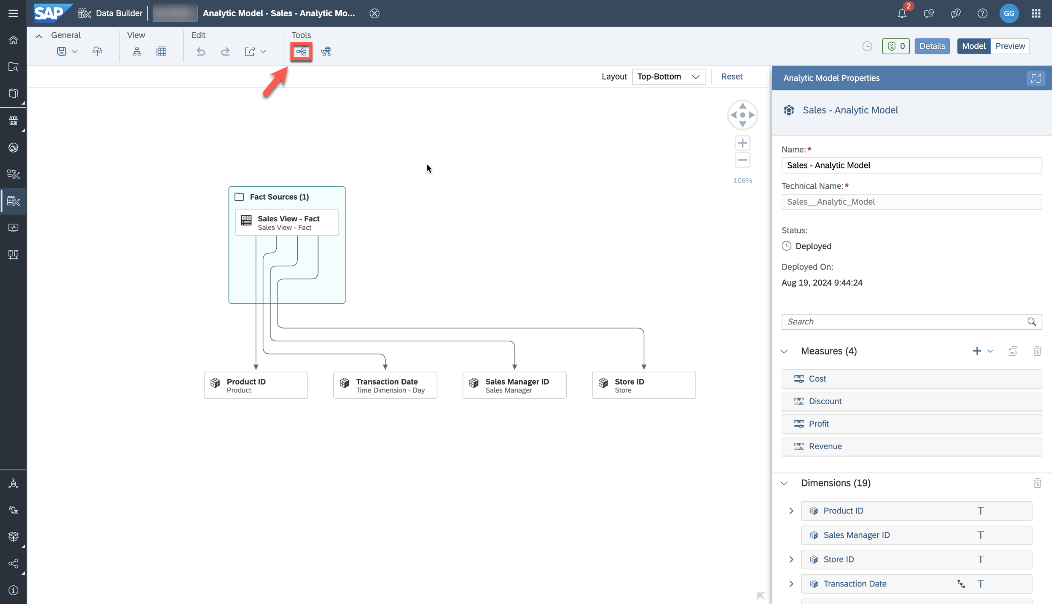

5. The ***Data Analysis*** diagram helps you understand the lineage of the Analytic Model.

1 / 6

README.md 2025-04-15

This view focuses on data movements and transformations, showing the flow from the local table containing sales transactions to the view and the Analytic Model.

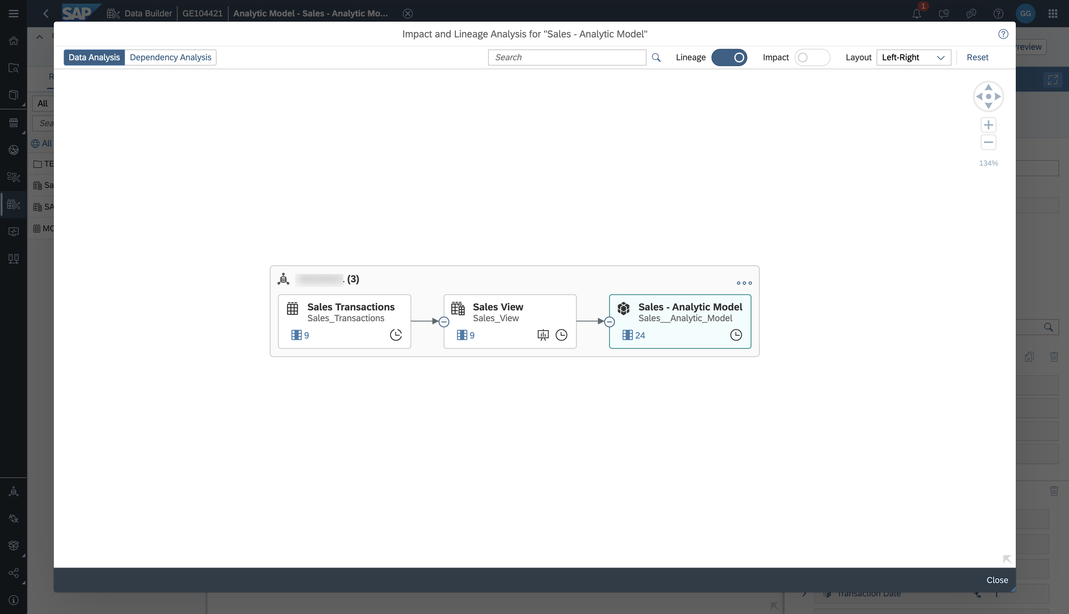

6. Switch to the ***Dependency Analysis*** diagram to display objects connected through associations (and data access controls, if defined). Here, you can view the lineage of the associations, such as the time dimension.

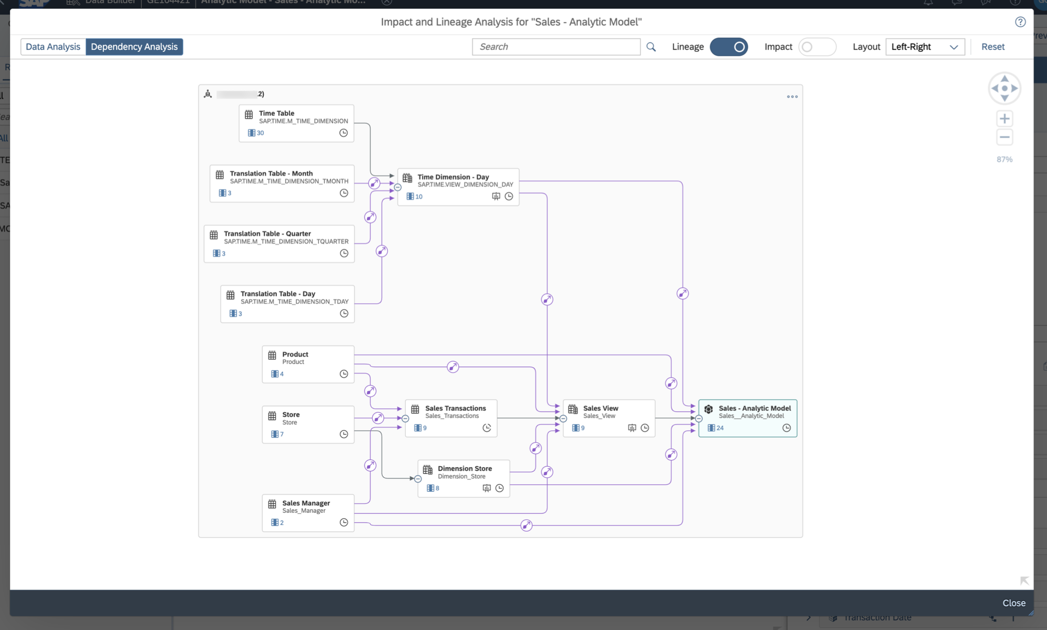

7. In addition to the lineage and impact of objects, you can analyze columns of tables, graphical and SQL views and Analytic Models. Click the columns icon on the Analytic Model to open the list of columns, select ***Store City*** and click ***Select***.

2 / 6

README.md 2025-04-15

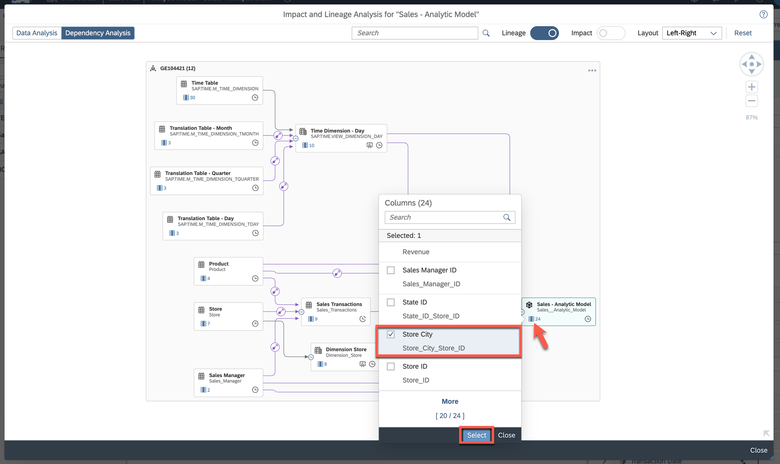

8. The diagram refreshes to show the lineage of the selected column under the analyzed object.

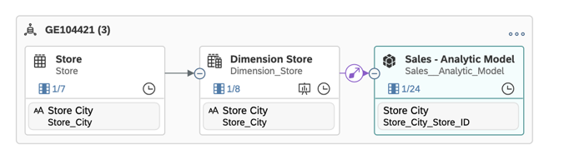

9. Select ***Close*** to return to the Analytic Model editor.

10. Create a new ***Restricted Measure***. Restricted measures are based on existing measures but apply flexible filter expressions. They can use static filters (as done in this exercise) or refer to dimension attributes or variables.

3 / 6

README.md 2025-04-15

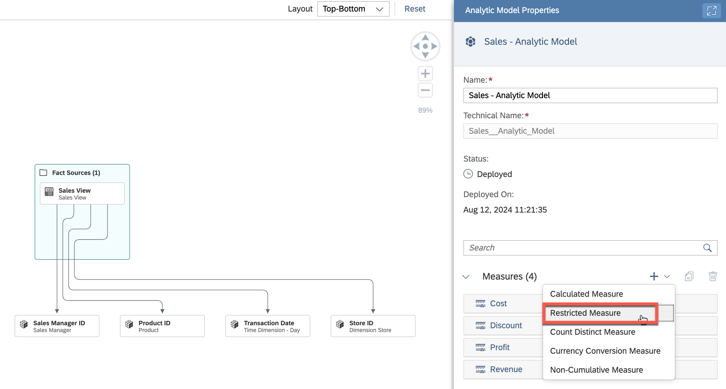

11. We define a restricted measure to analyze the profit generated by the sales managers, specifically focusing on Janet Bury.

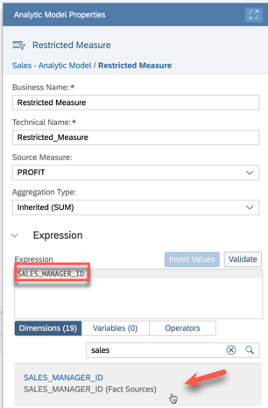

12. In the ***Expression*** editor, add ***=*** after SALES_MANAGER_ID. Click ***Insert Values*** and select Janet Bury (ID SM1).

4 / 6

README.md 2025-04-15

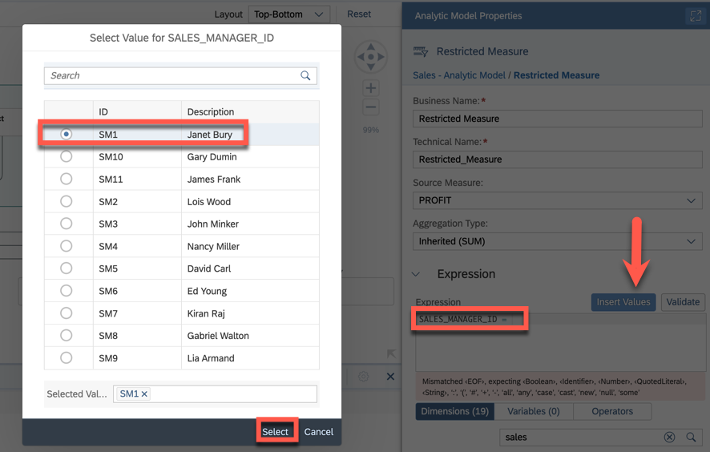

13. Change the Business Name and the Technical Name to ***Profit-JanetBury***.

14. Open the ***Preview*** in the upper-right corner. This is an analytical preview that allows you to navigate through various dimensions and view the aggregated data. It provides a glimpse of how the data will appear in an SAP Analytics Cloud story.

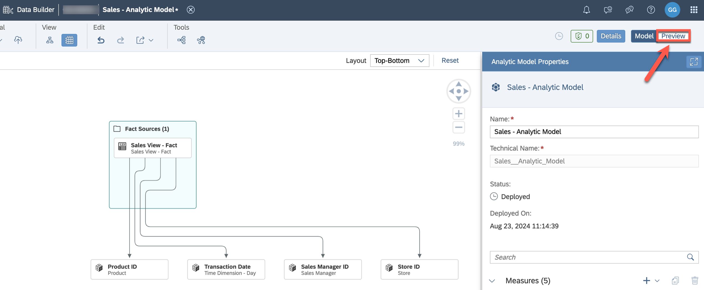

15. Open the Builder on the right side and select the measures ***Profit*** and ***Profit-JanetBury***, as well as ***Product Category ID*** in the ***Dimensions*** section. The two measures allow you to compare the profit generated by Janet with the overall profit.

5 / 6

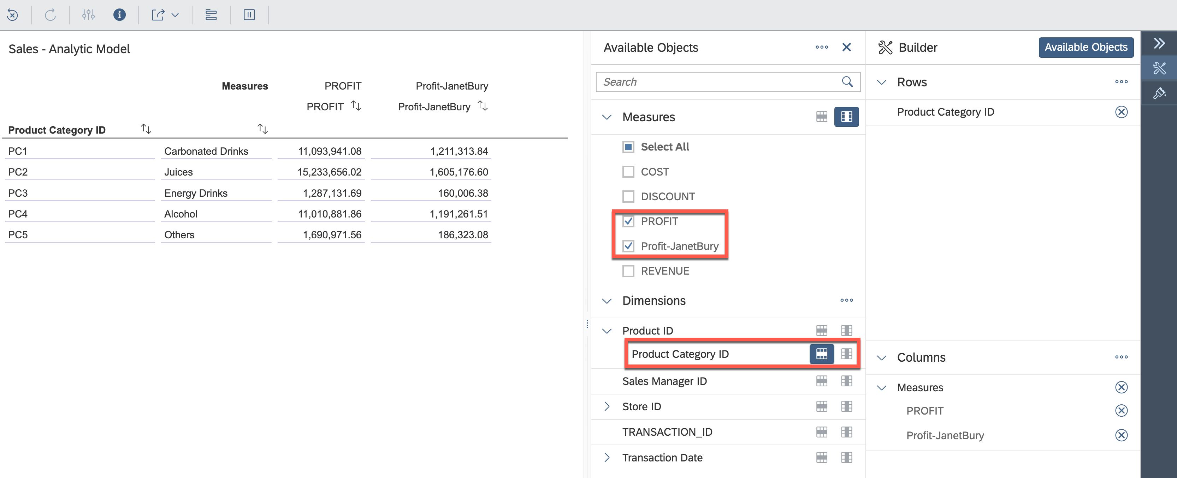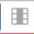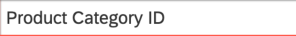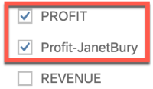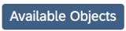

|  |  |
| --- | --- |
| README.md | 2025-04-15 |

16. Return to the Analytic Model editor by selecting ***Model*** in the upper right corner.

17. Save and deploy the model.

Summary

You have now explored more of the various features of the Analytic Model.

You can continue with one of the *optional* exercises:

|  |  |
| --- | --- |
|  | Exercise 20: Identify Top-Performing Sales Managers with Just Ask Exercise 21: Create Row-Level Permissions based on External Hierarchy Exercise 23: Create a Transformation Flow |

6 / 6

README.md 2025-04-15

Exercise 23 - Create a Transformation Flow

|  |  |  |  |
| --- | --- | --- | --- |
|  | | |  | | --- | | **Note:** This is an OPTIONAL exercise. | |
|  | Detour: SAP Datasphere - Transformation Flows | |

Transformation Flows load data from one or more sources and persist the result in a target table. This integration entity can detect delta changes when reading data from a local table which is enabled for delta. Transformation Flows are also useful in scenarios when utilizing Replication Flows for Premium Outbound Integration: Replication Flows can access local tables (delta enabled) which are updated by a transformation flow and transfer the data records in a delta mode.

 Detour: SAP Analytics Cloud - Replace Model in Stories

You can replace a model in your SAP Analytics Cloud story with another compatible model, for example an SAP Datasphere Analytic Model with a different Analytic Model. You don't have to recreate your full story if you want to replace the data source (model) with a compatible one. While some features may need to be recreated, the structure and formatting of your dashboard won't be affected.

End of Detour

Start of the exercise

In this exercise, we will access a shared local table which is delta enabled for sales transactions. New sales transactions are generated in a source system and transferred to SAP Datasphere using a Replication Flow in a central admin space of the tenant. Assume that the store ID includes an additional prefix ***US*** which we need to remove so that we can map the store ID to the dimensions available in the view dimensions.

We will create a new Analytic Model which accesses the regularly updated data and use the replace model feature in SAC to have a second story accessing the new Analytic Model. This functionality is beneficial for development activities when you need to transition from one data model to another. Initially, we utilized CSV files, but now we are looking to map the data to a new data source for the sales transactions.

1. Log On to your SAP Datasphere tenant.

2. Select the menu option ***Data Builder*** on the left-hand side.

3. Click ***New Transformation Flow***.

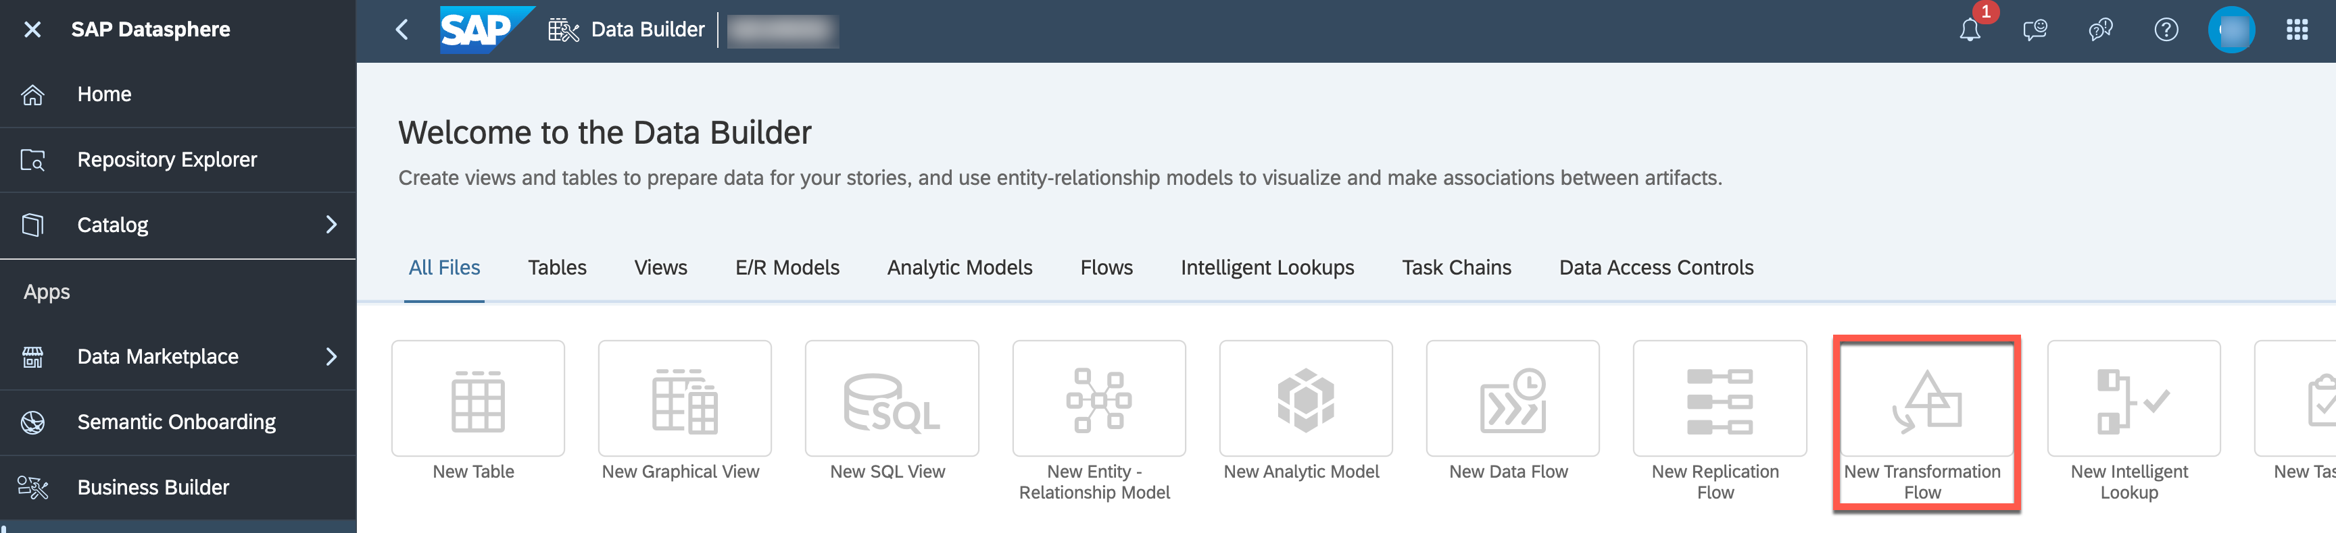

1 / 16

README.md 2025-04-15

4. You see the Transformation Flow editor with options to define view transformation and create a new table.

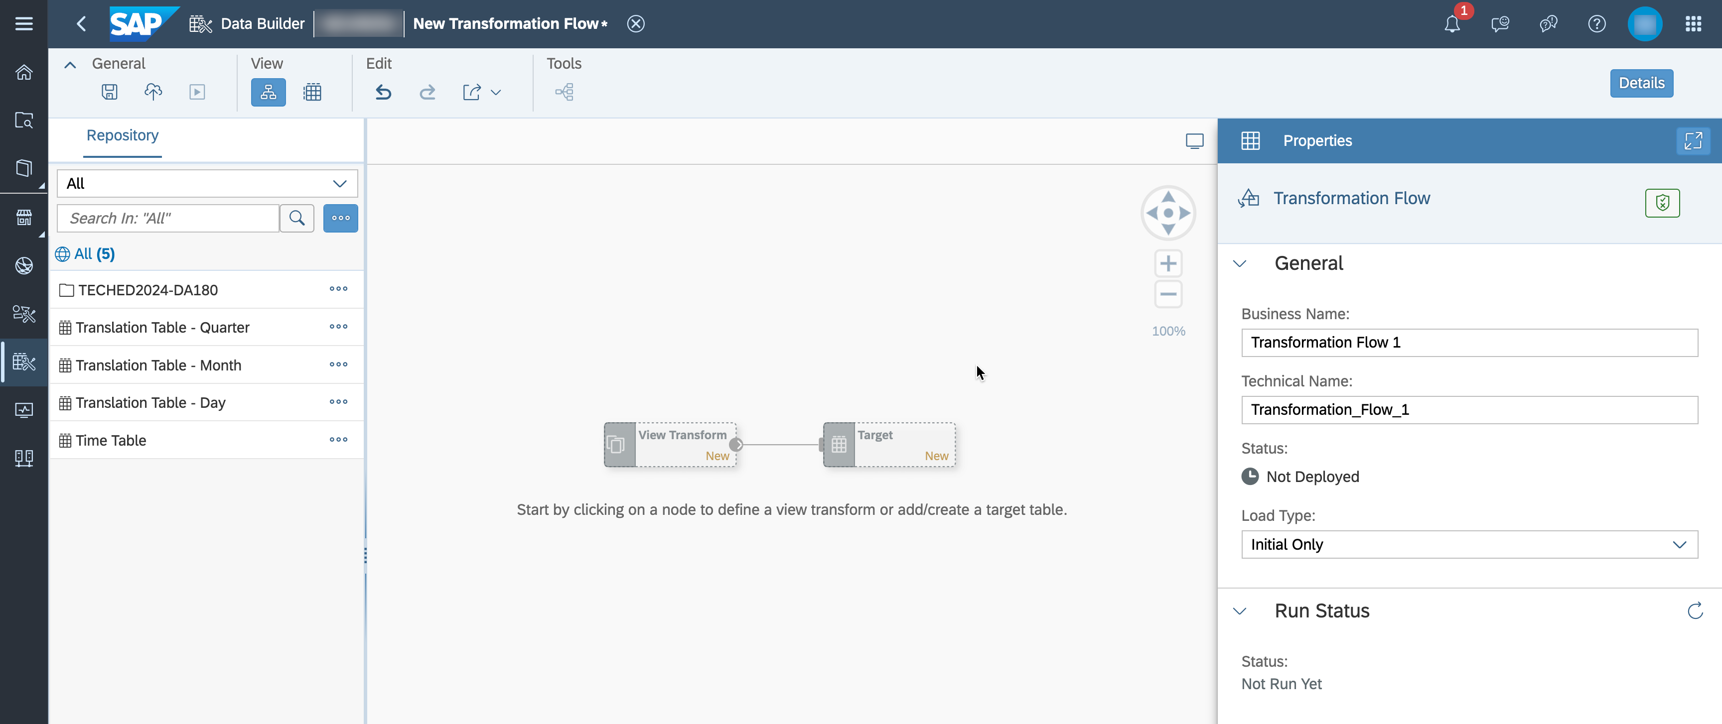

5. Click on the ***View Transform*** node and select the ***Graphical View Transform*** option.

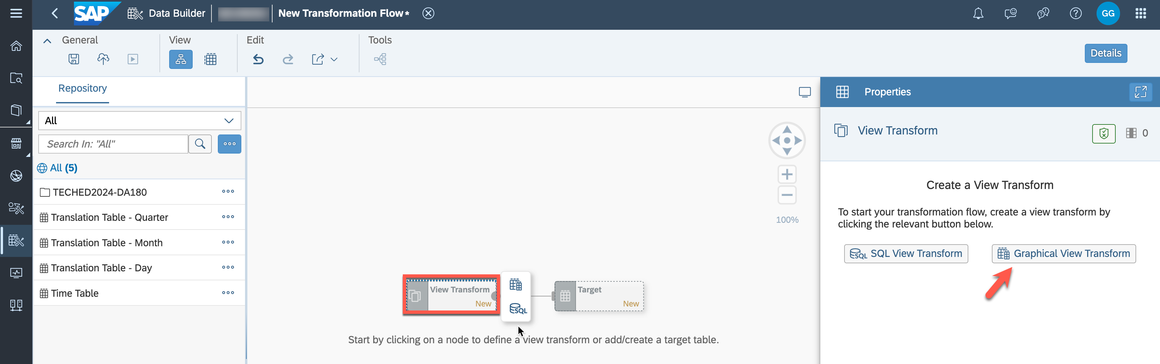

6. Drag and drop the table ***TECHED2024_SALES_TRANSACTIONS*** into the editor. The details on the right-hand side display that this shared table is capturing delta. (If you don't see this table, ensure that you are in the ***Graphical View Editor***.)

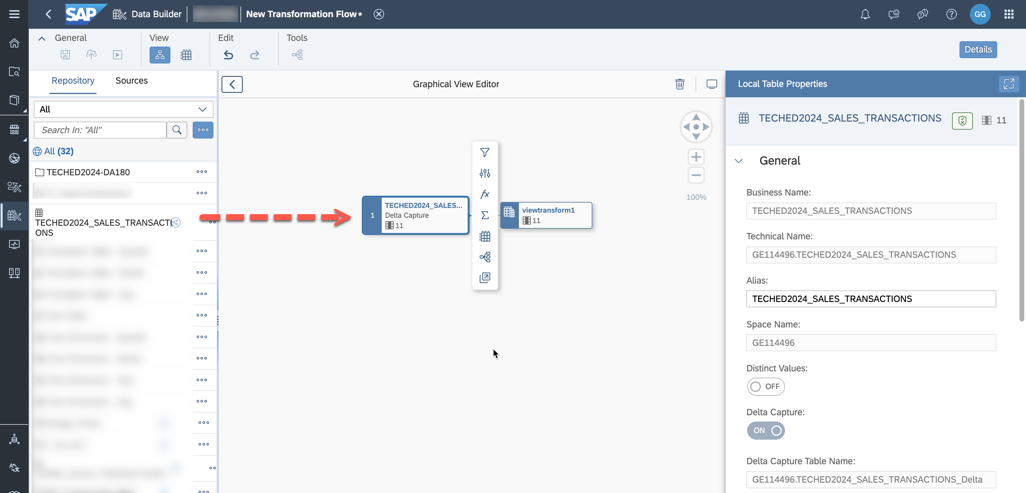

7. If you scroll down, ensure that ***Load from Table*** is set to ***Delta Capture***. As the delta capture setting is enabled for the source table, the columns ***Change Date*** and ***Change Type*** are automatically mapped

2 / 16

README.md 2025-04-15

to these columns in the target table. Mapping these columns (or a calculated column that contains the content of these columns) to any other target column is not permitted.

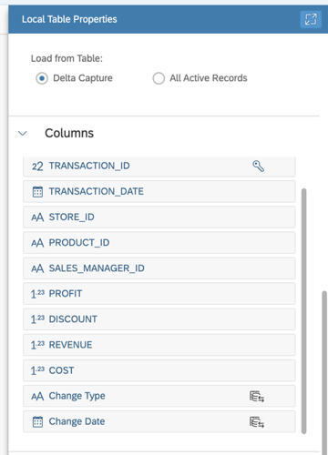

8. Add a new node for ***Calculated Columns***. Choose the existing column ***STORE_ID*** and enter the expression ***SUBSTR_AFTER(STORE_ID,'US')*** as we will exclude the prefix of the STORE_ID so that it can be mapped to the dimension IDs. Adjust the length to 6 characters.

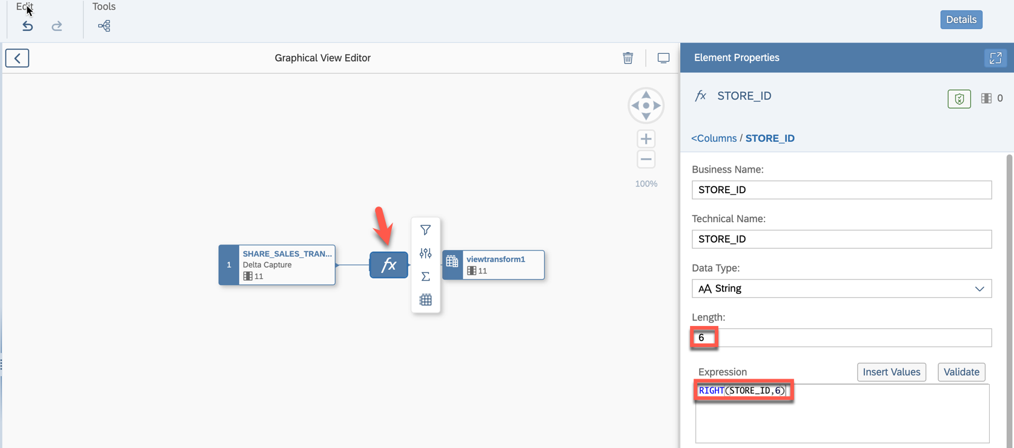

3 / 16

README.md 2025-04-15

9. Exit the graphical view editor and go back to the transformation flow overview.

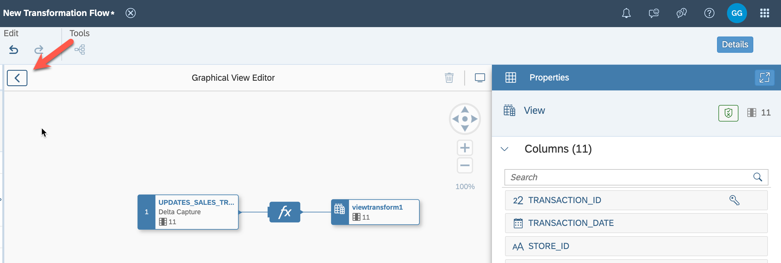

10. Click on ***Create New Target Table***.

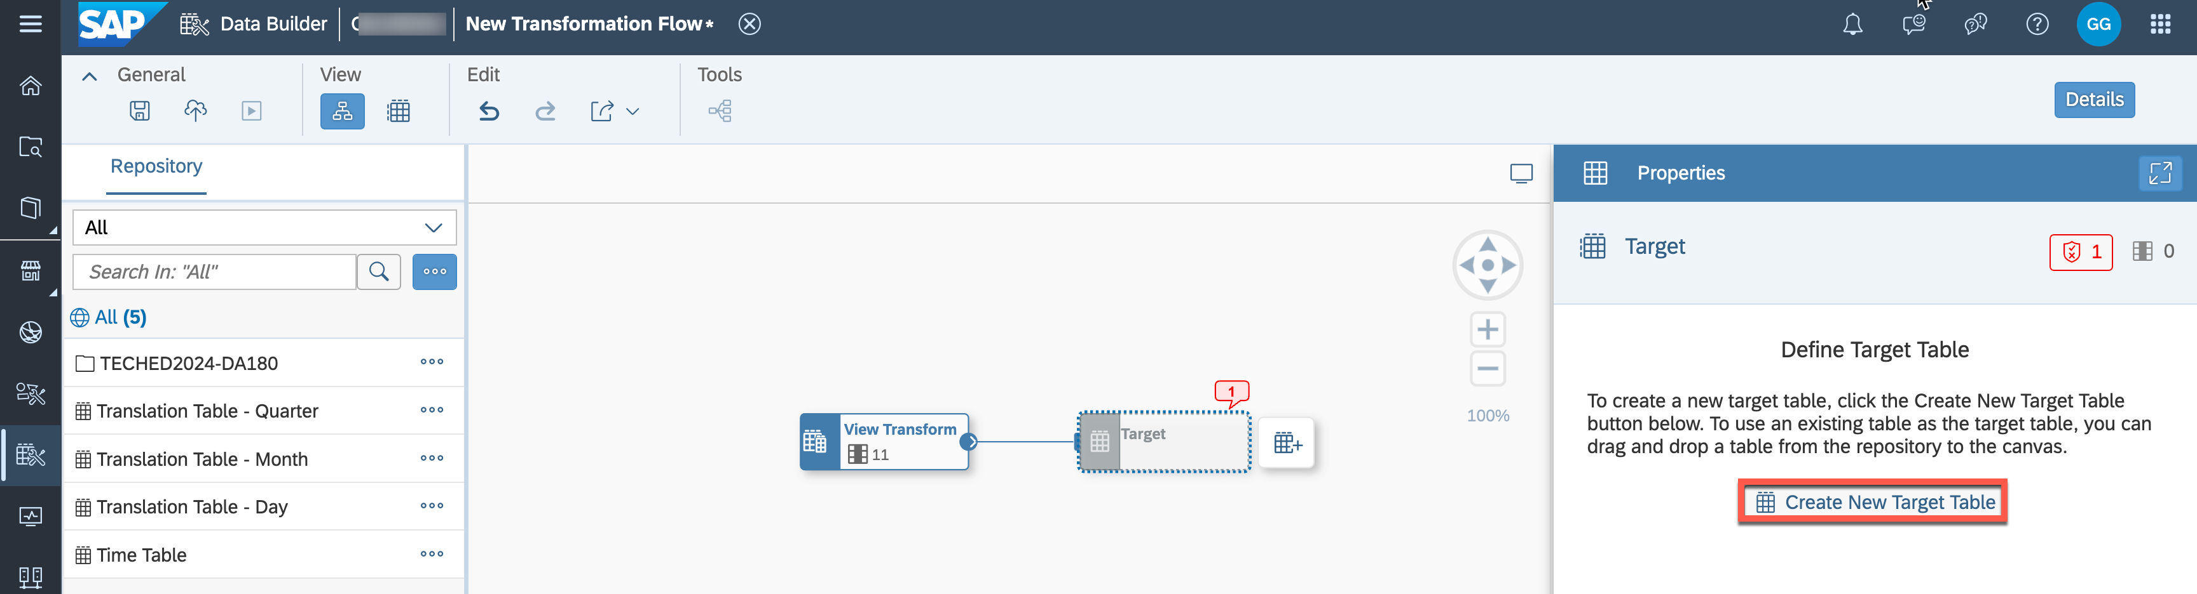

11. Set the business name to ***TRANSFORMED_TECHED2024_SALES_TRANSACTIONS***. Verify that ***Delta***  ***Capture*** is turned on.

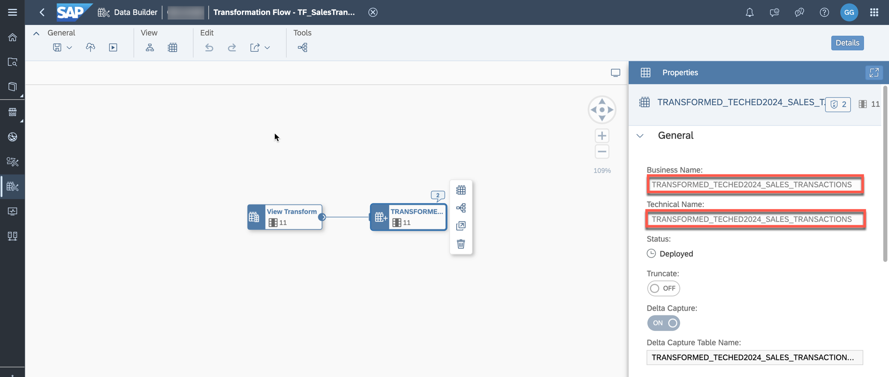

12. Deselect the target table by clicking somewhere else in the editor field. The properties for the Transformation Flow will appear on the right-hand side. Set the business name to

4 / 16

README.md 2025-04-15

***TF_SalesTransactions*** and the Load Type to ***Initial and Delta***.

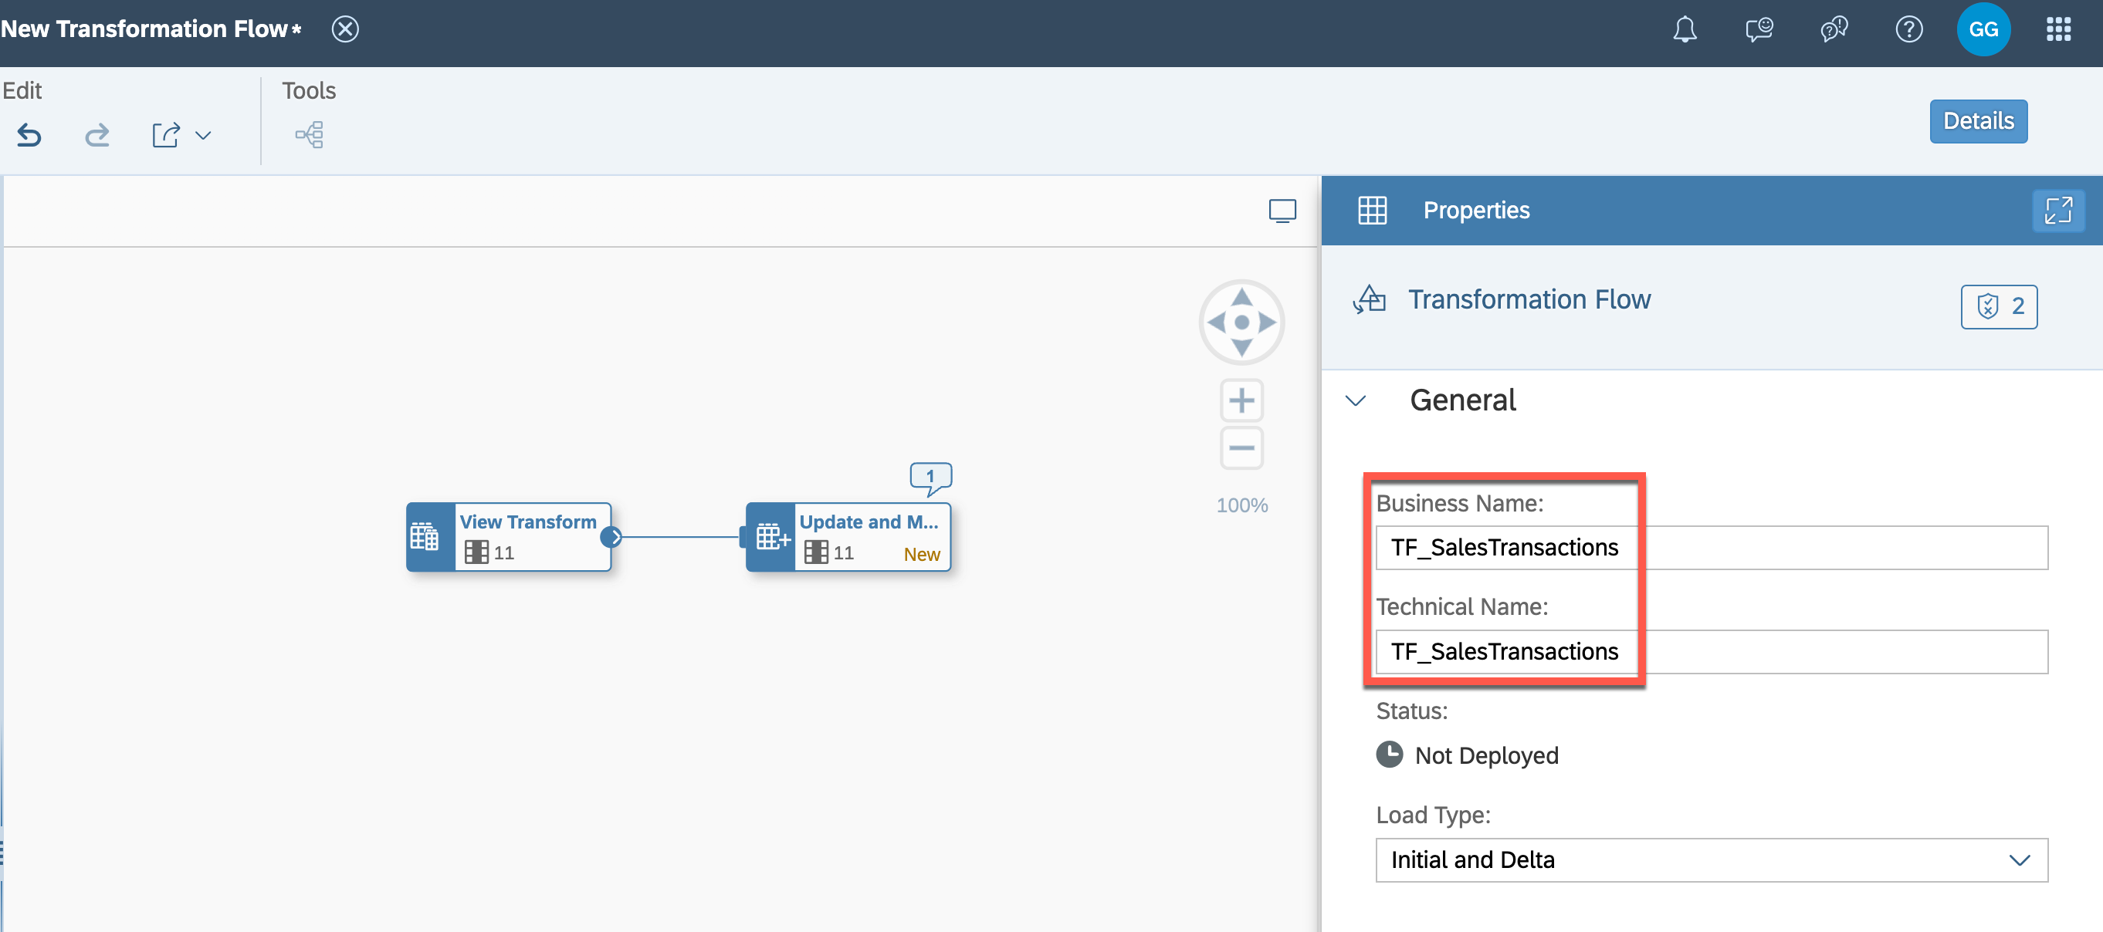

13. Save and deploy the Transformation Flow in the folder TECHED2024-DA180, afterward click on ***Run***.

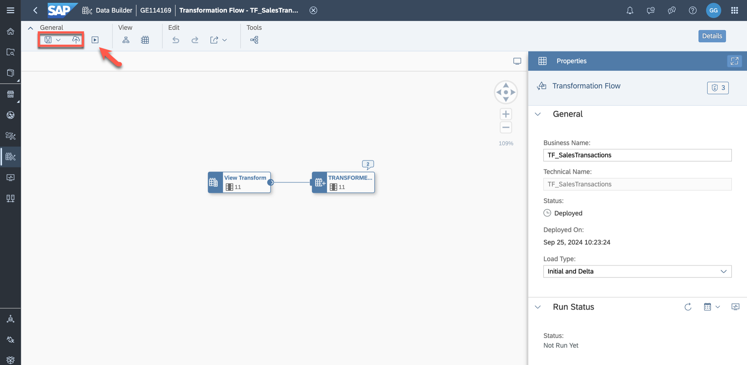

5 / 16

README.md 2025-04-15

14. Open the Data Integration Monitor to have a look at the Transformation Flow run.

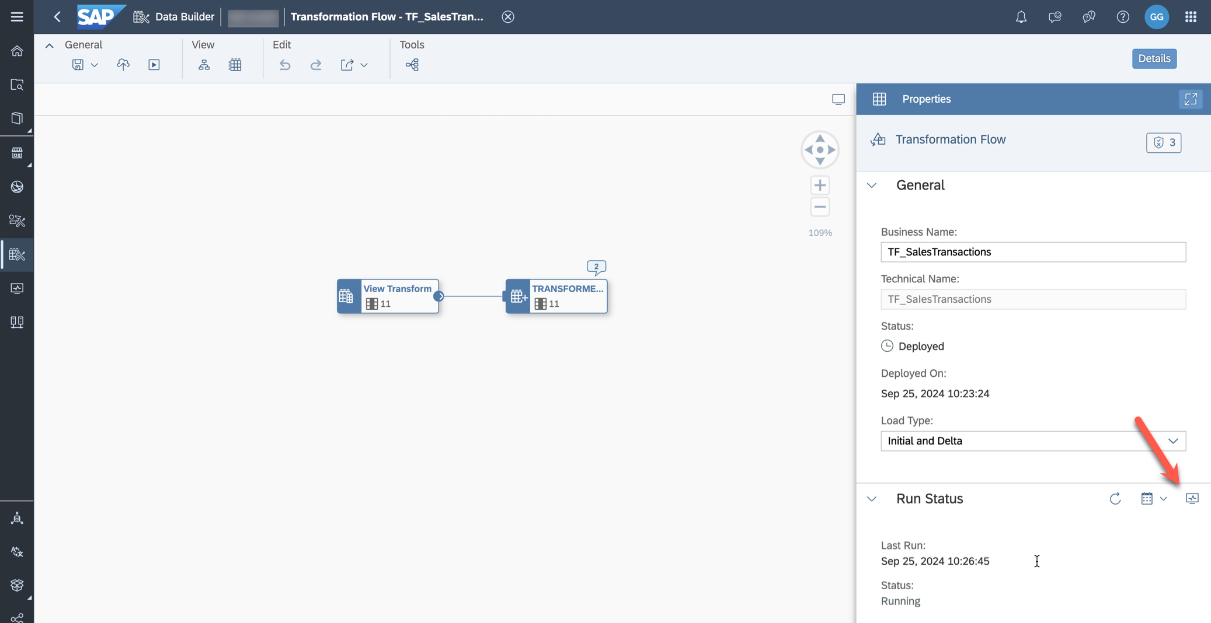

15. The Data Integration Monitor details display of the Transformation Flow run. Have a look at the messages and the section ***Metrics*** to check the number of processed records.

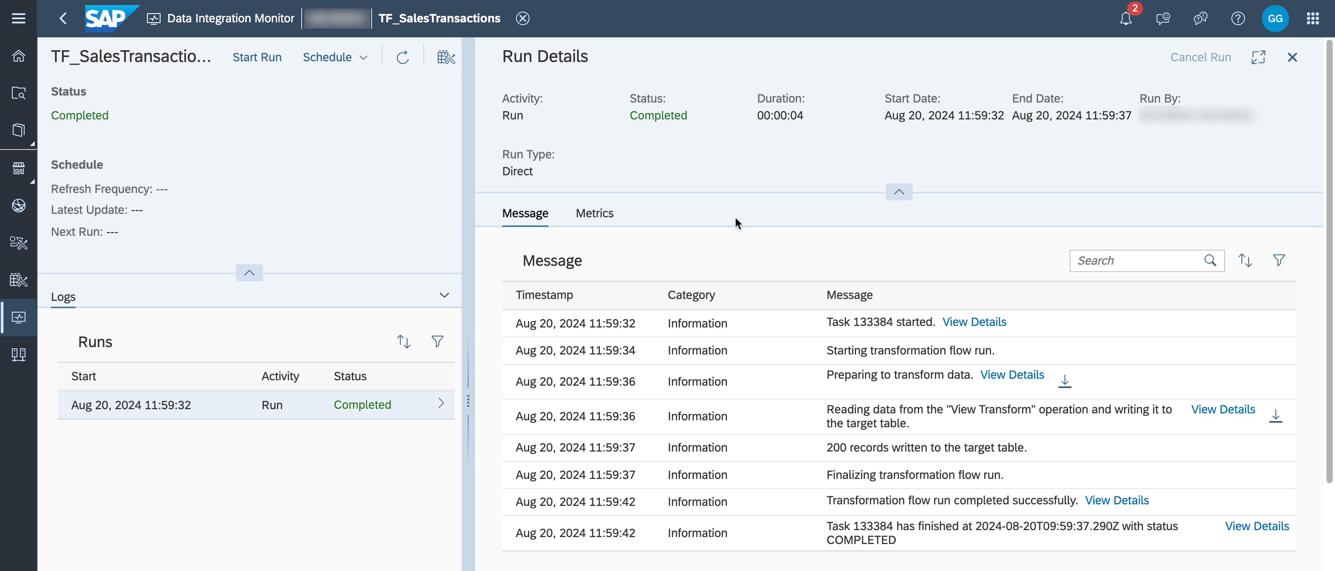

16. The Transformation Flow run should run scheduled. User consent is required to run scheduled tasks or task chains. Authorize SAP Datasphere to run these tasks.

6 / 16

README.md 2025-04-15

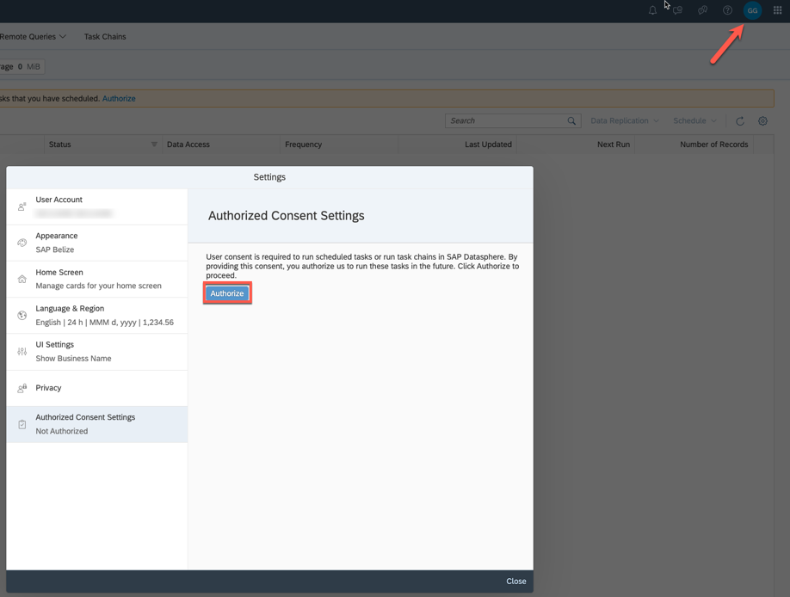

17. Schedule the Transformation Flow to run once a day. It will retrieve the newest and changed records and add them to the local table. Click ***Create Schedule***.

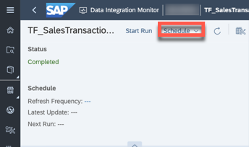

18. Define the scheduling as ***Simple Schedule*** which is repeated every 10 minutes. Choose a time and select ***Create***.

7 / 16

README.md 2025-04-15

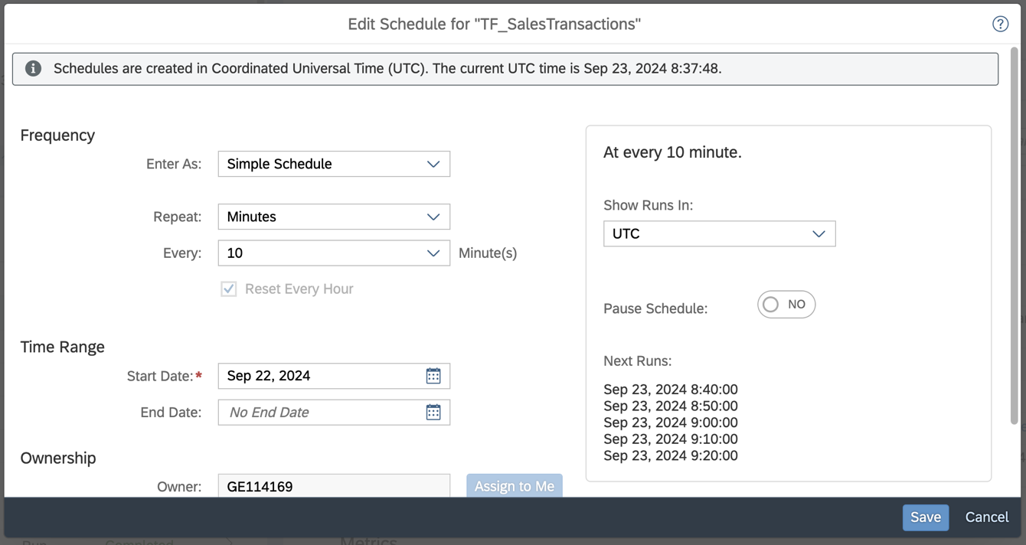

19. You can go back to this monitor after new runs to see that new records are written to the target table.

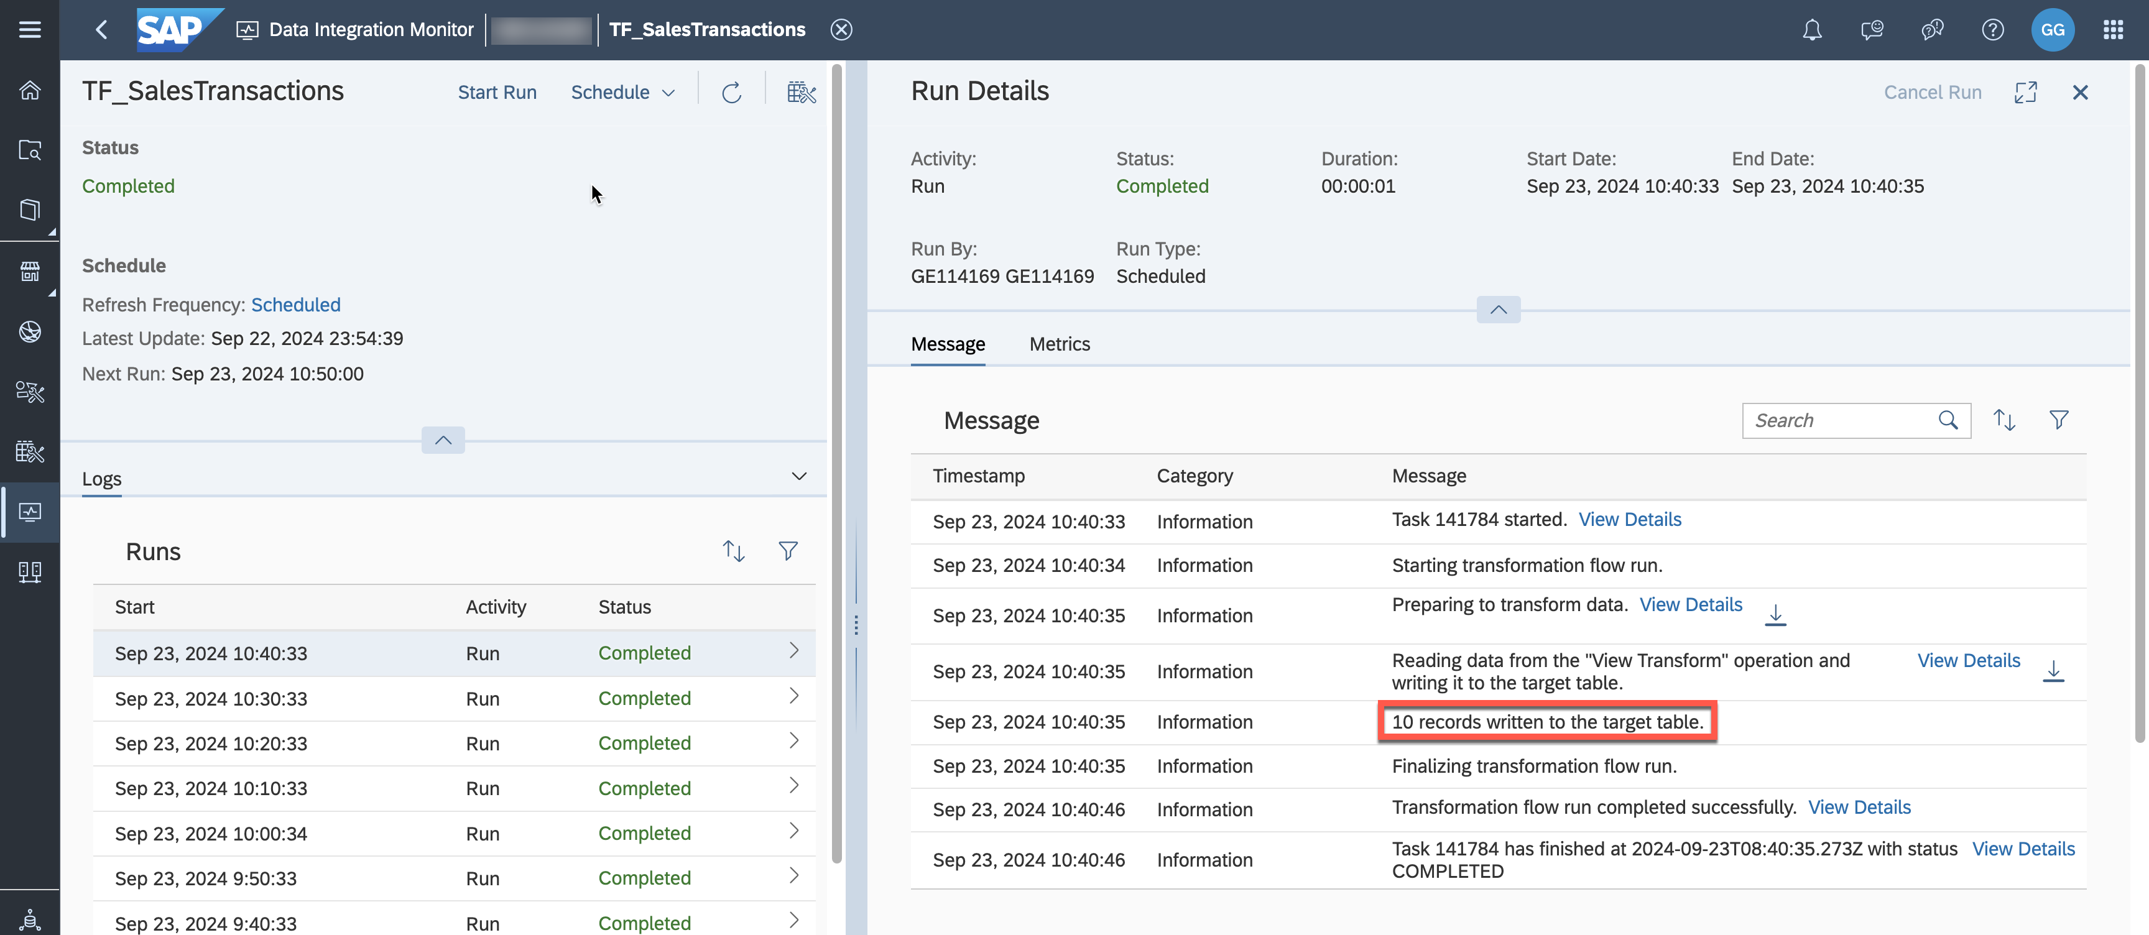

20. The Analytic Model used until now (Sales__Analytic_Model) is based on data of local tables. We will copy the fact model and replace the source so that the sales transaction data is coming from the table updated via the transformation flow instead of data imported once via CSV. Copy the view ***Sales View -***

8 / 16

README.md 2025-04-15

***Fact***. Name it ***Sales View - Fact (Updated)***.

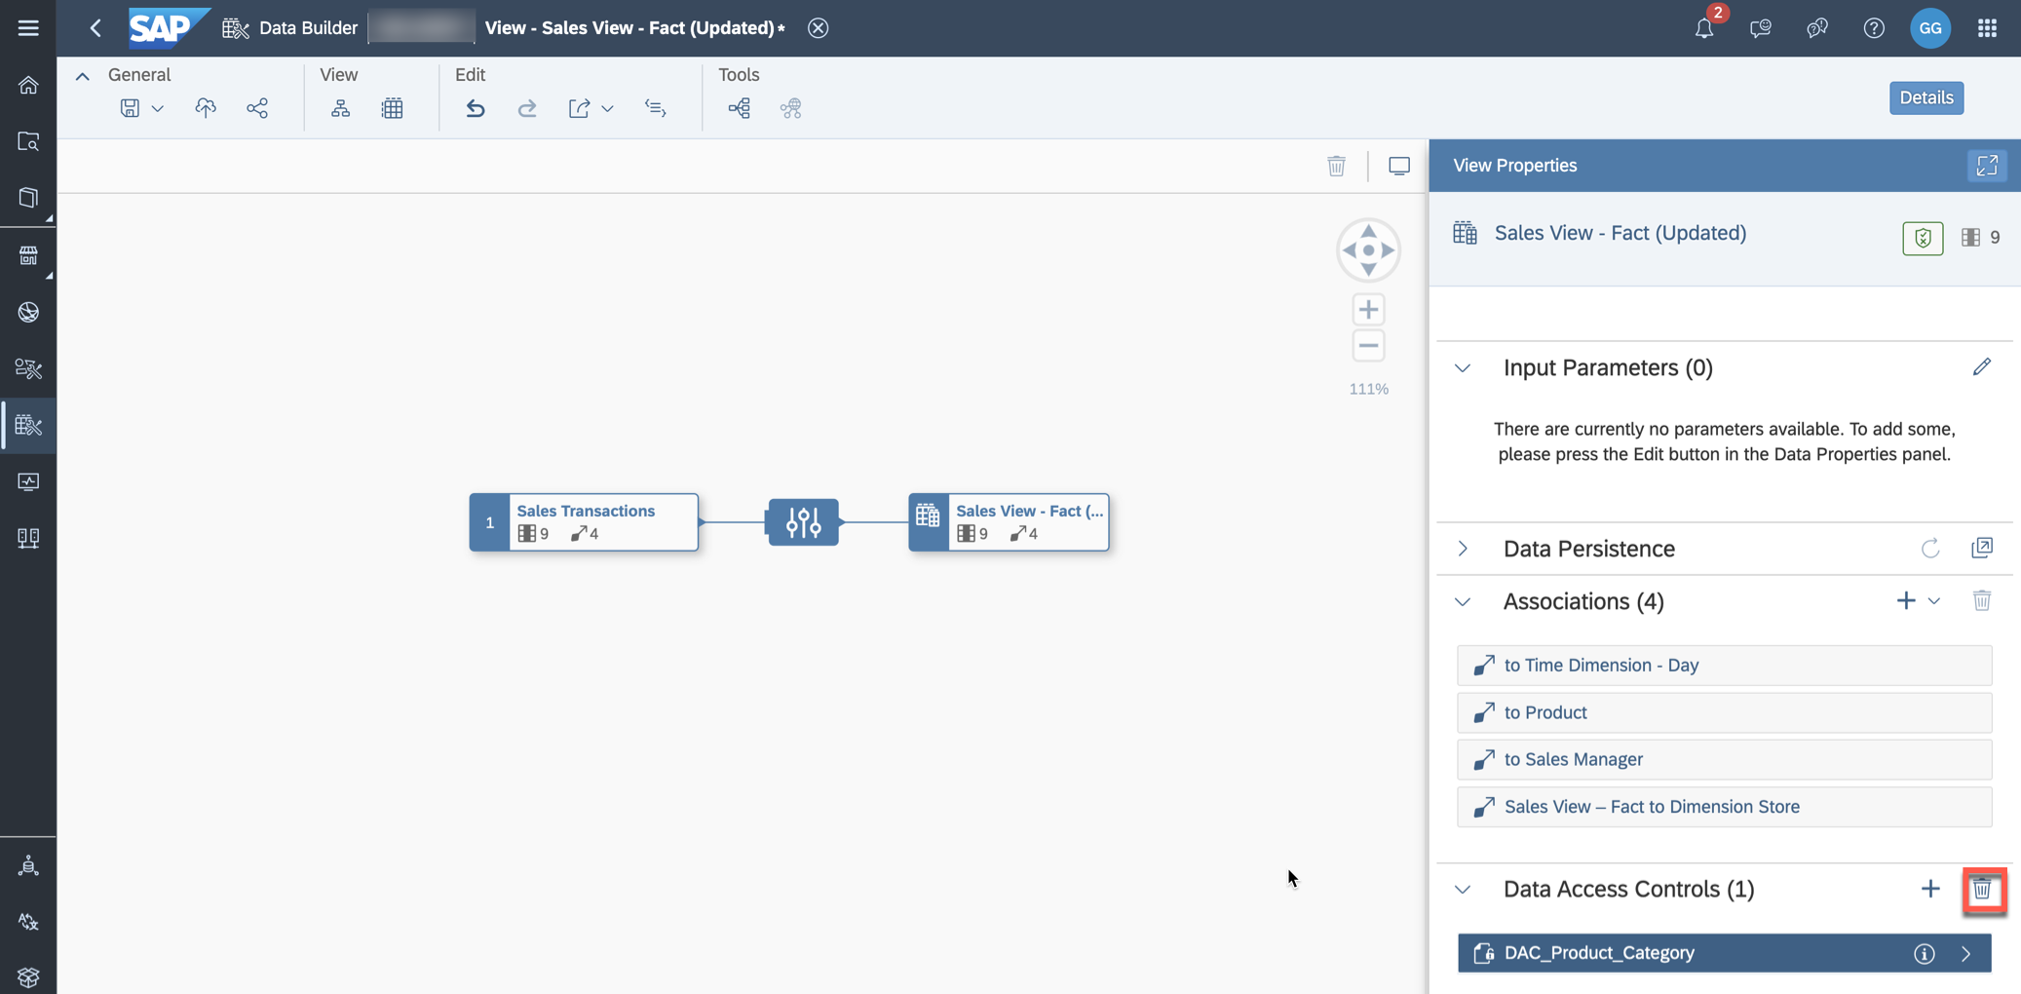

|  |  |
| --- | --- |
|  | **Tip:** We create a copy of the fact view (and Analytic Model & SAC story) to preserve the previously |

|  |
| --- |
| created models based on the CSV files. You will copy the existing SAC story and replace the model so |

|  |
| --- |
| that you don't need to recreate a full story. Another option would also be switching the source table of |

|  |
| --- |
| the currently used fact view so that the updated records are displayed in the already existing SAC story. |

21. Open the copied view ***Sales View - Fact (Updated)***. If you previously did the exercise about data

access controls, the view does not look as displayed on the screenshot. Remove the join with

***ProductDim_DAC*** and the assigned DAC.



22. Drag and drop the table ***TECHED2024_SALES_TRANSACTIONS*** into the canvas and replace the

original source table.

9 / 16

README.md 2025-04-15

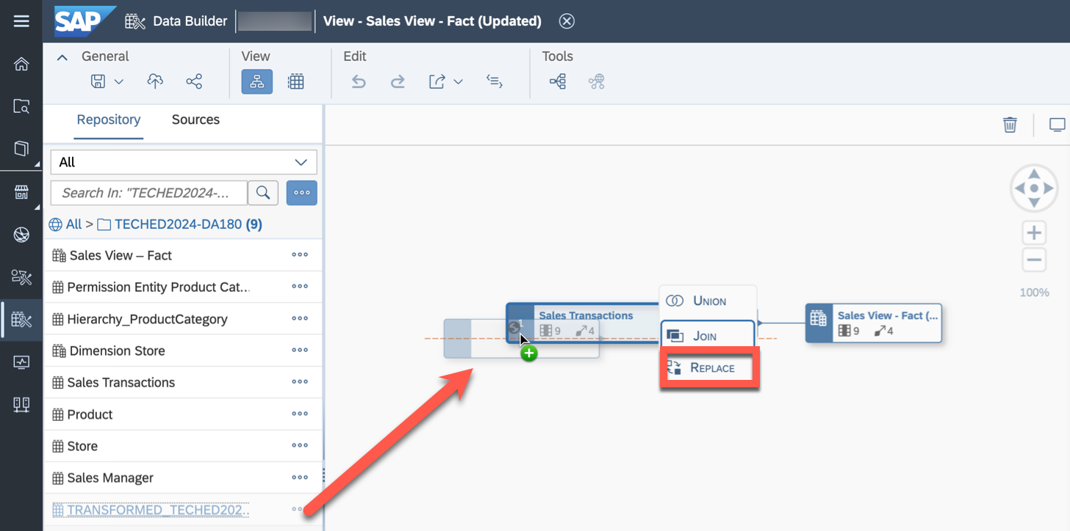

23. Map the columns from the old source to the new source by dragging them from the left to the right side. Ensure that all nine columns are mapped and click ***Replace***.

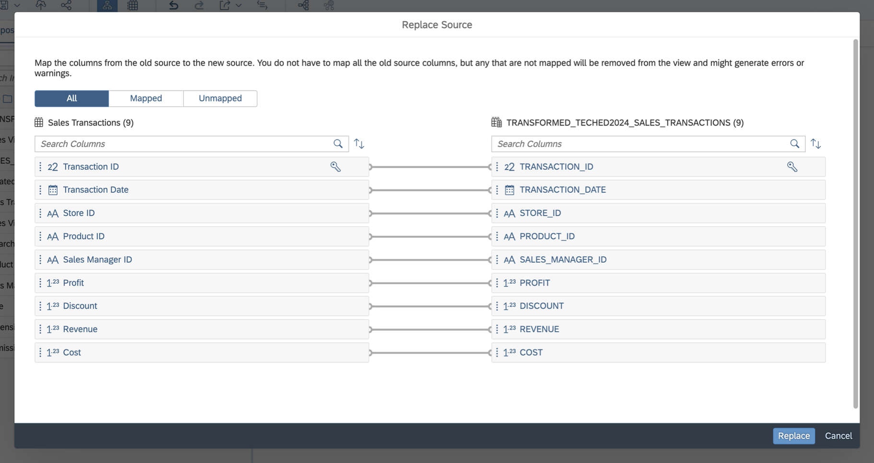

24. Now the source table is replaced with the local table which is enabled for delta capture. Ensure that the view validation of ***Sales View - Fact (Updated)*** displays a green status.

10 / 16

README.md 2025-04-15

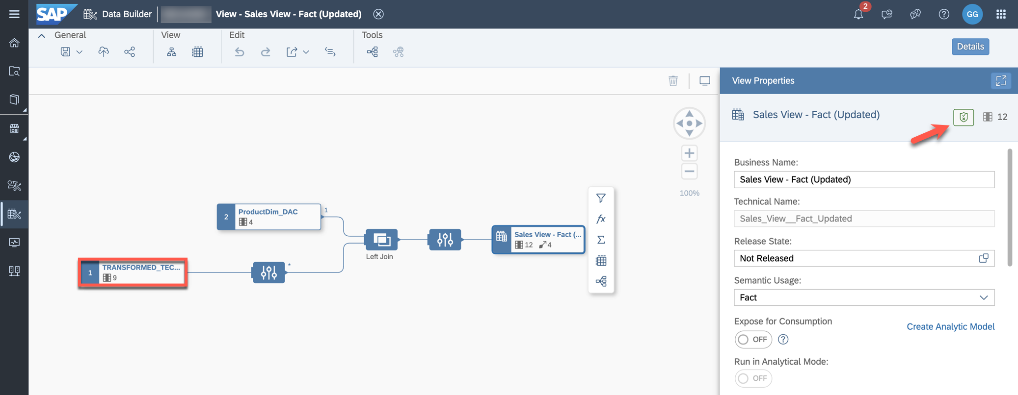

25. Save and deploy ***Sales View - Fact (Updated)***.

26. Select ***Create Analytic Model*** (in the view properties of ***Sales View - Fact (Updated)***).

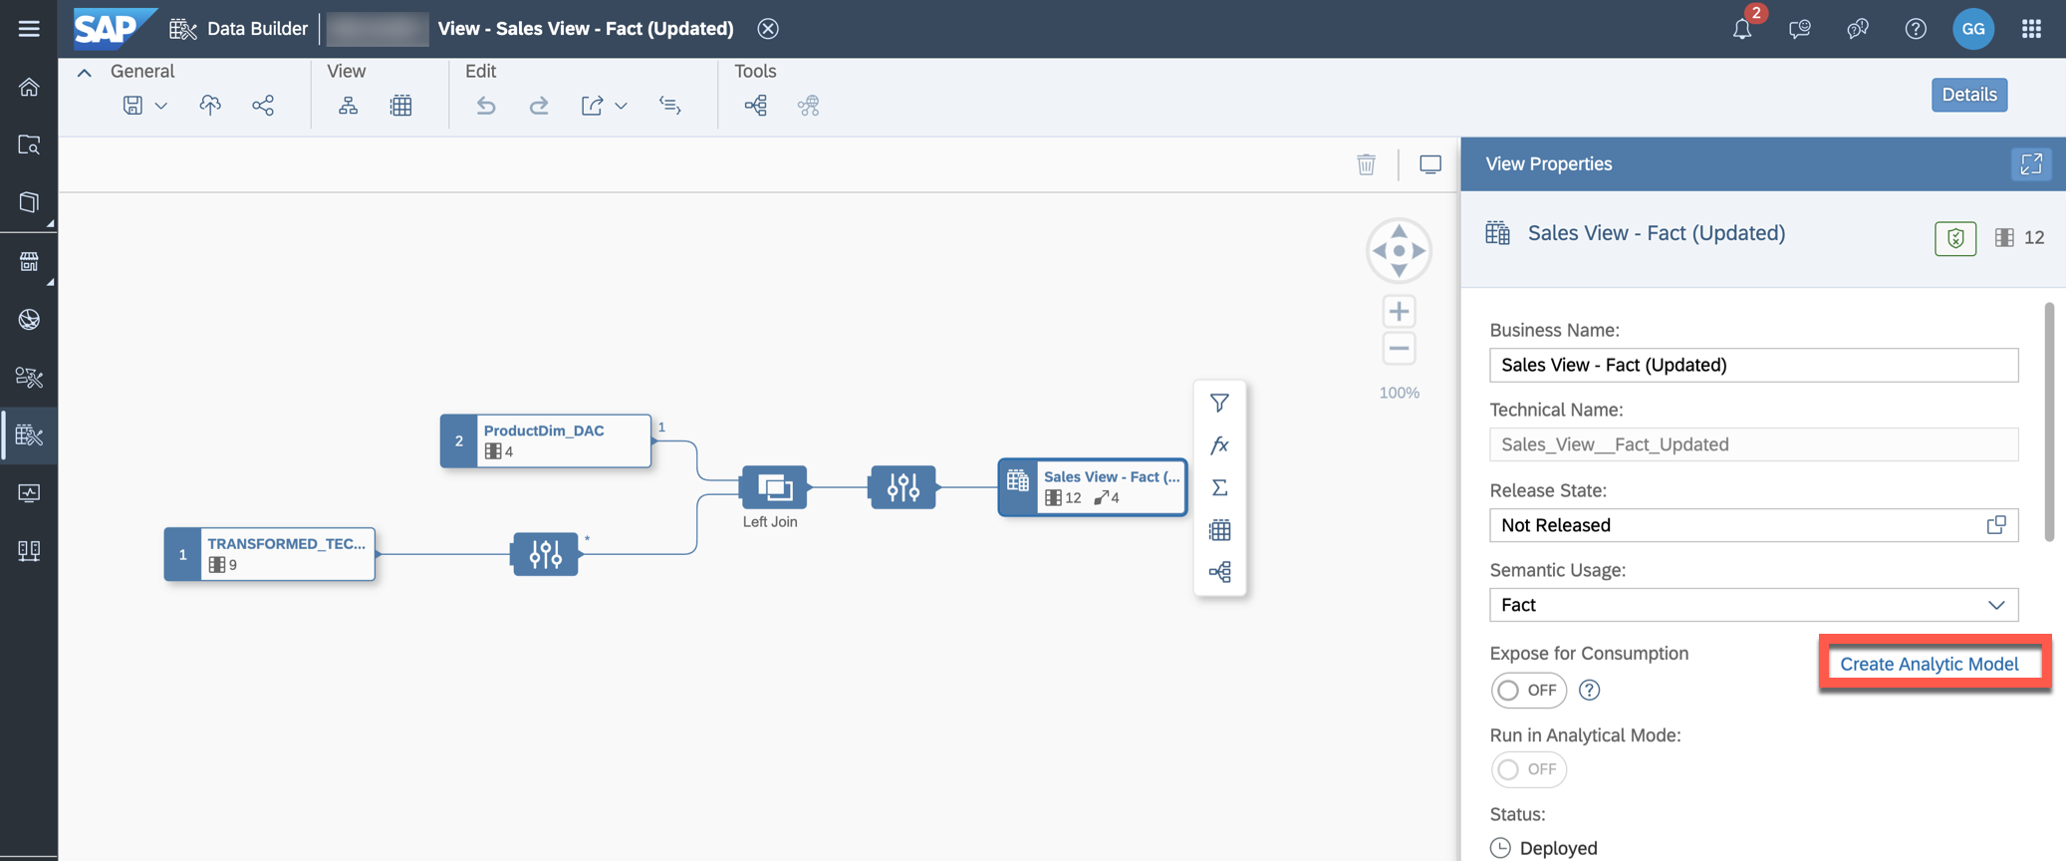

27. When creating an updated data model, it is likely that measure or attribute names change. To simulate this, select the measure ***Revenue*** and adjust the business and technical name to ***Updated_Revenue***.

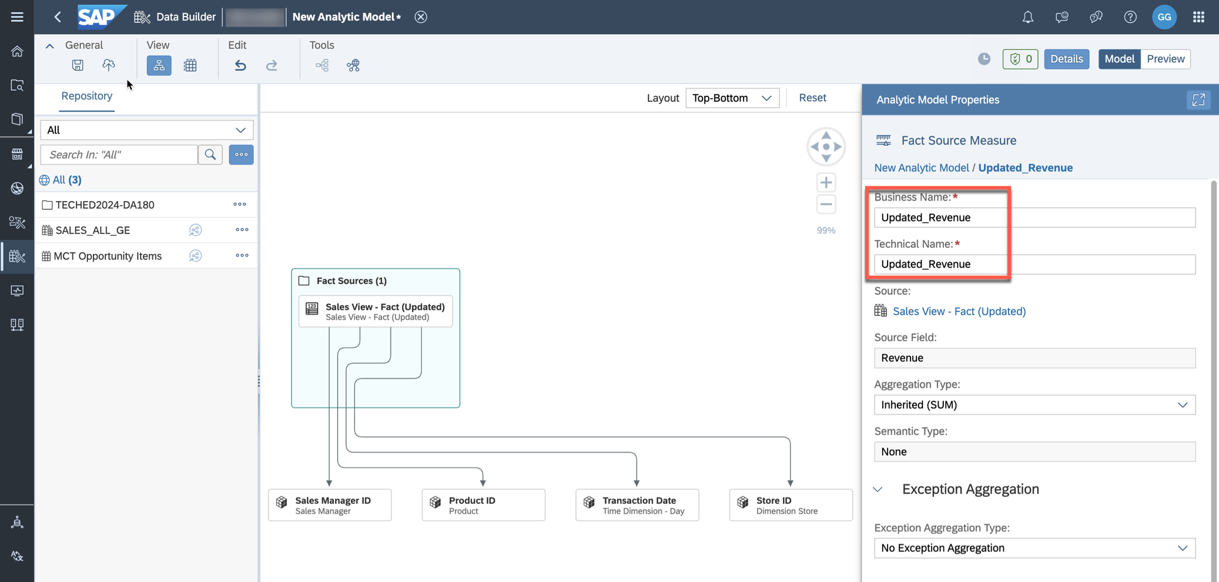

11 / 16

README.md 2025-04-15

28. Save the Analytic Model as ***Sales - Analytic Model (Updated)*** in the folder **TECHED2024-DA180**. You need to confirm the warning "Renaming measure technical name might affect existing stories" once before saving and deploying the model. The Analytic Model is now accessing delta enabled local table which is receiving updated records. We will reuse the previously created SAC Story and map it to the new updated Analytic Model so that the report displays the incoming sales transactions.

29. Use the product switch button in the upper right corner to switch to SAC.

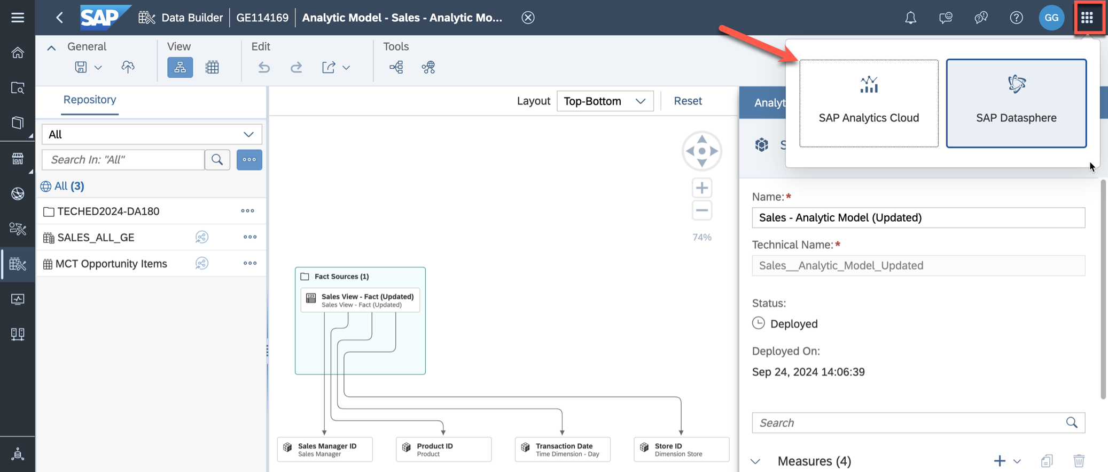

30. Switch to the ***Files*** application and copy the previously created story ***Revenue Analysis - Products*** to keep the previously created story as a backup. Copy it to the same folder and name it ***Revenue Analysis - Products (Updated)***.

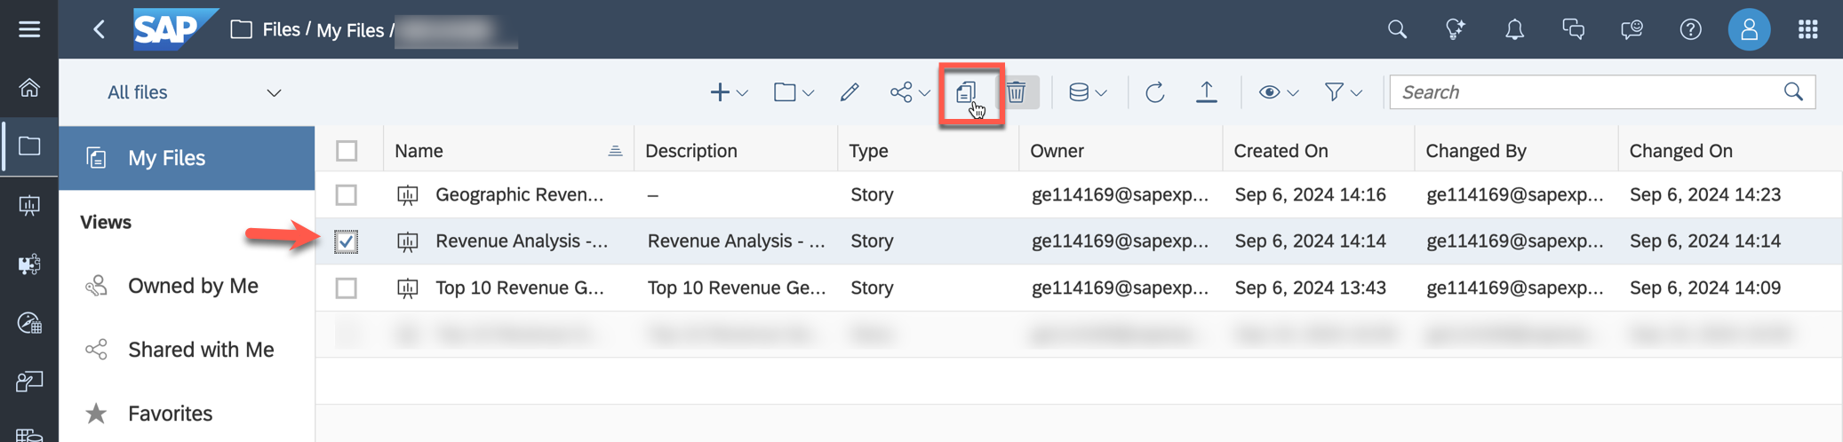

31. Open the story ***Revenue Analysis - Products (Updated)*** and switch to the ***Edit*** mode.

32. To replace the model, access ***...*** -> ***Add New Data*** -> ***Sales__Analytic_Model***

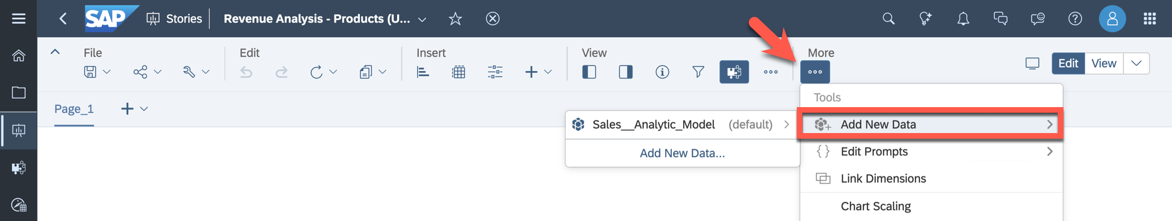

33. Select ***Replace***.

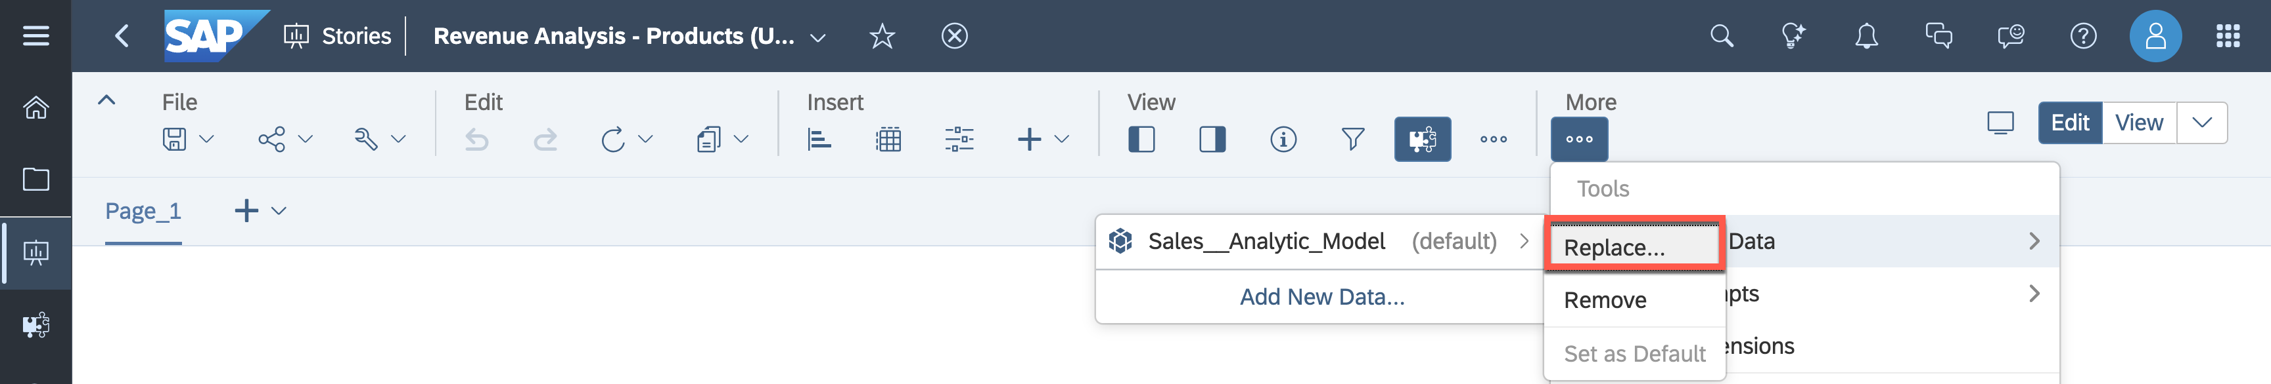

12 / 16

README.md 2025-04-15

34. Read the warning displayed and click ***Continue***.

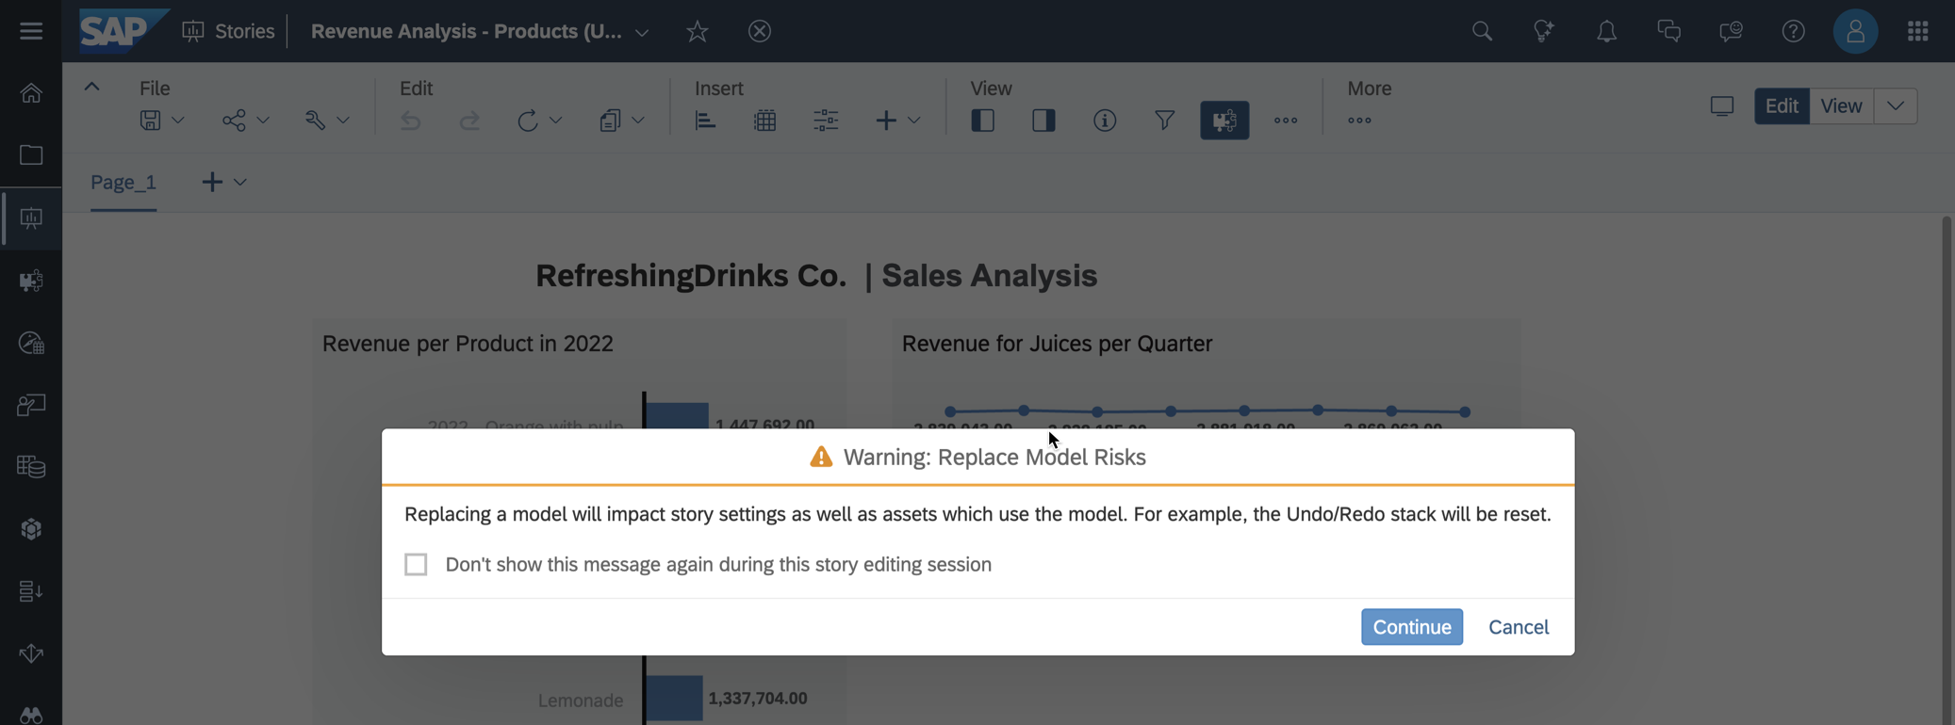

35. Select ***select other model***. You can replace a model in your SAC story with another compatible model, an Analytic Model can be replaced with a different Analytic Model. Choose the connection   
***DATASPHERE*** and click on the folder with your user's ID. Select the folder ***TECHED2024-DA180*** and click on the Analytic Model ***Sales - Analytic Model (Updated)***.

36. The replace model dialog displays the objects from the replacement model and the objects that need to be mapped (only objects used in the story are mapped). Some objects will automatically be mapped if they are similar to the original objects or if they are mandatory objects. Then they will be disabled (greyed out) in this panel. Map the measure ***Updated_Revenue*** to ***Revenue***. Check that the mappings are done correctly like displayed in the screenshot.

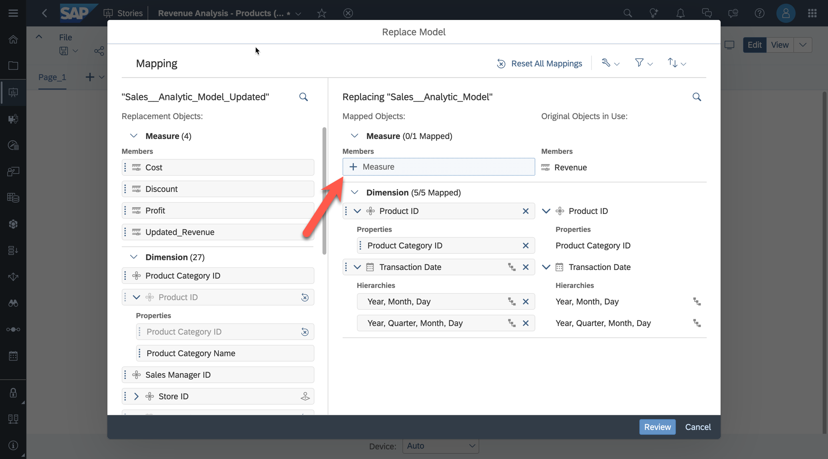

37. When you have finished mapping objects, select ***Review***. Verify that no issues have been found and click ***Replace Model***.

13 / 16

README.md 2025-04-15

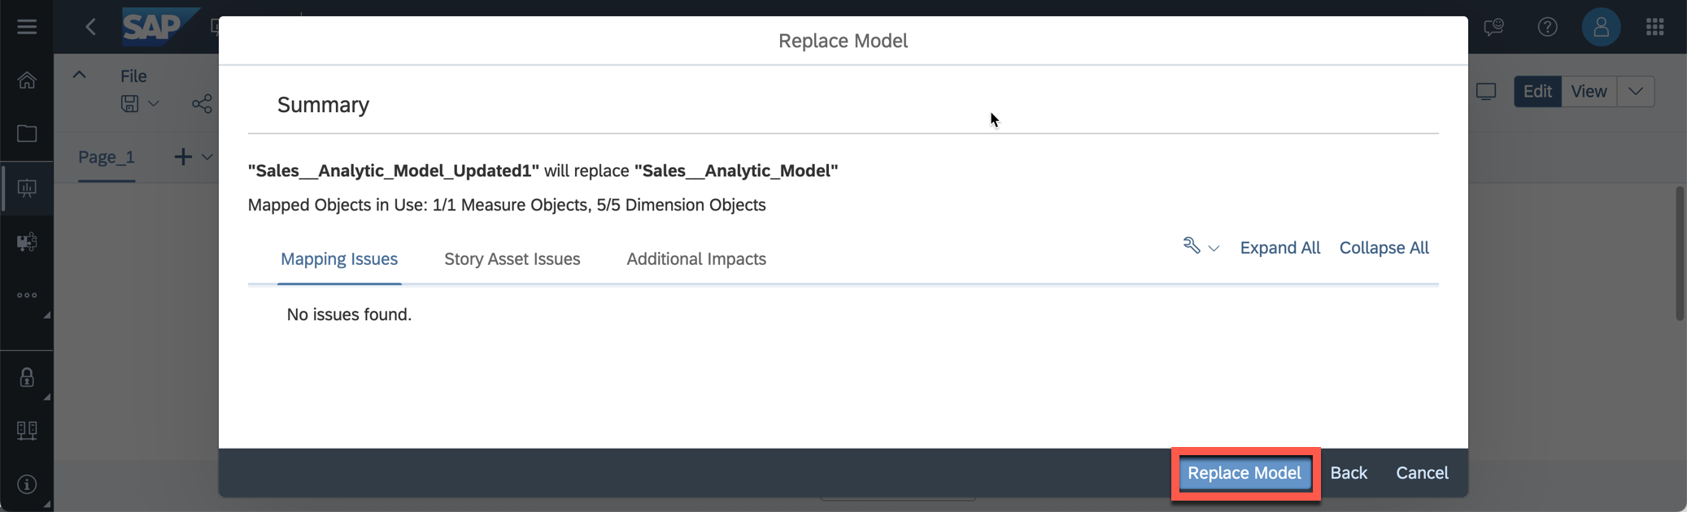

38. The story now accesses data from the new source. The filter for revenue per product is set to 2022. As

there is no data available for this year, now data is displayed. We will modify the story in the next steps.

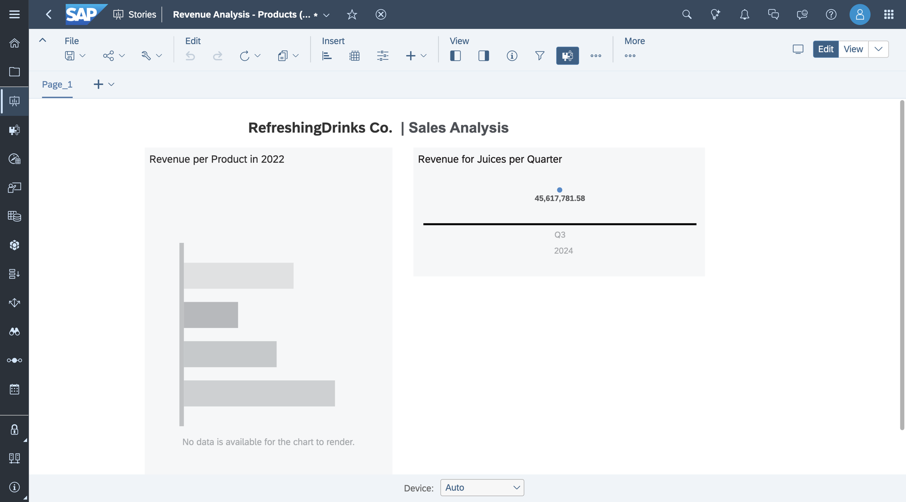

39. Select the chart ***Revenue per Product*** and remove the filter set for ***Transaction Date***.

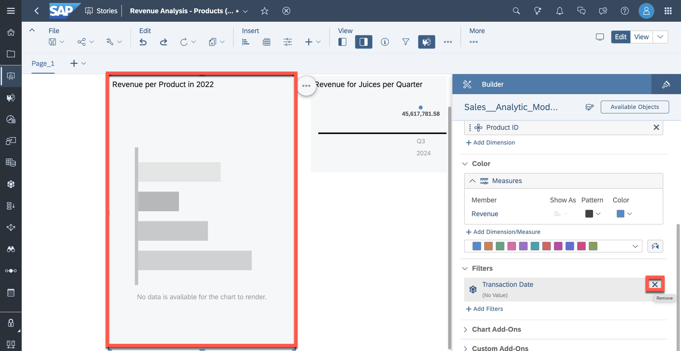

14 / 16

README.md 2025-04-15

40. The revenue per product is displayed.

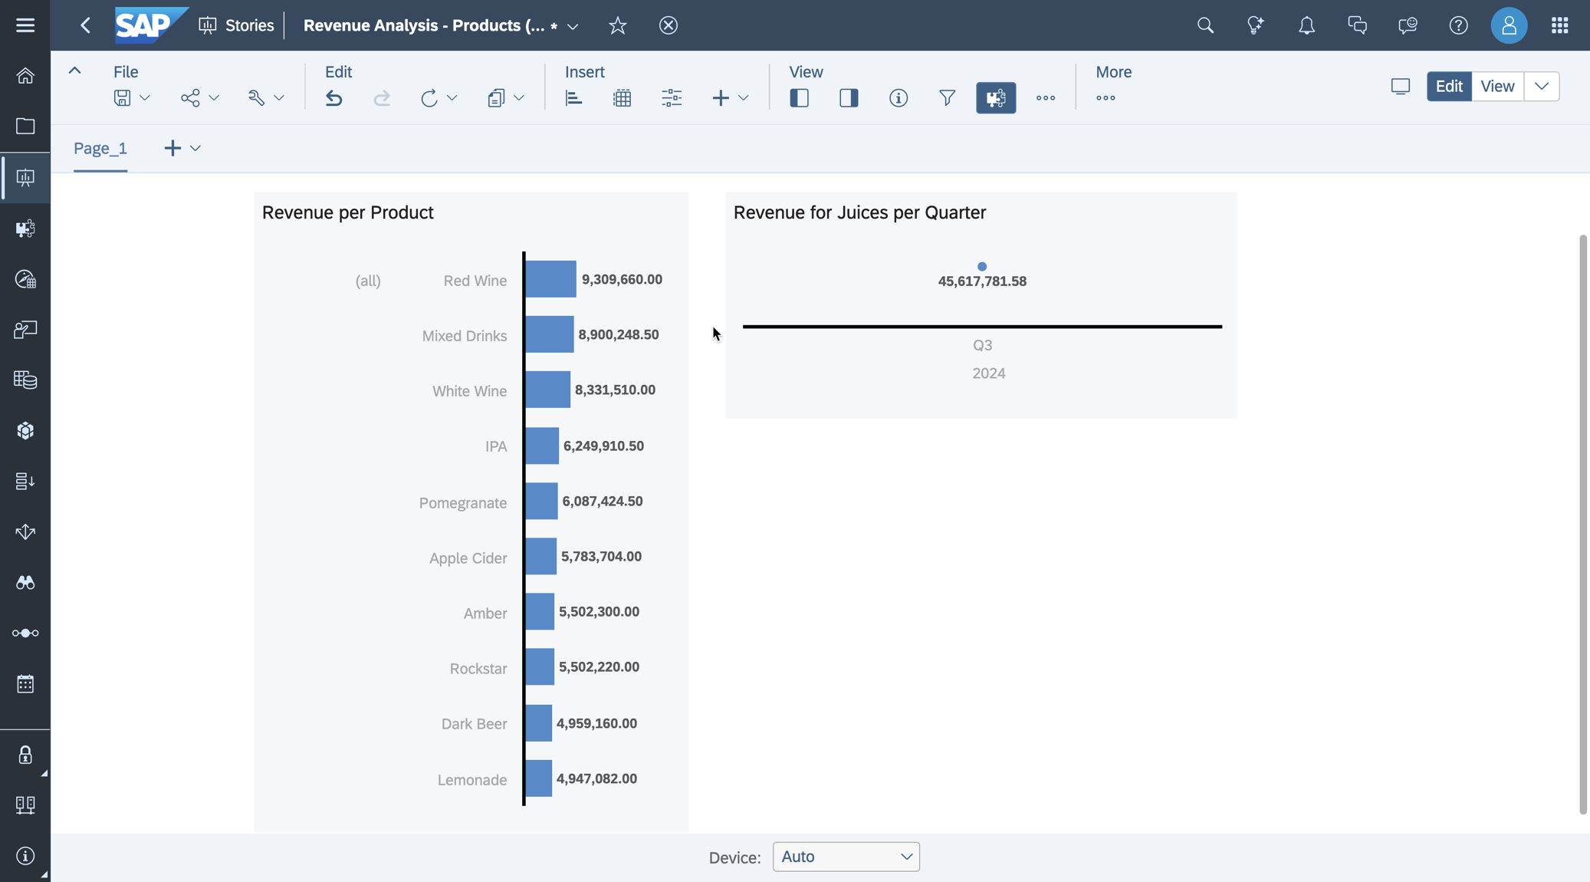

41. Now we focus on the chart on the right-hand side. We would like to receive a daily summary of recent sales of juices from the past few days. Open the wizard for drill-down when clicking onto the data point. Drill down on the transaction date until it is based on days (click twice on the ***Drill Down*** button).

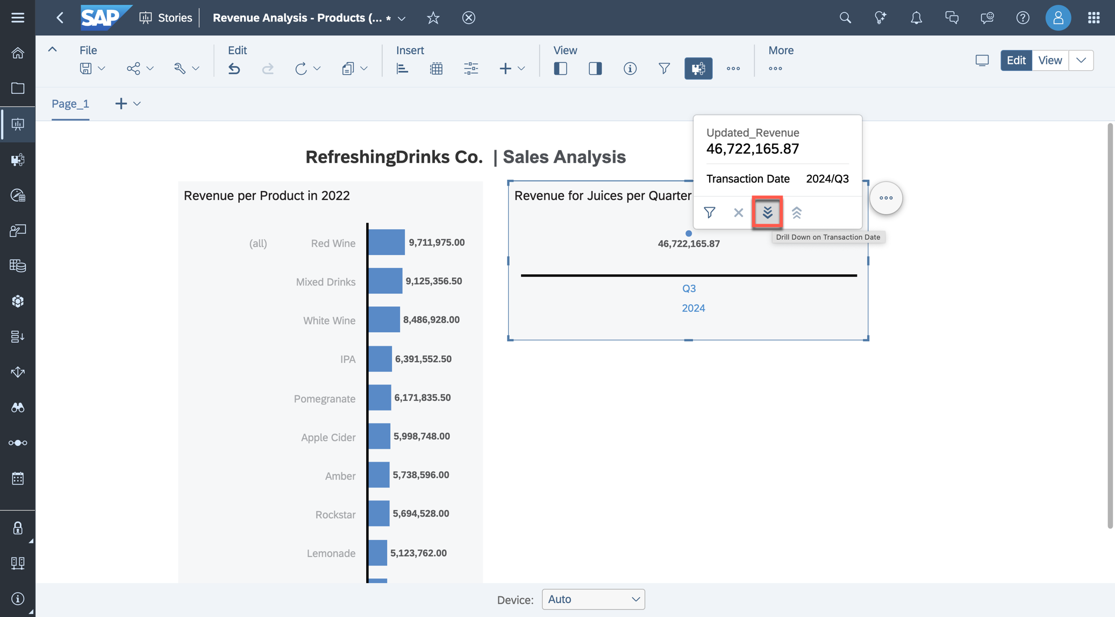

42. Save the story. You are asked if you want to remove the unused model, select ***Remove data source***.

43. Your final report dynamically displays the most recent beverage sales, allowing you to analyze the changes in revenue from sold juices over the past few days.

15 / 16

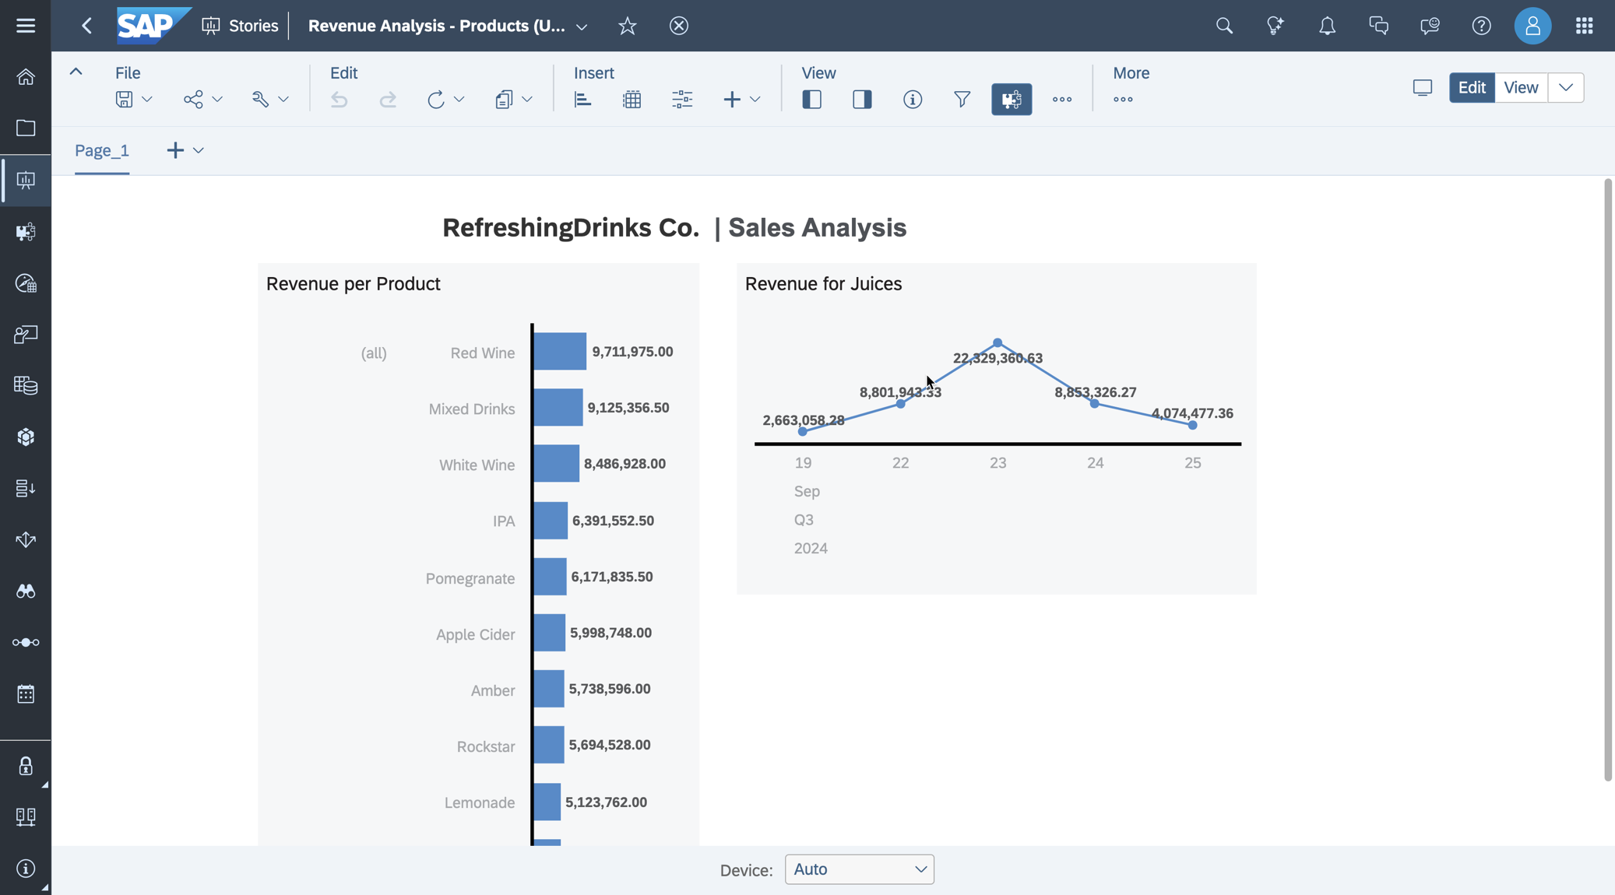

|  |  |
| --- | --- |
| README.md | 2025-04-15 |

Summary

You have now created and deployed your first transformation flow to transform and access changing records

in a scheduled approach. You replaced the data source while keeping the story structure and format intact.

You can continue with one of the optional exercises:

|  |  |
| --- | --- |
|  | Exercise 20: Identify Top-Performing Sales Managers with Just Ask Exercise 21: Create Row-Level Permissions based on External Hierarchy Exercise 22: Explore the Analytic Model |

16 / 16